ENVIRONMENTAL AUDIT HANDBOOK: Guideline/synthesis for assembling

This document includes a step-by-step flow derived from earlier WGEA Guidance that summarizes the steps of conducting an environmental audit. These steps could be further complemented with detailed instructions and audit examples to conduct a general guideline, how to address possible issues in the audit process and what best practices can be utilized when it comes to conducting environmental audits.

Flow of conducting an environmental audit (visual flowchart) – DRAFT!!

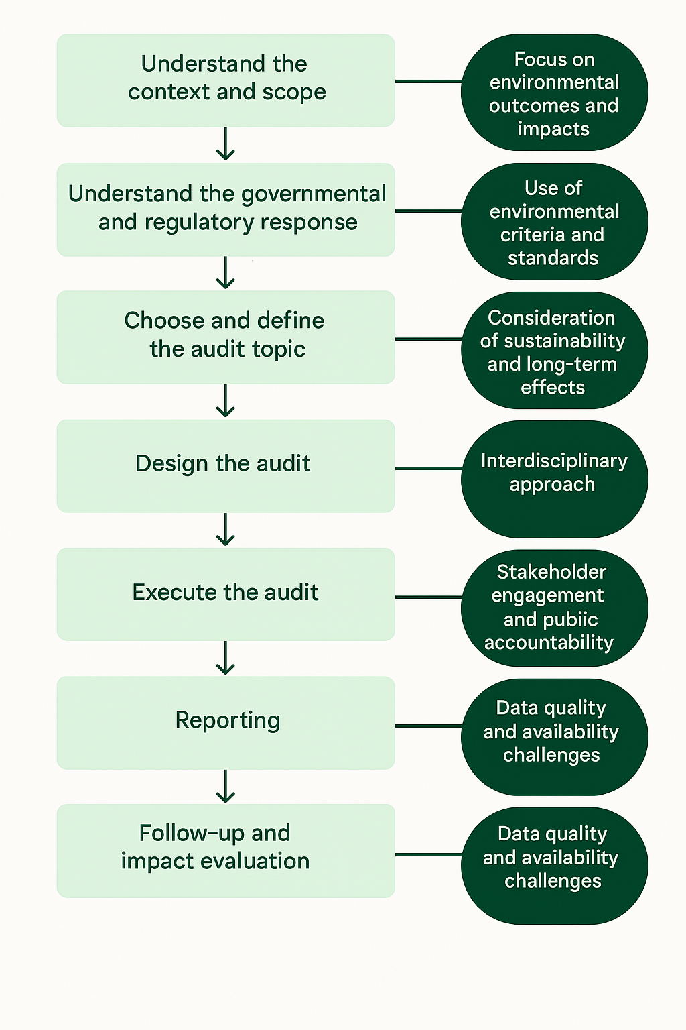

Step-by-Step Guide to Conducting an Environmental Audit (with additional guidance needs highlighted with blue)

1. Understand the context and scope of the audit
- Identify the environmental issue or sector (e.g., sustainable energy, water management, waste, etc.) relevant to your audit.
  - Consider including a topic selection matrix or checklist that evaluates relevance, auditability, timing, data availability, stakeholder interest, and potential impact.
  - Consider providing a framework for assessing the "significance" of environmental, social, and economic risks.
  - Provide examples of how cooperative audits can be used to address transboundary environmental issues.
- Assess the influence on society, economy, and the environment: understand how the issue impacts these domains, and what the main environmental risks and opportunities are.
  - Could include explicit guidance on how to integrate environmental perspectives into audits in policy areas where environmental concerns may not be immediately obvious (e.g., transportation, energy).
  - More detailed steps could be included on how to integrate environmental risk assessments into the overall audit planning process.
  - It is also suggested to provide frameworks for identifying and prioritizing environmental risks, as well as methodologies for assessing the potential economic, social, and environmental consequences of these risks.
  - Content could be provided in the handbook on how to explain the environmental impacts of government operations (governments can have a significant environmental footprint through consumption of energy, water, and natural resources, release of emissions like greenhouse gases, generation of waste and stewardship of land, etc.)
- Determine the audit mandate: confirm your legal authority and scope for conducting the audit, including any international or national obligations.
  - Would be useful to include guidance on how to tailor audit approaches to address the complexity of environmental issues.
  - Examples of audit approaches that could be included in the manual:
A. System-oriented approach, which examines the proper functioning of management systems.
B. Result-oriented approach, which assesses whether outcome or output objectives have been achieved as intended or programmes and services are operating as intended.
C. Problem-oriented approach, which examines, verifies and analyses the causes of particular problems or deviations from criteria. For example, Audit of specific Environmental Issues such as increase in Air Pollution, adverse impact on Biodiversity in an area, depletion of Groundwater, etc.

2. Understand the governmental and regulatory response
- Review international agreements and national legislation: Identify obligations from treaties, EU directives, and national laws that are relevant to the environmental issue.
  - Include examples of international environmental agreements and reports published for reference
  - It might be helpful to include a list of key MEAs or International Environmental Treaties, providing auditors with an overview of the major global issues and the relevant criteria associated with them
- Map out policies, programmes, and instruments: Understand what policies, programmes, and management instruments (e.g., subsidies, taxes, regulatory measures) exist to address the environmental issue.
  - proposed to consider the evaluation of incentive and financing mechanisms (such as funds, subsidies, etc.) provided to support the implementation of policies and programs
- Identify key stakeholders and auditees: Determine which ministries, agencies, or private entities are responsible for or affected by the environmental issue.

3. Choose and Define the Audit Topic
- Assess risks and materiality: Use risk analysis to select audit topics that are significant in terms of environmental impact, public interest, or financial exposure.
  - risk assessment guidance would benefit from technical depth, especially on integrating environmental indicators and data uncertainty into the risk analysis. This could include examples of environmental risk indicators and guidance on managing missing or unreliable data, along with acceptable assurance levels. Consider adding a prioritization matrix to help audit teams rank risks by impact and likelihood.
  - as for financial audit, consider giving examples on identification of financial impacts, such as of environment related risks, environmental liabilities, asset impairment due to environmental crisis, clean-up costs, carbon credits, etc.
- Define audit objectives and questions: Clearly state what the audit intends to achieve (e.g., compliance, performance, effectiveness, efficiency, or impact).
  - as for performance audit, it is suggested to provide specific examples of how to assess risks related to economy, efficiency, and effectiveness in the context of environmental policies and programs.
  - as for compliance and financial audit, it is suggested to include detailed guidance on how to assess the risk of non-compliance with environmental regulations and the risk of material.
- Select audit criteria: Use authoritative sources (laws, standards, policies) and, where necessary, non-authoritative sources (expert opinion, academic literature) to define what “success” or “compliance” looks like.
  - Consider giving examples of audit criteria specifically applicable to environmental audit within the context of financial audit, to guide financial auditors.
  - It is suggested to provide more detailed guidance (through examples) on developing relevant, complete, understandable, and reliable audit criteria.

4. Design the Audit
- Plan the audit methodology: Decide on the audit type (financial, compliance, performance), scope, timeframe, and methods (document review, interviews, field visits, surveys, data analysis, etc.).
  - Would be useful to specify the appropriate examination period (number of years) to collect and analyze environmental data this would help auditors to determine the minimum historical data needed to express better audit results
  - The use of modern auditing techniques should be considered to obtain relevant evidence with scientific value to qualify and quantify the negative impact on the environment and natural resources, such as satellite images and multitemporal analysis to determine the loss of forest cover, analysis of geographic information to identify contaminating points, and laboratory tests to analyze environmental quality with respect to official parameters and standards.
  - It is suggested to add explanations regarding the application of emerging technologies, such as satellite analysis, geographic information systems (GIS), and the use of drones, and appropriately explain their specific application methods, advantages, and potential challenges in each stage of environmental auditing, to assist auditors in better selecting and applying these technologies.
  - Consider including guidance on using tools that can provide systematized information on environmental conditions and the inherent risks related to climate change, such as early warning systems, geo-referencing systems for the identification of high risk areas that cannot be mitigated, satellite information for climate prospecting, risk scenario simulation laboratories, etc.
  - Addressing cost inefficiencies: guidance could consider providing scalable approaches, recommending alternative low-cost tools, or encouraging regional cooperation and capacity-building to support SAIs in overcoming these barriers while still promoting high-quality environmental audits.
- Develop an audit logic matrix: Map audit questions to criteria, evidence sources, and methods of analysis.
  - It is suggested to clearly position environmental auditing as economic supervision and focus on the supervision of the authenticity, legality, and efficiency of financial and fiscal revenue and expenditure. For example, following the main thread of "strategy - policy - project - funds", integrate research throughout the auditing process, pay attention to the entire cycle of collection, management, allocation, expenditure, and use of government fiscal funds and special funds for resource and environmental protection, and reveal issues such as misappropriation, waste, and inefficient fund usage.
- Assess internal controls and management systems: Evaluate whether the auditee has adequate systems for environmental management, monitoring, and reporting.

5. Execute the Audit
- Collect evidence: Gather and analyze data, conduct interviews, perform site visits, and review documentation.
  - guidance on conducting an environmental audit could also include the issue of open data, which is a likely topic to become more topical in the future
  - Guidance would be needed on what data sources environmental audits use – this could be outlined through examples. The handbook could discuss that environmental audits utilize data from diverse sources, including government databases, scientific studies, stakeholder input, scientific studies, satellite imagery, and even citizen opinions requiring auditors to assess the reliability of each source.
  - Similarly, the handbook could discuss what data collection techniques are there to conduct relevant environmental audits. Through examples, it could be shown that data collection techniques in environmental auditing can include e.g. the use of remote sensing to analyze changes in vegetation cover or water quality, or the use of Geographic Information Systems (GIS) to map the geographical distribution of pollution.
  - The handbook could also include instructions for auditors to clearly state in audit reports the extent to which reliability of data sources are verified: practical guidance is needed on efficient data collection by prioritizing existing government resources and to ensure transparency by requiring auditors to report on the reliability of these sources.
- Test compliance and performance: Check adherence to laws, regulations, and policies; assess the effectiveness and efficiency of environmental programmes and management systems.
- Evaluate environmental impacts: Where possible, quantify environmental outcomes (e.g., emissions reductions, resource savings, biodiversity impacts).

6. Reporting
- Draft a clear, objective, and evidence-based report: Present findings, conclusions, and recommendations in a way that is understandable and actionable.
  - consider including case examples on how to use modern tools to communicate audit results to stakeholders (e.g. use of podcasts, social media platforms)
  - consider elaborating through guidance on communication protocols for handling sensitive findings involving international political dimensions (to ensure appropriate and diplomatic reporting)
  - Characteristics of a high-quality audit report could be outlined. The key characteristics of a good audit report are as follows:
    - Clear and concise – Information is presented in a way that is easy to understand without compromising factual accuracy.
    - Relevant and focused – Each finding is directly linked to the audit objectives and the impact on stakeholders.
    - Balanced and objective – The report presents both strengths and weaknesses of the audited entity.
    - Reliable – Supported by sufficient and appropriate audit evidence.
    - Actionable – Contains practical, result-oriented recommendations that can be implemented.
- Highlight significant environmental risks, gaps, or achievements: Focus on issues that have material environmental consequences or that affect public accountability.
- Recommend remedial actions: Suggest improvements to policies, management systems, or controls as needed.
  - Consider including in the handbook the suggestion of categorizing environmental audit recommendations according to the following dimensions: (1) Short-term versus long-term actions; (2) Level of environmental risk; (3) Priority groups for follow-up. This classification would support SAIs in developing structured follow-up strategies and assessing the effectiveness of recommendation implementation. It would also assist audited entities in prioritizing actions and allocating resources more efficiently.

7. Follow-up and Impact Evaluation
- Monitor implementation of recommendations: Track whether auditees act on audit findings and recommendations.
  - Consider suggesting an appropriate period to follow up on the environmental audit report.
  - A section or practical notes could be added in the handbook offering detailed instructions to facilitate the implementation of environmental audit recommendations.
- Evaluate long-term impacts: Where feasible, assess whether the audit led to improved environmental outcomes or management practices.
  - Despite environmental audits including recommendations with long-term targets, a "tweak" indicating a direction towards real change and impact is needed in the now: consider including examples on how such a direction could be expressed.

Other aspects to be addressed in the handbook
- A section could be added that specifies the level of environmental knowledge expected of audit teams.
- Examples and best practices could be included to articulate new or advanced ways to shift public culture in the right direction (take behavioral change and improvements into account)
  - Consideration could be added in the handbook of environmental improvement relying heavily on behavior change.
- Explanation could be included on what environmental liabilities are.
- An important section to consider adding is region-specific examples/thematic sections across the handbook.
- The handbook would benefit immensely from including appropriate auditing practice cases across the steps and areas of the audit process. Select typical cases where audits have revealed e.g. significant risks of resource damage, ecological destruction, and environmental pollution, briefly introduce the process from planning and project initiation to conclusion, including difficulties encountered and solutions, to help readers more intuitively understand the application of the auditing process across different scenarios.
- Including linkages with evolving standards would support the handbook as well, for example, IPSASB exposure drafts, the TCFD and other related information. This would help ensure it is current and make the link between financial audit and performance audit on environmental issues more concrete.

