Improving the visibility of SAIs’ work - Communicating environmental audit results

Foreword
Supreme Audit Institutions (SAIs) as external auditors hold their governments accountable for public spending. An essential part of this task is to make the audit reports available for the parliament, stakeholders and general public. The visibility of audits ensures that SAIs get their message heard, and it contributes to the transparency and accountability of public sector funds.

The INTOSAI Working Group of Environmental Auditing (WGEA) committed to developing a research paper on visibility of environmental auditing in its Work Plan 2017-2019. The project was led by the European Court of Auditors, and the project team included of SAIs of New Zealand, Russia and USA. Vivi Niemenmaa coordinated the project with the support of Jerneja Vrabic and Dilyanka Zhelezarova (European Court of Auditors), Jonathan Keate and Patricia Johnson (SAI New Zealand), Marina Mazykina (SAI Russia) and Barbara Patterson (SAI USA). In each of these organisations, SAIs’ communication teams provided crucial input. Finally, the Steering Committee of the INTOSAI WGEA provided important comments and insights regarding the project plan and report draft.

This project builds on previous work of the Working Group, and concentrates on how SAIs communicate about environmental audits to increase their visibility. Although the context of this project is environmental audit and many examples and case studies concern environmental audits, the key messages apply to all audits that SAIs conduct on various policy sectors.

Globally, not all SAIs are in a position to publish their audit work. This research paper urges SAIs to use their power, when applicable, to publish their audit findings in public domain, in order to increase the transparency and accountability of public sector funds. In the era of “fake news” and anti-environmental communication SAIs have an important role in providing fact-based information.

Contents

Foreword 1
Executive summary 4
1. Introduction 5
Communication is SAIs’ tool to strengthen accountability 5
Environmental communication 6
Project scope and methodology 6
2. Communication strategies 8
3. Who communicates in SAIs? 11
4. Who SAIs communicate with? 12
5. What SAIs communicate and what attracts the public interest 15
Examples of high visibility environmental audits 16
6. How SAIs communicate 20
The importance of social media 24
The power of visuals 26
Increasing visibility with the right timing 29
7. Measuring the visibility of audits 30
8. Conclusions: Trends in how SAIs communicate 33
Recommendations: It is useful to have a communication strategy and plan communication on audits early 33
Annex I Questions in the INTOSAI WGEA survey 35
Annex II OAG New Zealand’s communication plan 36

Executive summary
The INTOSAI WGEA project on the visibility of environmental auditing studied the purpose and manner that Supreme Audit Institutions (SAIs) communicate their environmental audit results to the parliaments, stakeholders and general public. The visibility of audits ensures that SAIs get their message heard, and contributes to the transparency and accountability of public sector funds.

This research paper explores who communicates in SAI, who SAIs communicate with, what SAIs communicate and what tends to attract public interest, how SAIs communicate and how SAIs can measure the visibility of audits. The report includes examples on communication strategies, practices and high visibility environmental audits from SAIs all over the world. The report recommends SAIs to have a communication strategy, plan the communication early and regard the whole staff of a SAI as a resource in communication. A well-prepared media strategy and proper communication planning makes it easier to communicate to parliaments and public, and thus fulfil SAIs role in enhancing accountability and transparency.

The most important trend in recent years is the rising importance of social media, and the possibilities and challenges it poses for communication. Another strong development is the growing importance of visual journalism, particularly in digital media. While keeping abreast of these developments, SAIs should ensure the quality of all their products in various media channels and formats.

The research paper acknowledges that media attention should not be the sole guiding principle in assessing the importance of an audit, as there are topics that never receive broader public interest but are still essential for the government accountability. Nevertheless, this project found out that environmental audits tend to get high publicity because people are interested and care about environmental issues.

1. Introduction

Communication is SAIs’ tool to strengthen accountability
Supreme audit institutions (SAIs) are the external auditors of governments. SAIs hold their governments accountable for public spending, and have a key role in promoting good governance, enhancing transparency and building public trust.

One important tool for SAIs to push for better governance is to communicate their audit findings to Parliaments and the wider public. International Standards of Supreme Audit Institutions (ISSAI) ISSAI 12 and 20 emphasise that SAIs should make their reports publicly available in a timely manner. These ISSAIs stress the importance of open communication with media and stakeholders, the use of appropriate communication tools, and being visible in the public arena.

At the global level, there has actually been a decline in the publication of audit reports. A global SAI Stocktake report from 2017 found that 10% of SAIs have no freedom to publish reports, and 31% face restrictions in publishing. Many SAIs have found ways to overcome restrictions, but a minority do not publish despite the power to do so. Only half of the SAIs undertake additional communication beyond making reports publicly available. This project urges SAIs to use their power, where it exists, to publish their audit findings in the public domain.

In this project, we report on the visibility of environmental audits, meaning the publicity these audits receive among parliaments, stakeholders and wider public, as a result of communication efforts of SAIs. The media attention and the visibility of audits ensures that SAIs get their message heard, and it increases the likelihood that the audited entities take actions to implement the recommendations. Moreover, visibility contributes to transparency and accountability of public sector funds. Therefore, communication about audits is an important part of SAIs’ work.

It is, however, important to note that the media attention received by an audit is not an indicator for whether an audit is important or of high quality. There are audits that never receive broader public interest, but are still of high quality and very important from the perspective of government accountability and for key readers and stakeholders. Therefore, high visibility and media interest should not be the sole guiding principle in audit planning or when assessing impact.

Environmental communication
Communication about environmental issues started to take off towards the end of 1960s with the raising awareness of environmental issues. With the turn of the millennium, various organisations, researchers and journalists are producing increasing amounts of environmental information. The environmental audits of SAIs can be included in this body of information.

Scholars have identified that environmental communication serves two different functions, which both can be connected to SAIs’ environmental audit work. First, environmental communication is pragmatic, meaning that it educates, alerts and helps us to solve environmental problems. The specific perspective of SAIs here is to pay attention to how governments can solve these issues in the most economic, efficient and effective manner.

Second, environmental communication is constitutive, meaning that it helps us to construct and compose representations of environmental problems as subjects for our understanding. This perspective assists us in defining certain subjects as problems. By carefully choosing the audit topics and communicating about them, SAIs participate in the public discussion on what is important.

This research paper was conducted in the context of environmental audit practice. Although we found that SAIs do not have any special communication mechanisms for environmental audits but rather follow general communication procedure, we highlight some specific features that affect communication on environmental auditing.

Project scope and methodology
This project is a continuation from the research project on How to Increase the Quality and Impact of Environmental Audits, which INTOSAI WGEA published in 2016. That project studied environmental audit from a performance audit perspective, and suggested it is possible to increase the impact of these audits and to improve their quality through careful audit topic selection, planning, execution and reporting, and communication.

This paper concentrates on how SAIs communicate about audits to increase their visibility. The project studied the purpose and the manner that SAIs communicate the key messages of their environmental audit activities in order to raise the awareness of stakeholders and policy makers. It concentrates on external communication and excludes internal communication inside the institutions. The focus of the publication is performance audits that assess the economy, efficiency and effectiveness of government policies, in the environment sector.

During the project, four project group SAIs (European Court of Auditors, New Zealand, Russia and USA) developed case studies on their communication practices as at the end of 2017. These contributions can be found in INTOSAI WGEA webpage. In February 2018, the INTOSAI WGEA Secretariat sent a survey to all SAIs, which included three questions related to this project (Annex I). We received responses from 42 SAIs, which were analysed and used as examples in this paper.

Further, we organised a focus group meeting at the INTOSAI WGEA Assembly meeting in Bandung in July 2018 to discuss the results. In October 2018, the Steering Committee of the INTOSAI WGEA provided contributions to draft research paper. These contributions were also steps in the quality assurance of the project, which was done internally in the Working Group.

2. Communication strategies
In the past, SAIs did not pay very much attention to communicating to the public about their work, but from 1990s, they started to establish links with the media and to publicize and explain the value of their audit work. By 2008, for instance most European SAIs had a communication strategy.

An organisation’s communication strategy sets the basic principles for communication to support the mission of the organisation and achievement of its goals. Such a strategy typically includes:

Common topics in a communication strategy
Communication objectives
The key target audiences
Communication principles
The timing of communication
Products
Communication tools and channels
Practices for how communication is planned
Capacity building and training needs
Budget
Key performance indicators for communication

The key elements are target audience, message and communication channels. First, the target audience can vary based on the content and purpose of the audit. It is important to know the audience. For example, if the target audience is the members of Parliament, they may not have the time to read long reports, so it will be important to provide short, bottom line statements based on audit work. Second, the message has to be clear. Third, using appropriate communication channels is important. This may involve both traditional and social media.

to integrate both traditional and social media (Kaplan &
Haenlein, 2010, p. 65) into an ecosystem whereby everybody works together
to integrate both traditional and social media (Kaplan &
Haenlein, 2010, p. 65) into an ecosystem whereby everybody works toget
The February 2018 INTOSAI WGEA survey confirmed that SAIs usually have a communication or media strategy, or at least standard procedures for communicating audit results. For example, the Australian National Audit Office has a communications strategy which highlights that communication underpins the overall effectiveness of the office. The purpose of the strategy is to maintain communication practices across the organisation so that the office communicates effectively both within and outside the office.

As another example, the SAI of Bulgaria adopted a Media Policy in 2016 with the main priorities and principles, the means of communication with the media and the public, and the responsibilities related to the implementation of the policy. At the same time, the SAI appointed two professionals in charge of communications and PR.

The SAI of India has an External Communication Policy for interaction with media and dissemination of information. The policy has following objectives:
- Create awareness about the role, vision and mission of SAI India
- Create awareness about the impact and influence of audit on good governance
- Convey in a timely manner facts contained in the audit reports
- Indicate that SAI is responsive to meeting the diverse information needs of the stakeholders in a transparent, objective and timely manner.

The SAI of New Zealand’s communication strategy is built around key concepts:
- Planning for impact is at the heart of the communications strategy, to ensure that efforts are focused and give a good return on investment
- A more strategic, purposeful, and integrated approach to communications throughout the Office
- Digital communication that reflects global and domestic trends in communication and supports an intention to ‘publish more, print less’
- Not relying solely on traditional media to write about and promote the SAI’s reports/activities, but also producing videos, blog posts and articles, and using social media engagement - to be more in touch with the people who receive public services and to make the most of relationships and partnerships with a full range of stakeholders, and developing a stakeholder engagement framework and engagement plans for our priority stakeholders (individuals and groups).

The Accounts Chamber of the Russian Federation included communication in the SAI’s 2013-2019 strategy. It specifies the tasks for communication in relationship with society:
- Maintain information openness, increase transparency and public accountability
- Continuously improve the mechanisms and procedures for feedback from citizens and civic institutions
- Increase the proportion the audits focused on social areas, including those audits which are invoked by the Accounts Chamber of the Russian Federation corresponding to citizens petitions and reports
- Expand the cooperation with civic institutions
- Facilitate expanding the practice of the public assessment of the work by the public administration bodies in general. In the framework of the new communication strategy, the SAI is developing a poll methodology to assess public trust and attitude to the Accounts Chamber.

The European Court of Auditors traditionally centres its communication around final audit reports. In the Court’s 2018-2020 audit strategy one of the goals is to “Get clear message across to our audiences”. In particular, the Court is committed to establish a continuous dialogue about its products. Further ECA is committed to communicate better on planned work, work in progress and intermediary results such as risk analysis. Interacting with the outside world on the work in progress intends to improve the products and maximise the impact of Court’s work.

The above examples show that SAIs communication strategies deal with both communication about the SAIs and their work in general, and communication about audit reports. Communication strategy is an useful tool for a SAI to highlight the importance of communication and to serve the purpose of transparency.

3. Who communicates in SAIs?
The question of who communicates on behalf of an organisation is a starting point for any external communication activity. There are various ways to organise the communication in practice. Larger organisations tend to have special public relations or communication departments, while smaller entities might not have a dedicated staff for communication.

In some SAIs, communication is the responsibility of the senior management, while some SAIs have hired a special spokesperson. In some SAIs, all auditors share responsibility for communication, and they regard it as an important part of auditors’ everyday work.

Larger SAIs tend to have communication offices with dedicated staff with specialist qualifications in communication, or with a background in journalism. Some SAIs do not have a professional communication team, but instead they train their auditors to become better communicators.

CASE Office of the Auditor-General New Zealand: Staff as Ambassadors Programme

The OAG New Zealand has identified its own staff as one of the most successful ways to increase the visibility of its work. OAG NZ does not employ specialized professionals working with communication, but it does engage an external public affairs agency to assist with training staff in giving presentations and media interviews.

This includes the Staff as Ambassadors training programme, which aims to equip staff with presentation skills and the ability to speak about the Office and its work in formal and informal settings. With the training programme, the OAG encourages staff to find opportunities to speak in public about office’s work.

CASE National Audit Office of Finland: Communications activity contributes to the salary

In Finland, salaries in the public sector are linked to job evaluations and performance appraisals. In the SAI Finland, the annual staff appraisal procedure includes criteria on the communication activity of an auditor. Evaluation of this criteria is based on how active the auditor has been e.g. in writing articles, blog texts or social media feeds on their audits, or giving presentations about their work in seminars and conferences. Media activity is only one indicator among several other factors, but it contributes to the overall appraisal. SAI Finland considers auditors’ communication important because it is essential for the overall impact of the SAI.

Social media gives a new perspective to the question of who communicates. On the one hand, usually only a limited number of people can access the organisation’s social media account, and social media feeds are carefully planned. On the other hand, social media blurs the line between public and private communication, as each employee can communicate using their own social media accounts. SAIs have started to provide guidelines for staff about acceptable behaviour in the social media, if they comment on the SAI work in their private social media accounts.

4. Who SAIs communicate with?
One essential part of any communication activity is to think about the audiences the organisations wish to reach. A specific audience for any SAI is the Parliament. In many cases, SAIs present the audits to Parliamentary Committees, or annual reports to the Parliament’s plenary session. Some SAIs have found that members of parliament prefer face-to-face contacts and live presentations.

Communicating to the stakeholders can be an effective way to get the message to the key audiences. Apart from parliaments, the audience can include audited bodies, donor organisations, the media, professional associations, private sector auditors, investors, creditors, civil society, political parties, and research organizations. A previous EUROSAI project noted that SAIs’ institutional stakeholders also include SAIs around the world, INTOSAI and other international organisations.

CASE: Stakeholder Management System in the European Court of Auditors (ECA)

In the European Union, there are 28 Member States (as of 2018) and 24 official languages, and this creates a specific communication environment for the ECA. ECA has tried to map the media world and stakeholders in order to identify who might be interested in the audit reports. The ECA has developed an online database of stakeholder contacts (the stakeholder management system, SMS). The database contains over 18 000 contacts, but communication is always tailored according to the topic. The ECA’s communication team has found that it is wiser to target communications rather than sending everything to everyone and risk the “spamming” effect. The communications are planned in close cooperation with the audit teams.

Some SAIs identify primary and secondary audiences for every performance audit. In SAI New Zealand, the primary audience depends on the audit, but usually it entails the groups or individuals that SAI has identified as most likely to bring about the improvement that the audit recommends. Sometimes the primary audience is a Parliamentary committee, in other instances the primary audience might be the leadership team in the audited entity or a particular group of entities such as local government bodies. SAI New Zealand has analysed its e-mail subscribers and found that about 40% of the list is made up of public sector employees.

Finally, the general public and citizens are an audience for SAIs. The public interest in audits depends on the topic. Environmental audits tend to be among the topics that attract most public interest.

A special case for communication are cooperative audits, where the audience is global or regional. For instance the Coordinated International Audit on Climate Change, published in 2010, included a specific communication plan to reach the global audience. Similarly, The Pacific Association of SAIs (PASAI) has produced regional overview reports summarising the results of the cooperative environmental audits that its members have undertaken. These regional overview reports were aimed at regional institutions and donor organisations, and other interested stakeholders in the Pacific region, and had their own communication plans.

Figure 1 presents an infographic on a coordinated audit on the United Nations Sustainable Development Goals (SDGs) in Latin America. It summarizes the cooperative audit results concerning the SDG Target 2.4 on sustainable food production with a help of radar illustration, which effectively communicates the findings of SAIs.

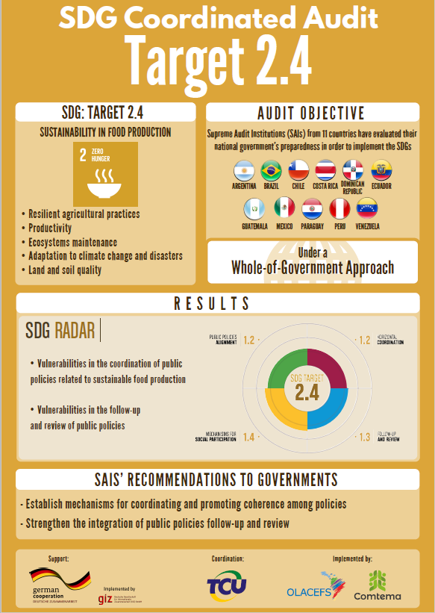

Figure 1 Infographic from a collaborative audit in Latin America. Source: SAI Brazil, Comtema & OLACEFS (2018). http://www.olacefs.com/wp-content/uploads/2018/09/Executive-Summary-Latin-America-SDG-Audit-web.pdf

5. What SAIs communicate and what attracts the public interest
ISSAI 20 on the principles of transparency and accountability notes that SAIs should communicate in a timely way and widely about their activities and audit results. Usually the communication is concentrated on audits, which provides opportunities to increase the visibility of the organisation.

All 42 SAIs that responded to the INTOSAI WGEA survey communicate about their audits to the public in various ways. Only some specific audit reports might not be publicly available due to national laws or regulations concerning the sensitivity of information included in the audit reports.

SAIs main communication efforts deal with the finalised audits. Some SAIs communicate only on published audits, while others publish also information about their audit plans and ongoing audits.

CASE: Foundation reports and reflections reports to communicate about a theme-based work program

The SAI of New Zealand has been operating a theme based work program for several years, by grouping its discretionary work under broad themes such as service delivery, governance and accountability, and investment and asset management. These themes influence all of the SAI’s activities, including financial audits and performance audits. For the first few themes, the SAI produced a short ‘reflections’ report to summarise the work undertaken under the theme and give the SAI’s observations and suggested improvements. The interest in these reflections reports is from a much broader stakeholder base than our traditional reports to Parliament, and confirms the value of short reports in terms of impact. The SAI also uses the reflections reports to engage directly with citizens at formal speaking events, and in other informal settings.

More recently, the SAI has also begun preparing a ‘foundation report’ to introduce a new theme. A foundation report sets out the SAI’s interest in the topic and the proposed work program, to build interest and engagement with the work. The SAI produced foundation reports for its recent themes of water management and procurement. The reflections report can then be a ‘bookend’ for the foundation report prepared at the start of the program, and can set out actual findings against earlier expectations.

The European Court of Auditors has piloted Background Papers on high priority audits. They are based on the preliminary audit work and they aim to provide information, but not audit results, on a policy area where an audit is about to take place. For example, European media has been very interested in air pollution, and the Background Paper on an air quality audit contributed to awareness of this topic even before the Court finalized the audit.

Some SAIs see that publishing the annual audit planning increases their transparency and accountability to Parliament and the public, and their visibility. In addition, SAIs often publish annual reports, which is a way to communicate more generally about the SAI as an organisation including about the impact of the SAIs work.

Examples of high visibility environmental audits
SAIs have no specific methods for communicating about environmental audits. Yet, there are some specific elements that make it relatively easy to communicate about environmental topics. First, environmental issues tend to easily attract public interest. Second, there is often a wealth of good pictures, illustrations, videos and maps available on environmental issues compared to many other audit fields such as fiscal policies. This makes communication efforts easier.

The INTOSAI survey results show that many environmental audit topics attract high visibility. In particular, almost a quarter of the high visibility audits were about nature protection, such as national parks, marine protection, or protection of species. One example is the SAI India’s audit on retaliatory killings of animals (Figure 2).

Figure 2. Pictures about retaliatory killings of animals as presented in the performance audit on Administration of National Parks and Wildlife Sanctuaries in Karnataka (Government of Karnataka Report No. 6 2017). https://cag.gov.in/sites/default/files/audit_report_files/Report_No.6_of_2017_-_Administration_of_National_Parks_and_Wildlife_Sanctuaries_Government_of_Karnataka.pdf

As another example, in a Russian audit on the fishery industry, the facts connected to the sale of 10 rare white whales to China gained the greatest media attention (Figure 3). One explanation for the popularity of this topic is that people care about nature and particularly animals, and audits that deal with them are relatively easy to communicate about.

Figure 3. White whale. Source: Accounts Chamber of the Russian Federation

The second most popular topic was the audit of waste (Figure 4) including municipal waste and specific waste types such as medical and mining waste. Several SAIs also mentioned as high visibility products the audits on forest management (Figure 5) and climate change.

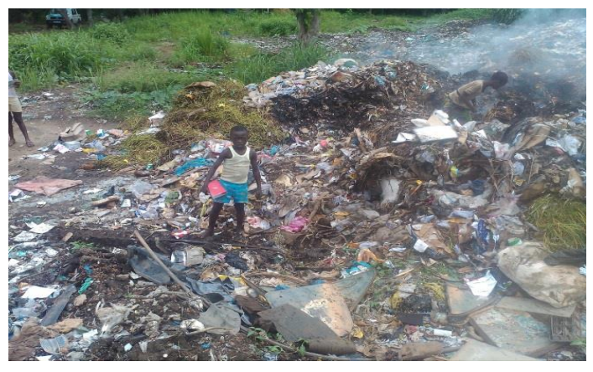
Figure 4. Audit report on solid waste management in Sierra Leone. Source: http://www.auditservice.gov.sl/report/assl-auditor-general-annual-report-2015.pdf

Figure 5. Audit on forest, picture made with a drone. Source: Tjokorda, Senior Auditor Specialist on SDGs, SAI Indonesia.

Some SAIs also analysed the reasons for high visibility of environmental audits. SAI Ecuador noted citizens' concerns, or the engagement with strategic sectors, as key reasons. In the SAI of New Zealand, a report of biosecurity received large media attention, and the Parliament held an urgent debate on the topic. The reason for the public attention was that biosecurity and the protection of New Zealand’s unique environment is very important for the whole country’s identity.

The SAI of Russia remarked that environmental protection and environmental security always obtain the public's attention. SAI of Estonia pointed out that audits of policies involving large sums of money tend to get attention. For instance, an Estonian audit on recycling packaging waste gained publicity even long after it was published, because it calculated how much packaging waste levy might be lost for the state due to insufficient controls over the packaging producers.

A Czech audit on renewable energy gained wide publicity because especially solar energy obtained considerable public funding. Funding also played a role in a Latvian audit on municipal waste management: it received high media attention because the improper calculation of the waste management fee affected many inhabitants.

An audit on climate change in Canada received high visibility because it was able to answer the question "so what" i.e. explaining why the issue is important to the Parliamentarians and Canadians. The collaborative nature of the audit – it involved almost all provinces, territories and the federal government – made it an interesting, true pan-Canadian audit (Figure 6). Moreover, the use of social media by the involved and interested parties, the use of webinar and the involvement of parliamentarians through committee presentations helped to increase public attention.

Figure 6. Greenhouse gas emission sources in each province and territory in Canada. Source: http://www.oag-bvg.gc.ca/internet/English/parl_otp_201803_e_42883.html

In Russia, one of the high visibility audits included prevention of forest fires. Like the climate audit in Canada, it covered all regions in Russia. The Russian SAI also investigated public opinion with the help of an Internet survey, in which respondents from sixty regions took part. This increased the interest in the audit results. Moreover, the audit resonated the acute social importance of the topic.

In Jordan, the audit on management of medical waste in the biggest hospital gained attention because of the seriousness of the subject. In Indonesia, an audit on the contract between the Indonesian government and the private mining company PT Freeport Indonesia was of high public interest because the contract was subject to renegotiation and because a new law was passed to ensure that the natural resources were managed sustainably.

Finally, an Australian audit of the Award of Funding under the 20 Million Trees Programme gained greater visibility due to the Joint Committee of Public Accounts and Audit undertaking a review of the audit.

6. How SAIs communicate
The INTOSAI WGEA publication How to Increase the Quality and Impact of Environmental Audits from 2016 noted that when audit reports are drafted well, their messages are understood. In other words, it is easier to communicate about audit reports that are properly planned and prepared. A clear language, logical structure and speaking titles are important, and therefore it is useful to start to think about communication already in the planning phase, or at the latest, in the report-writing phase.

Many SAIs have a standard procedure for communication. The New Zealand Office of the Auditor General has developed a template communications and impact plan, which is available in Annex II. Figure 7 summarises this plan. The audit team prepares the plan at the start of the process, but it covers the whole life-cycle of an audit as communication is seen as an ongoing process.

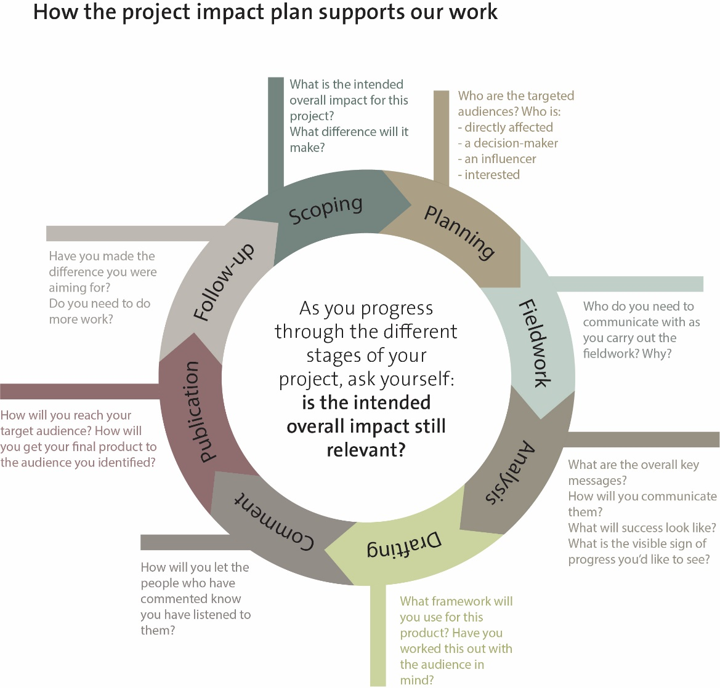

Figure 7. Summary of SAI New Zealand’s project lifecycle impact plan.

In the SAI USA, all audit teams attend an Engagement Review Meeting about 2-3 months prior to publishing their reports. In this meeting, the teams scrutinize draft titles and select projects for podcasts or other multimedia based on congressional and consumer interest.

As another example, Figure 8 presents the general timeline that European Court of Auditors uses when planning the communication before the publication.

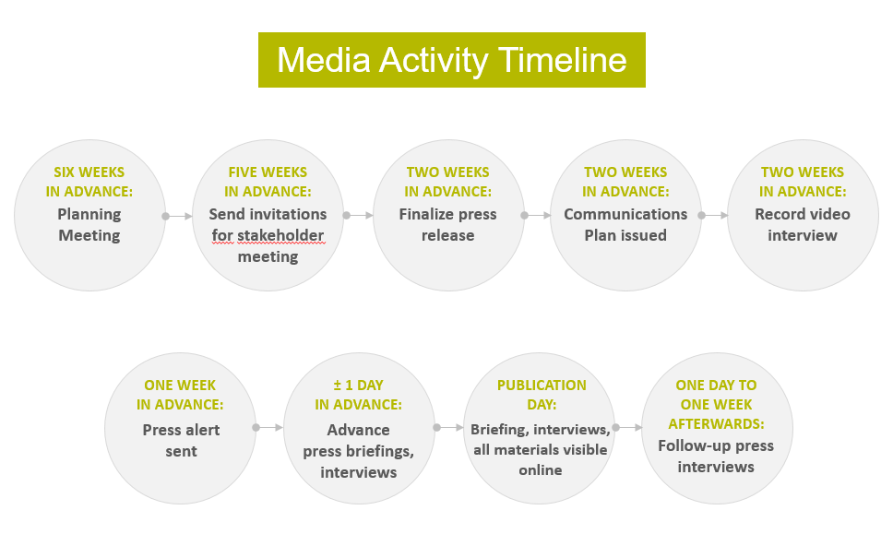

Figure 8. The media activity timeline for planning communication in the European Court of Auditors.

When it comes to choosing the communication channels, SAIs typically publish press releases and upload audit reports to their website and share key points in social media. In some cases, a press release can be replaced with web news if the topic is not seen relevant enough for the press.

Based on the INTOSAI survey, as well as traditional print media, important channels include radio and television, and increasingly social media. Additional tools include e-mail alerts, SAI newsletters, blogs, podcasts, videos, articles in press or scientific publications, as well as presentations in conferences and events.

SAI Canada organizes interviews with journalists, presents audit findings and recommendations to parliamentary committees, promotes work on social media, organizes webinars, and presents audits at various conferences and speaking engagements. Concerning environmental audits, SAI Norway sends press releases to targeted stakeholders among NGOs and academia, and to media that publish articles on environmental issues. This often leads to invitations to present audits to the stakeholders.

SAIs can organise a conference to support the publication of an audit, but also attend conferences organised by other parties. For example, European Court of Auditors (ECA) organised a conference after the publication of the landscape review on EU action on energy and climate, and it served as a tool to reach stakeholders and expert audiences. Moreover, ECA participated in the international climate conference COP23 side-event in Bonn and presented its audits on climate there. Access to various conferences can be relatively easy in the environmental field because it is rich in such events.

As an innovative approach, both SAIs of Afghanistan and Philippines have developed participatory audit mechanisms, which can help to increase the visibility and public interest on environmental audits. The SAI of Philippines has produced videos about its participatory audits involving citizens (Figure 9).

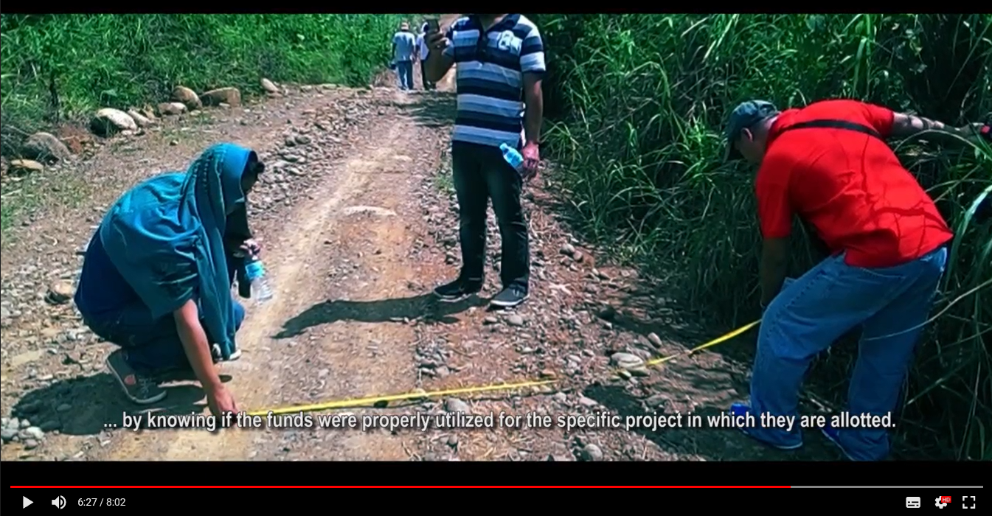

Figure 9. A video produced on a Citizen Participatory Audit in Philippines. CPA Farm to Market Roads with credits.mp4

CASE: Polls tool in the Account Chamber of Russian Federation

Since 2016, the Account Chamber uses a “Polls” tool, which opens an opportunity to keep a dialogue with the community through surveying the population to obtain an independent public opinion on the quality of the audited entities’ public/municipal functions and services rendered to the population.

The Accounts Chamber uses the tool when conducting its control and expert-analytical activities. During its operation, 45 polls were organised. The results were used both in the planning and in direct conduct of the control and expert-analytical activities. The main purposes for the use of the tool were:
  - To define/clarify the subject of the control and auditing, that is, the effect on choosing the areas of activity to be controlled and assessed (obtaining information on the knottiest areas of activity)
  - To identify of the entities to be audited (the array of organizations whose activities to be monitored and assessed)
  - To evaluate and compare the results of the surveys conducted to those of the relevant control and expert-analytical activities
  - To receive public feedback in respect of any changes in the relevant areas of activity and the work of government bodies and organizations, based on the outcomes of the control and expert-analytical activities.
In accordance with the new communication strategy some changes are being introduced in the “Polls” methodology aimed at making the polls more representative and attract more people to take part in them.

The importance of social media
One of the most dramatic changes in communication has been how people access and consume news, reports and other information. For example, SAI USA focuses on keeping its work clear and accessible, and its strategy is to ensure that its reports are available on the platforms that its audiences use and, regardless of platform, that the reports are easy to access, read, and understand.

SAIs use various social media platforms, such as Twitter, Facebook, LinkedIn, YouTube, Flickr and Instagram. Each of these have slightly different profiles. While Facebook is more for everyone, LinkedIn reaches professionals, and Twitter is used by journalists, institutional stakeholders and other interested parties. On top of that, Twitter is a very fast platform.

CASE: SAI USA’s (GAO) response to changing communication needs

Figure 10 provides an analysis of the development of social and digital media in SAI USA. The tools GAO applies have developed in less than ten years from Twitter to Facebook and LinkedIn, with new tools such as Fast Facts pilot and Facebook live events: Cuppa GAO: Coffee with Our Experts. Podcasts are short, 5-6 minute podcasts for certain high-visibility reports or those with a broader or consumer-oriented audience, such as on lead in school drinking water, freshwater supply concerns, genetically engineered crops, and resilience and hurricanes. You can find these in GAO Podcast Gallery: https://www.gao.gov/multimedia/podcast/. Fast Facts is a response to the demands of readers to gain quickly and clearly communicated ‘bottom lines’ of audit reports. Fast facts are 650-character introductions to GAO’s work along with visual elements that are not part of the official audit product.

Figure 10. Social and digital media timeline in GAO, SAI USA.

The Social Media Report 2017 of SAI USA shows that more users come to the GAO’s webpage from social media, than from traditional mass media. While GAO has most followers on Twitter and LinkedIn, Facebook drove most of traffic to GAO.gov website (Figure 11).

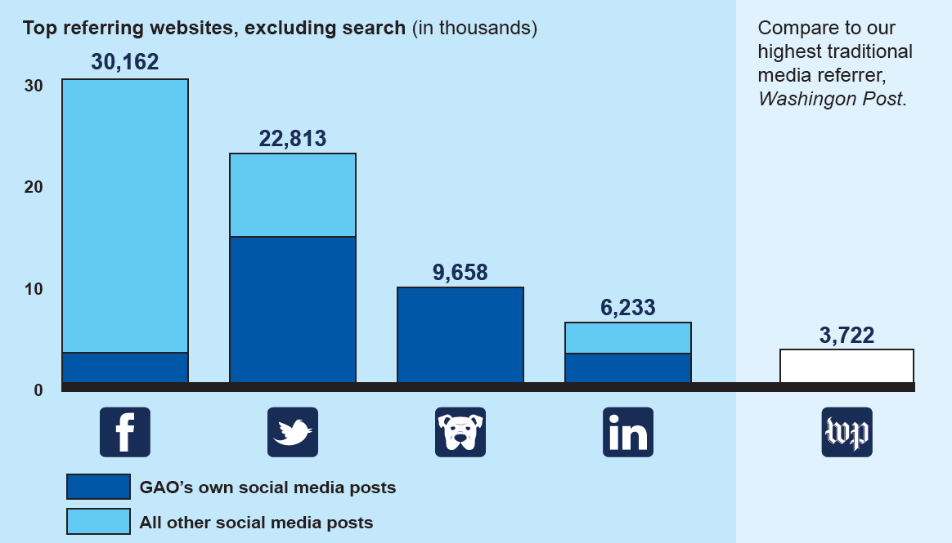

Figure 11.Platforms that drive readers to GAO.gov. GAO 2017 Social Media Report, SAI USA. The third icon refers to GAO’s own WatchBlog.

Social media includes some challenges too. Social media is by definition a media for mutual interaction, often at fast pace. One key question is whether an organisation regards social media as one-way communication, or whether it invites the followers to the dialogue. In this case, SAI should consider how it responds to questions or arguments. This also means that SAI should organise some social media monitoring. Yet another question is whether social media surveillance should be continuous on a 24-hour basis, as the discussions can quickly expand with the risk of messages being “hijacked” and misinterpreted or distorted. Full social media interaction would need internal guidelines and sufficient resources.

Another aspect in the interactive nature of social media is whether organisations engage with discussions that other entities or individuals have initiated. This might mean that a representative of the SAI, e.g. Auditor General or Communications Office shares and reacts to social media feeds that other organisations have made.

Finally, communicating in our digital world sets requirements for the format of information that SAIs share. SAI USA has found that the amount of people accessing their webpage via mobile devices has increased at the expense of desktop computers. In 2017, about 20% of the traffic to GAO.gov was from the mobile devices. Especially PDF files can be clunky on mobile devices, if users must download, zoom and navigate a document meant for printing. Ideally, reports should be published in HTML format, so that they can adapt to whatever device a reader is using.

The power of visuals
Visual communication is getting very important compared to communicating only with text. In the SAI survey, SAI Norway stressed the importance of figures and photos, and SAI Brazil the use of videos and infographics. For example, the OLACEF coordinated audit on biodiversity in Latin America illustrated the implementation and management of protected areas in Latin America with an index and visualised it in maps (Figure 12).

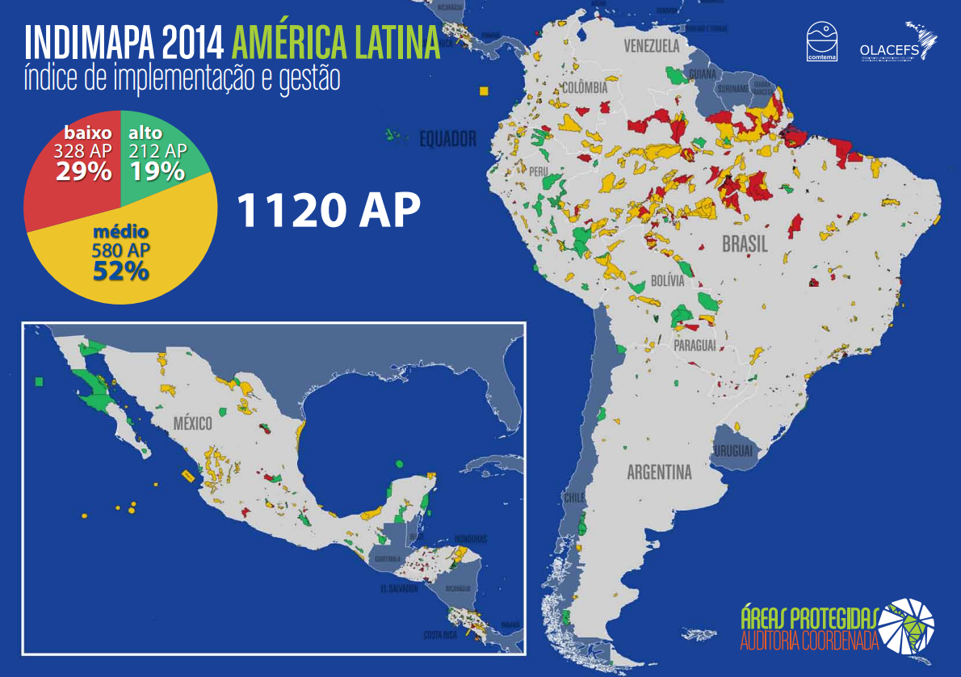

Figure 12. Protected areas in Latin America. Baixo = low, médio = medium, alto = high. Source: http://www.olacefs.com/wp-content/uploads/2015/10/Sumario-Executivo-Auditoria-nas-Areas-Protegidas-da-America-Latina-web.pdf

An example of a longer infographic explaining the problem with lead in school drinking water produced by SAI USA is available at https://www.gao.gov/multimedia/GAO-17-424/infographic/summary.

Some SAIs have started to hire special professionals to help with infographics (Figure 13).
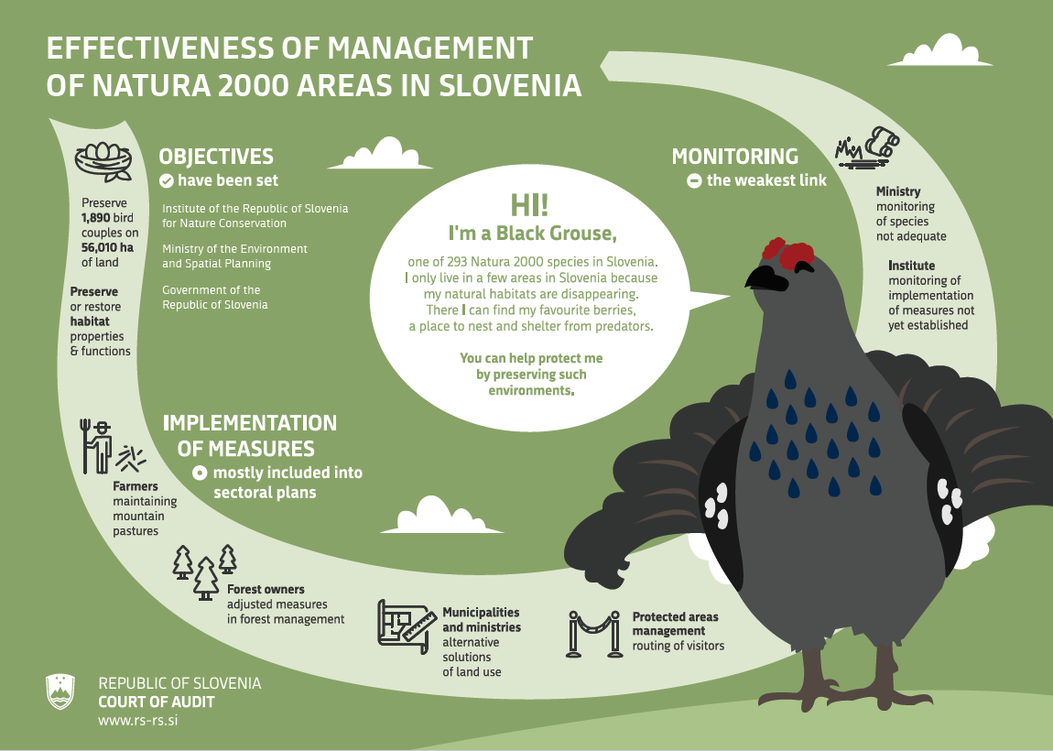

Figure 13. An infographic made in Slovenian audit office. http://www.rs-rs.si/en/audits-auditing/audit-archive/audit/managing-natura-2000-areas-in-slovenia-2355-1/

Pictures can be useful especially in explaining abstract concepts (Figure 14):

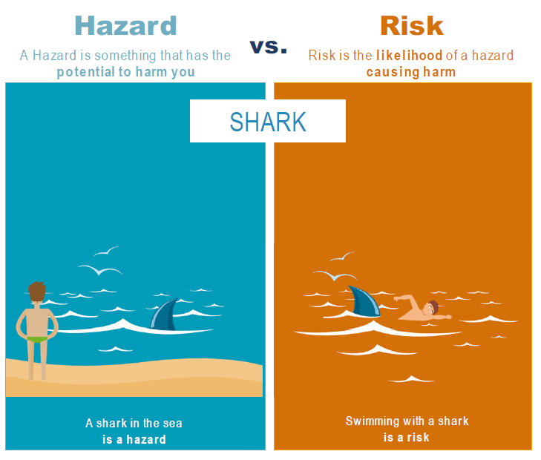

Figure 14. The difference between hazard and a risk. Source: EFSA, quoted in ECA Special Report 02/2019 on Food Safety.

Besides infographics, videos can be very efficient tools to communicate audit results. In the case of the cooperate audit on Lake Chad, a video was a captivating way to describe the problems, the audit work and recommendations (Figure 15).

Figure 15. Video on the cooperative audit on Lake Chad. https://www.youtube.com/watch?v=S24jFG2LlwM

SAI USA has found that the first 10 seconds of videos are critical since that is how long the average viewer watches the content. Since many people watch videos without sound, text or key points should be integrated with the video.

Some examples of SAI videos are SAI USA’s video on lead in the school drinking water:
https://www.gao.gov/multimedia/video#video_id=687732
and European Court of Auditor’s video on Landscape review on EU action in energy and climate:
https://www.youtube.com/watch?v=LjA2M7iaRVw

CASE: SDGs and the successful use of iconography
United Nations adopted in 2015 the Agenda 2030 and 17 Sustainable Development Goals (SDGs). The UN has summarized the SDGs to logos, as it presents SDGs in 17 colourful icons (Figure 16). The icons summarize each goal in simple graphic picture, which encapsulates the core message of the goal without the words. The successful use of these logos is definitely one of the strengths of the SDGs. The icons are easily recognizable, and they make it easy to communicate about the SDGs in various contexts.
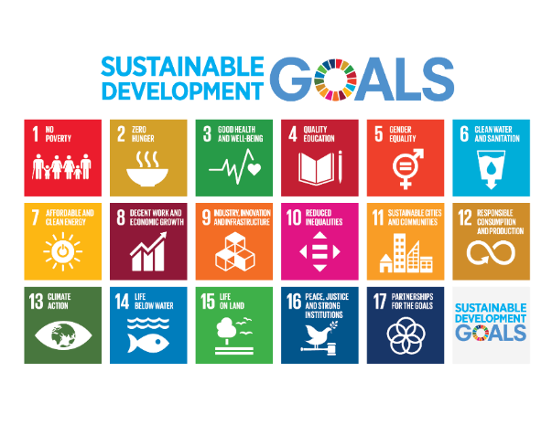
Figure 16. Sustainable development goals. Source: United Nations 2015.

Increasing visibility with the right timing
Sometimes the timing for publishing an audit might be unfortunate, if some other important news gets all the media attention. For instance in Estonia, an audit on recycling packaging waste was published on the same day there was a huge snowstorm, which got all the media attention. The audit, however, gained visibility in the longer run and was a good example that not only the first-day publicity is important.

One option is to plan other activities after the press release, such as additional feeds or articles in social media or traditional press.

CASE: SAI USA’s tools to attract media attention after the publication data

SAI USA has found its blog a useful tool to control the timing of posts, and feature work that may not have received as much attention when first issued. Blog posts allow to set the agenda and discuss audit work at times when most relevant. For example, SAI USA blogged on the 10th anniversary of Hurricane Katrina, providing information on the storm and links to related audits., SAI USA also blogged at the start of the summer travel season and provided links to audits about the national parks, which are travel destinations for many vacationing Americans. In addition, SAI USA has a GAO Plugged In for staff to suggest tweets to post to the twitter feed. Those tweets help tie previous audit work to current events and thus give an opportunity to connect to the real world. For instance, SAI USA tweeted when news broke that a particular bee was listed as endangered, when there was a swine flu outbreak, and around coverage of antibiotic resistance in farm animals.

7. Measuring the visibility of audits
In order to evaluate the success of an organisation’s communication efforts, SAIs can analyse how well they were able to get their message to the audience, and what was the impact of communication efforts. Moreover, it is possible to evaluate in detail some communication activities, such as publications, press events, or conferences. EU Commission’s Toolkit for the evaluation of the communication activities, includes detailed instructions for evaluating the following tools:

Qualitative research tools | Tools for online media | Surveys | Other tools | Analysis and comparison | Media analysis | Advertising measurement | Tools for cost analysis
Case studies | Social media monitoring | Paper/Print surveys | Content mapping | Benchmarking (strict) | Quantitative media analysis | Advertising recall | Return of investment
Focus groups for stakeholders | Web analytics | On-line surveys | Customer journey mapping | Extended benchmarking | Qualitative media analysis | Frequency | Cost benefit analysis
Focus groups for experts | Website usability audit | Face to face surveys | Mystery shopping | Analysis of secondary data |  | Reach & coverage | Cost effectiveness analysis
Focus groups direct target audiences | Web-visibility mapping | Telephone surveys | Organisational review | Analysis of quantitative data |  | Opportunity to see/hear | Cost efficiency analysis
Electronic focus groups |  | Pre-post survey design | Technical audit | Analysis of qualitative data |  | Ratings (gross)
Participatory observation |  | Tracking studies | Data mining | Expert panels |  | Cost per thousand
Stakeholder interviews |  |  |  | SWOT analysis |  | Share of voice
Diaries |  |  |  | Multi-criteria analysis

Over half of the SAIs who replied to our survey measured the visibility of their audits. However, none of the SAIs had any specific methods regarding environmental audits.

SAIs measure visibility usually by calculating the coverage of audits in media, ranging from press to the social media, and observing the traffic on SAI and other webpages. For instance, SAI Canada collects statistics relating to the internet, social media, calls, emails, and media coverage. One tool that several SAIs use is Google Analytics, which can measure the number of online views, time that users spend on the page, shares, and other key information.

Some SAIs have outsourced the media monitoring to contractors who do the external media analysis. In this field, new methods are developing fast with data mining techniques. For example, the European Court of Auditors gets graphs, heat maps and analysis from an external provider (Figure 17 and 18). Additional tools are sentiment scores, which measure responses to SAIs work, but the Court has found some challenges with interpreting them: a negative media statement does not necessarily mean a negative statement about the ECA, but reflects the fact that ECA has concluded something critical in its audit.

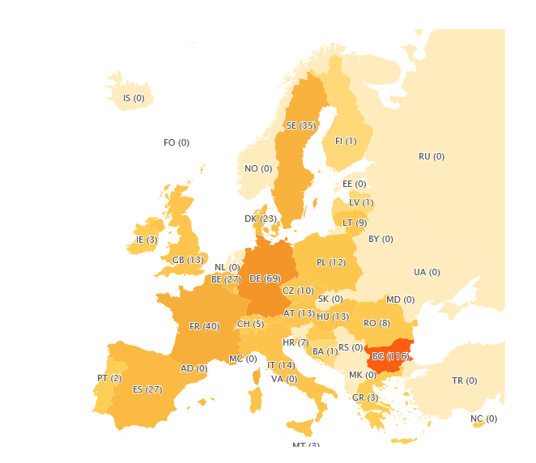

Figure 17. A heat map concerning the publicity of the ECA’s audit report on air pollution. Source: Meltwater Sweden.

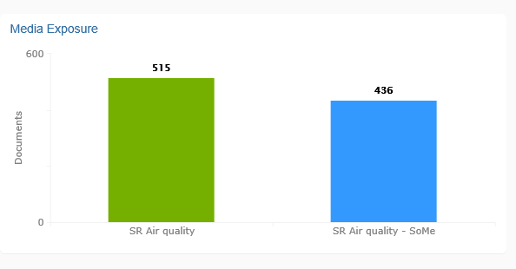

Figure 18. Number of online articles (green) and social media feeds (blue) on the ECA’s audit report on air pollution. Source: Meltwater Sweden.

In addition to the media attention, some SAIs measure the visibility that the audits gain in Parliaments. The Australian National Audit Office collects information about the number of appearances and submissions to Parliamentary Committees, and surveys Committee members on whether they were satisfied that the Audit Office improved public sector performance and supported accountability and transparency. SAI Indonesia conducts a survey to measure the satisfaction level of The Semester’s Audit Results Summary from the parliament. Finally, SAI Bulgaria made a broader sociological survey to investigate the awareness of citizens and audited organizations, and their trust in the National Audit Office.

A more challenging task is to measure the impact of communication. This might require surveying the target audiences on whether they have understood the message in the way the SAI intended.

POSSIBILE INDICATORS TO MEASURE THE VISIBILITY
Quantitative | Number of communications (press releases, tweets etc.) distributed
 | Analysis of the traffic in the SAI webpage
 | Number of followers on social media
 | Audiences reached, based on the number of communications shared in social media
Qualitative | Stakeholder satisfaction surveys
 | Stakeholder surveys to test for the awareness of audit reports
 | Study for target audiences who correctly comprehend the message
Indicators concerning the communications offices | Communication costs
 | Share of professional communication staff

8. Conclusions: Trends in how SAIs communicate
This publication studied how Supreme Audit Institutions communicate about their audits in the context of environmental auditing. A precondition for communication is that SAIs can publish their audits. Unfortunately, there are still many SAIs, especially in developing countries, that face problems with their right to report.

The project found that SAIs do not have any specific methods to communicate about environmental audits, but they are easy topics to communicate. People connect to environmental issues and care about nature, and there is usually plenty of good visual material available on environmental topics.

SAIs organise communication in different ways. In the age of social media, it is hard to restrict the communication solely to the communications professionals or top management, as all employees communicate in various platforms. This means that SAIs could develop their social media strategy and train their staff about preferred behaviour. A trend is that SAIs increasingly see all of their staff as a resource when it comes to communicating about audits.

Visual journalism is currently a very strong trend. Especially in digital media pictures, interactive infographics and videos are very effective ways to distribute the message. It might be useful for SAIs to engage professionals to help to visualise the data and audit findings. The project found that a good practice is to produce various products to support communication in different platforms. Besides traditional audit publications, SAIs can make shorter summaries and infographics for social media purposes. There is a general trend towards making the audit reports shorter, plainer, and user friendly.

Nevertheless, SAIs should pay attention to quality control for all of their publications and products. The audit reports are subject to rigorous quality assurance procedure. When SAIs make shorter summaries and infographics about these audits, these other communication methods should also comply with the quality standards. Therefore, it is important that communication professionals and visualizers work together with the auditors so that the SAI’s main messages will not get distorted.

The biggest recent change in communication has been the increasing importance of social media. There are some specific elements that organisations should consider, such as whether SAIs see it as a one-way communication channel, or an interactive platform. SAIs should also think who can post to the social media on behalf of SAI, and how it monitors the social media fora. On the other hand, they should understand that social media is by definition a dynamic and unpredictable environment which they cannot fully control. All communication entails a risk where media seeks a sensational angle, and social media can strengthen this tendency.

Recommendations: It is useful to have a communication strategy and plan communication on audits early
In the era of fast spreading communication, anti-environmental arguments and “fake news”, SAIs have an important role in providing fact-based information. In order to avoid the misuse of information, SAIs should plan the communication carefully. This project concludes that SAIs should have a communication strategy. It can identify the main lines of action for external communication, such as who are SAI’s audiences, what SAIs wish to communicate with them, and which channels and tools SAI uses in order to reach them.

Moreover, such communication is always an opportunity to share information about SAIs ongoing process, and not only as a one-time activity on a specific audit report, or an activity taking place only in the final phase of an audit. Instead, SAIs could start to plan the communication in the beginning of the audit process.

Good audits are more likely to get media attention, but the media attention cannot be the foremost goal of the audit. Audits can be very valuable even with limited attention. A well-prepared media strategy and proper communication planning makes it easier to communicate abstract and difficult topics to the parliament and public. A strategic approach to communication helps SAIs to spread their message, and fulfil their role in holding their governments accountable.

Annex I Questions in the INTOSAI WGEA survey
1: Does your SAI have a communication/media/PR strategy which has been helpful in increasing the visibility of environmental audits?

2. Are there any examples where the visibility of an environmental audit was particularly high? Please explain the reasons for this. Please provide also the audit title and link to the audit if available, as well as a contact person who could tell more about the case.

3. Does your SAI measure the visibility and public interest that audits receive? In case yes, please explain how. Do you have any special methods to measure the visibility of environmental audits?

Annex II OAG New Zealand’s communication plan
Project lifecycle impact plan for [working title of project]
Project owner: [name]

If you need help filling out this form, please see someone in Reports and Comms.
Impact = change in what people know, think/feel, do

What is the intended overall impact for this project? | Think of this as your mission statement – what are you hoping to achieve as an end result? What overall change(s) do you want to see?

As you progress through the different stages of your project, ask yourself: is the intended overall impact still relevant?

- Who are the target audiences?

Directly affected
Decision-makers
Influencers
Interested

- What impact do we aim to achieve throughout the lifecycle of the project?

Stage | Desired impact | Why? (The “so what”) | Did we succeed? (Y/N) | Evidence
Considering (listening, consulting, scoping, planning) | What sort of change(s) do you hope to see at each stage of your project? Be specific!  E.g. Acceptance and co-operation from the entity/OAG Leadership Team understand evolving scope of the audit/Interested parties have expectations in line with the work we’ll do | What difference will success make?  E.g. Faster and easier to get evidence/Confidence that the audit topic is worthwhile to senior management/More focused consideration by OAG Leadership Team of revised scope
Before starting work | E.g Target audiences are interested in our audit work | E.g. We gain advocates for the work we’re about to do
During | What is the visible sign of progress or change you’d like to see? | What difference does it make that this progress or change takes place?
Reporting | What would success look like?  E.g. Select committee asks the right sorts of questions and focuses on the entity’s need to improve/Entity comments publicly on plan to address our recommendations | E.g. entity will be held to account for improving xxxx and yyyy /Puts a commitment out in public that entity will be expected to meet
After ‘product’ release | E.g. Report/blog/article is widely discussed/Report/blog/article is discussed by the influencers we had identified/Authors are invited to address xxxx group of influencers/Entity releases detailed action plan to address our recommendations | E.g. Goal was to raise awareness and stimulate public debate/Goal was for key influencers to engage with this topic/ Speaking engagement is a more cost-effective way to reach target audience/ Select committee has tangible plan with which to hold entity to account
Following-up/monitoring | E.g. Conversations continue about our work /Entity updates the action plan with progress reports | E.g. Need public opinion and pressure to secure the change we want to see/ Greater confidence that change is occurring

- What and how will we communicate? (by target audience as required)

What are the overall key messages? | 1. | 2. | 3.

Stage | Key messages | Product/channel | Audience(s) | Timing
Considering (listening, consulting, scoping, planning) | [What are you communicating at this point, and what could they usefully know to help you achieve what you’re hoping to do? Are you only talking internally, or could you usefully be more public?]  1. E.g. This topic looks like a useful one for the Office to look into.  2. Matters xxx and yyyy are already being looked at by the zzzzz.  3. If we do it, we need to be done by the month of xxxx. | [How you’ll reach them, and what you need to do this.]  E.g. Papers to OAG Leadership Team, letters to entity, blog posts, questions posed on LinkedIn pages or other social media, articles in industry journals or magazines, talks at conferences… | [Who – specifically, those identified in Table 1.]  E.g. Select Committee, Media, Consulted parties
Before starting work
During
Reporting
After ‘product’ release
Following-up/monitoring

Risks and issues

Risk/Issue | Internal contact person(s) | Parties involved | Notes | Actions and mitigations | Last update

ISSAI 12: The Value and Benefits of Supreme Audit Institutions – making a difference to the lives of citizens.
ISSAI 20: Principles of transparency and accountability.
IDI (2017). Global SAI Stocktaking Report 2017.
Jurin, Richard R., Donny Roush & Jeff Danter (2010). Environmental Communication. Second Edition, Springer.
Pezzullo, Phaedra C. & Robert Cox (2018). Environmental Communication and the Public Sphere. Fifth Edition, Springer, page 13.
Ibid, pp 13-14.
Insert a link later.
Belén González-Díaz (2008). Supreme Audit Institutions and their communication strategies. International Review of Administrative Sciences. Vol 74(3):435–461.
Belén González-Díaz, Roberto García-Fernández and Antonio López-Díaz (2013). Communication as a Transparency and Accountability Strategy in Supreme Audit Institutions. Administration & Society 45(5):583-609.
ECA Strategy 2018-2020: https://www.eca.europa.eu/en/Pages/Strategy.aspx
Belén González-Díaz, Roberto García-Fernández and Antonio López-Díaz (2013). Communication as a Transparency and Accountability Strategy in Supreme Audit Institutions. Administration & Society 45(5):583-609.
EUROSAI (2017). A roadmap for reaching Supreme Audit Institution communications goals.
The ECA Special Report on Air Pollution http://publications.europa.eu/webpub/eca/special-reports/air-quality-23-2018/en/
The Joint Committee of Public Accounts and Audit is required to review all reports that the Auditor-General tables in the Parliament and to report the results of its deliberations to both houses of Parliament. The Joint Committee reviews all audit reports but only about a quarter of those are subject to a Committee inquiry. In 2017–18 the ANAO completed 47 performance audits and the Committee conducted 11 inquiries.
EU Commission’s Toolkit for the Evaluation of Communication activities: https://ec.europa.eu/info/sites/info/files/communication-evaluation-toolkit_en.pdf. See also Audit Scotland’s communication indicators for public sector: http://audit-scotland.gov.uk/performance/docs/2011/CPI_1011_communications.pdf

