GREENING CITIES - SUSTAINABLE URBAN DEVELOPMENT

Acknowledgements
We would like to express our sincere thanks to our colleagues from all the Supreme Audit Institutions that participated in writing this document.
Writing this report was a collaborative effort of the project team members from the Supreme Audit Office of the Czech Republic led by Mr Petr Neuvirt. We would like to express our thanks to President of Supreme Audit Office of the Czech Republic Mr Miloslav Kala for his long-term support of the activities of the SAO within the INTOSAI WGEA. We would also like to thank our colleagues from the International Relations Department and colleagues from the Communication Department of the SAO for their cooperation on this project.
Together with the Supreme Audit Office of the Czech Republic, the Supreme Audit Institutions of China, Indonesia, Morocco, Philippines, Slovakia, and the United States contributed actively to this project.
We would also like to thank all the Supreme Audit Institutions that sent us information about audits carried out in the field of sustainable urban development and responded to our questionnaire survey as well.
The secretariat of the INTOSAI Working Group on Environmental Auditing and the Steering Committee members provided valuable help at various stages of the project.
We wish our readers much success in applying this study to their audits.

Mr. Miloslav Kala
President of the Supreme Audit Office
of the Czech Republic
Prof. Dr. Moermahadi Soerja Djanegara, CA., CPA.
Chairman of the Board of
Badan Pemeriksa Keuangan

Table of contents

Acknowledgements 2
Table of contents 3
Abbreviations and acronyms 4
Foreword 5
Executive summary 6
Introduction 8
Chapter 1 – Basic information on “Greening Cities – Sustainable Urban Development“ 10
1.1 THE IMPORTANCE OF CITIES AND URBAN AGGLOMERATIONS 10
1.1.1 Definitions of “a city“ and “agglomerations“ 13
1.1.2 Importance of sustainability in the cities and urban agglomerations 15
1.2 CITIES FROM THE VIEWPOINT OF SELECTED ENVIRONMENTAL COMPONENTS 16
1.2.1 Waste management system 16
1.2.2 Air pollution 17
1.2.3 Quality and system of drinking water supplies 19
1.3 EXAMPLES OF OTHER SIGNIFICANT CHALLENGES THAT INFLUENCE ENVIRONMENT IN THE CITIES ...............................................................................................................................................20
1.4 INITIATIVES AND TRENDS AFFECTING CITIES 27
Chapter 2 – Legal framework of the “Green Cities – Sustainable Urban Development“ 29
2.1 THE IMPORTANCE OF INTERNATIONAL AGREEMENTS AND STRATEGIES 29
2.2 SUSTAINABLE DEVELOPMENT GOALS 33
2.3 THE IMPORTANCE AND INFLUENCE OF TOOLS DESIGNED FOR SEVERAL AREAS OF THE ENVIRONMENT IN THE CITIES 36
2.3.1 Governmental/national level 36
2.3.2 Local/self-governmental level 36
2.4 INDICATORS FOR MEASURING THE SUSTAINABILITY OF CITIES 38
Chapter 3 – Examples of good audit practice 42
3.1 RESULTS OF THE SURVEY 42
3.2 CASE STUDIES 45
APPENDIX 1 – CASE STUDIES 49
APPENDIX 2 - SUMMARY OF MAIN CHALLENGES FROM THE SAIs´ POINT OF VIEW AS REGARDS THE GREENING CITIES ISSUE 76
Glossary 79
Bibliography 80
Other Internet Sources 80

Abbreviations and acronyms

ANAO Australian National Audit Office
CBD Convention on Biological Diversity
CITES Convention on International Trade in Endangered Species of Wild Fauna and Flora
COP-9 Conference of the Parties (Bonn, Germany, from 19 to 30 May 2008)
EEA European Environmental Agency
EIA Environmental Impact Assessment
EU European Union
FG-SSC Focus Group – Smart Sustainable Cities
GDP Gross Domestic Product
GI Greening Infrastructure
ICLEI International Council for Local Environmental Initiatives
ICT Information and Communication Technologies
IEA International Energy Agency
INTOSAI International Organization of Supreme Audit Institutions
IT Information Technology
ITF International Transport Forum
ITU International Telecommunication Union
JMP Joint Monitoring Programme
MDGs Millennium Development Goals
MEAs Multilateral Environmental Agreements
NAO National Audit Office
NP National Parks
OECD Organization for Economic Co-operation and Development
RFSC Reference Framework for Sustainable Cities
SAIs Supreme Audit Institutions
SDGs Sustainable Development Goals
SEA Strategic Environmental Assessment
SI Singapore Index
STAR Sustainability Tools for Assessing and Rating Communities
UN United Nations
UN DESA United Nations Department of Economic and Social Affairs
UNEP United Nations Environment Programme
UN HABITAT United Nations Human Settlements Programme
UNICEF United Nations International Children’s Emergency Fund
UNWTO United Nations World Tourism Organization
US GAO U.S. Government Accountability Office
WGEA Working Group on Environmental Auditing
WHO World Health Organization

Foreword
This research project summarizes important information and experience of the development of urban agglomerations (urban areas) from the point of view of the supreme audit institutions. Why should we – the independent state auditors - pay attention to the sustainable cities issue?
One of the most significant challenges that the policymakers and citizens of individual countries will have to deal with in the ever-changing world is the growth of urban agglomerations, no matter what they look like in the given part of the world. This is a complex task for which there is no simple solution and which, moreover, includes a wide range of areas.
The increase in population has its reasons and is, to some extent, also expected. Declining employment opportunities outside cities along with environmental changes and the impact of global economic trends motivate increasing numbers of people to change location for the opportunities that an urban environment can offer them. Thus, it is not surprising that the share of the population in cities is projected to rise from the current 50% to 70% already in 2050.
The question is whether the cities are able to meet the needs and expectations of the people who are moving in. And what kind of impact will such a thickening of the urban population have? It is a specific environment in which social issues intertwine with environmental issues. One is influenced by the other and the solution requires close cooperation between the central government and local governments, as well as with municipalities - whether the focus is on air quality issues, waste management, housing policy, transport, or many other areas. In addition, these questions do not only concern the cities themselves. The expansion of cities and the relocation of the population raise a number of questions and challenges concerning their surroundings, as well as the demographic and economic development of the countries themselves.
If we assume that there will be up to two-thirds of the world's population living in cities in the future, we also have to take into account that individual countries have to respond to it in their policies. We can already observe the shift to the cities today. If policymakers want to succeed in this great challenge and also ensure sustainable urban development in the future, then they will need to channel resources towards solving all issues that are related to the city. And here, the right time for audit institutions comes. They can, with their findings and recommendations, show soon enough whether the direction the countries are taking is right. They can, for example, reveal which areas are neglected or, on the contrary, highly preferred in state policies. They become co-initiators of the future of urban agglomerations.
An essential role for the work of the audit institutions is therefore the possibility of sharing experience and important information with colleagues abroad, and being inspired by examples of good practice. Only in this way will audit institutions be able to offer feedback to the state, and the answer the question of whether public money can help improve the conditions for citizens’ lives in the ever-changing and growing organism of the city. We believe that our study will also be beneficial for the work of audit institutions in this area.

Executive summary
The report seeks to map and describe the most serious environmental problems of urban agglomerations and to describe the experience of audit institutions in this area, while emphasizing the importance of the INTOSAI WGEA in the next years. This study also provides basic information for the analytical and audit activities of the supreme audit institutions. The theme of "Greening Cities - Sustainable Urban Development" could become an important part of the audit activity.
The growth of population on Earth is one of the global challenges of mankind. In some parts of the world, the population is growing at enormous speed, which brings other problems such as increasing demands on food, water, raw materials, etc. Today, 54% of the world's population lives in urban areas; by 2050, it will be two-thirds of all the planet's inhabitants. Nevertheless, there are also benefits to urbanization – e.g., services such as water supply and wastewater treatment are much more efficiently provided to centralized populations; also, urbanization allows land outside cities to remain open for different purposes—agriculture, recreation, forestry, or other natural resource extraction. In recent years, the fastest growing cities have been in Asia and Africa, while urbanization in Europe has been very slow. According to publicly available data, about 70% of the population already lives in European cities. Most people will move to cities in India, China, and Nigeria in the next decades. According to some forecasts and sources, it can be expected that up to 80% of the population will live in cities in 2050.
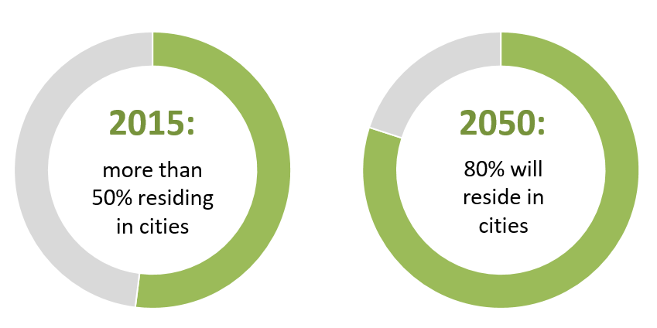
Source: http://reports.thomsonreuters.com/9billionbowls/
We understand the term "Greening City", as a city that is capable of providing basic sustainability requirements for present and future generations, especially requirements concerning the environment such as water quality, air quality, and waste management. The "Greening Cities" concept can also be classified as a long-term global and regional process to contribute to the development of cities and urban agglomerations in the coming decades with respect to the different components of the environment. The report also contains other topics related closely to ecological challenges in the cities: infrastructure for sewer systems and drinking water, noise and light pollution, green infrastructure, sustainable urban energy, urban mobility and tourism.

Instruments that influence urban development and sustainability start at an international level and continue through governments/national levels to the level of self-governments. At each of these levels of governance, everyone should implement strategies that would lead to their interconnection in order to achieve the goals of sustainable urban development.
The most important international agreement that directly address the issue of Greening Cities – Sustainable Urban Development is the document "Transforming our world: the 2030 Agenda for Sustainable Development”. The topic of Greening Cities is related to some of the SDGs that have been defined and approved by the UN summit in September 2015 in the document "Transforming our world: the 2030 Agenda for Sustainable Development”, e.g., Goal 3 “Ensure healthy lives and promote well-being for all at all ages “, Goal 6 “Ensure availability and sustainable management of water and sanitation for all”, Goal 7 “Ensure access to affordable, reliable, sustainable and modern energy for all” or Goal 11 “Make cities and human settlements inclusive, safe, resilient and sustainable”.
In order to meet the vision of sustainable cities, the cooperation between institutions at the international, national, and local level is crucial. Also, the involvement of cities´ inhabitants and the cooperation of individual cities in creating conditions for sustainability are equally important for urban sustainability.
The paper shows the importance of local governments as a prime actor in defining local environmental and development policies. There is also the ICLEI network, which associates towns, cities and regions to support green economy and smart infrastructure. To measure the sustainability of cities, many types of indicators were established, the essentials are described below.
In cooperation with the INTOSAI WGEA secretariat, a survey on Greening Cities had been sent to all members of the INTOSAI WGEA (78 members). We received 43 completed surveys, which represented 55% of all respondents.
The questionnaire survey shows that environmental issues related to cities are significant for most SAIs. The most important environmental issues related to urban sustainability are waste management and air quality. Significance is also attributed to the infrastructure of sewage systems, drinking water supplies, and transportation. According to 20 SAIs (i.e., 59% of the 34 relevant questionnaires), national legislation has the most significant influence on the Greening Cities topic in the countries concerned. Key national policies, programmes and other national instruments together with programmes and instruments of local governments also have a significant impact.
Overall, 25 SAIs are experienced in auditing of this topic. They have defined the challenges related to audits of sustainability of cities, and at the same time, 16 countries have defined obstacles which, according to their audit experience, may occur. A complete list of the challenges and obstacles is provided in the appendix of the evaluation.
The survey results show that approximately one quarter of respondents (10 of 43) does not have competences (mandate) to audit local authorities, regional governments, districts, provinces, etc. All of the SAIs are looking for appropriate ways for audit in this field as they consider carrying out environmental audits on urban sustainability as important.
Based on the questionnaire survey and on the basis of the overall assessment of the “Greening Cities” concept considered, SAIs are concerned with environmental audits. Among other things, due to the implementation of SDGs' national targets, the next challenge will be to evaluate and perform audits of selected environmental components in cities and urban agglomerations. The basic role of SAI's activity remains at the national system level, because governments set rules through legislation, strategies, programs, and through specific tools and measures.

Introduction
The project “Greening Cities – Sustainable Urban Development” follows up the UN Sustainable Development Goals that were defined and adopted in the document “Transforming our world: the 2030 Agenda for Sustainable Development” at the UN summit in September 2015. The supreme audit institutions are expected to focus their audit activities on evaluation of fulfilling the 2030 Agenda in the coming years. Aspects related to the cities and urban agglomerations intertwine with several goals of this Agenda. Together with the fact that the importance of cities and urban agglomerations will become highly relevant in the coming decades, the aim of this study is to contribute to ensuring that the audit activities of the supreme audit institutions are focused on evaluating the policies that should be implemented in the 2030 Agenda for cities and urban agglomerations.
Therefore, the study seeks to map and describe the most serious problems of urban agglomerations, such as waste management, air quality, quality and the supply system of the drinking water, and to describe the experience of foreign audit institutions in this area, while emphasizing the importance of the INTOSAI WGEA the following period.
This study provides basic information for the analytical and audit activities of the supreme audit institutions so that the audit institutions can help with sustainable development of cities through their work. The theme of "Greening Cities - Sustainable Urban Development" could become an important part of the audit activity.
For the purpose of this study, we understand the term "Green City" as a city that is capable of providing basic requirements of sustainability for present and future generations, especially as regards the environmental quality requirements such as water quality, healthy air, or the waste management requirements. "Greening Cities" can be also classified as a long-term global and regional process that shall contribute to the development of cities and urban agglomerations in the coming decades with respect to the different components of the environment. At the same time, this process should be linked to the Sustainable Development Goals (SDG) so that sustainable urbanization and the development of human settlements help to improve the environment of cities and urban agglomerations.
According to UN, sustainable development is defined as “development that meets the needs of the present without compromising the ability of future generations to meet their own needs” (World Commission on Environment and Development, 1987). Consisting of three pillars, sustainable development seeks to achieve, in a balanced manner, economic development, social development, and environmental protection.
In 1992, the international community gathered in Rio de Janeiro, Brazil, to discuss means to operationalize sustainable development. During this so-called Rio Earth Summit, world leaders adopted Agenda 21, with specific action plans to realize sustainable development at national, regional, and international levels. In 2002, this was followed by the World Summit on Sustainable Development, which adopted the Johannesburg Plan of Implementation. The Plan of Implementation built upon the progress made and lessons learned since the Earth Summit, and provided for a more focused approach, with concrete steps and quantifiable and time-bound targets and goals. In 2012, twenty years after the landmark Earth Summit, world leaders gathered once again in Rio de Janeiro to: 1) secure renewed political commitment to sustainable development; 2) assess the progress the implementation gaps in meeting already agreed commitments; and 3) address new and emerging challenges. The UN Conference on Sustainable Development, or Rio+20 Earth Summit, focused on two themes: 1) green economy in the context of sustainable development and poverty eradication and 2) institutional framework for sustainable development.

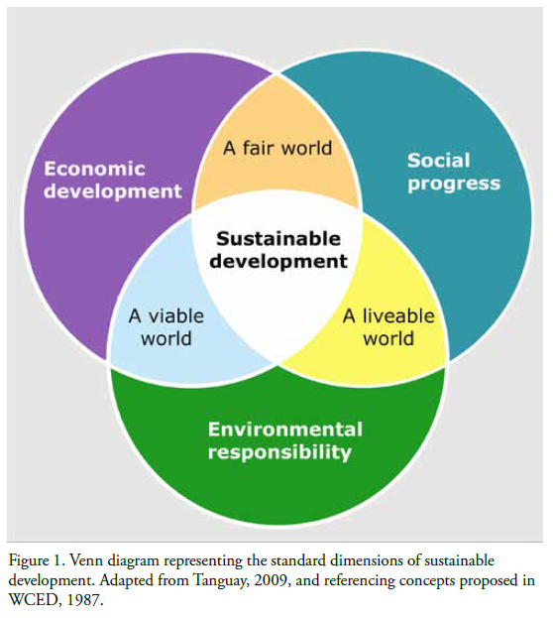

Chapter 1 – Basic information on “Greening Cities – Sustainable Urban Development“
This part addresses the importance of cities and urban areas in relation to the growth of the world's population. It defines terms such as cities and agglomerations and emphasizes the importance of sustainability. Moreover, it identifies selected environmental components, which are the most important issues in cities and urban areas, such as waste management system, air pollution, drinking water supplies, etc. It also presents examples of other significant challenges that influence environment in the cities. In addition, the chapter deals with initiatives and trends affecting cities.

THE IMPORTANCE OF CITIES AND URBAN AGGLOMERATIONS
The growth of population on Earth is one of the global problems of mankind. In some parts of the world, the population is growing at enormous speed, which brings other problems such as increasing demands on food, water, raw materials, etc.
Source: https://ourworldindata.org/urbanization
https://esa.un.org/unpd/wup/publications/files/wup2014-highlights.pdf

Today, 54% of the world's population lives in urban areas; by 2050, it will be two-thirds of all the planet's inhabitants. In recent years, the fastest growing cities have been in Asia and Africa, while urbanization in Europe has been very slow. According to publicly available data, about 70% of the population already lives in European cities. Most people will move to cities in India, China, and Nigeria in the next decades.
According to available data, there were only 746 million people living in the cities in 1950, while today, there are almost four billion. The continuing urbanization and overall growth of the world’s population is projected to add 2.5 billion people to the urban population by 2050.
Source: https://population.un.org/wup/Publications/Files/WUP2018-KeyFacts.pdf

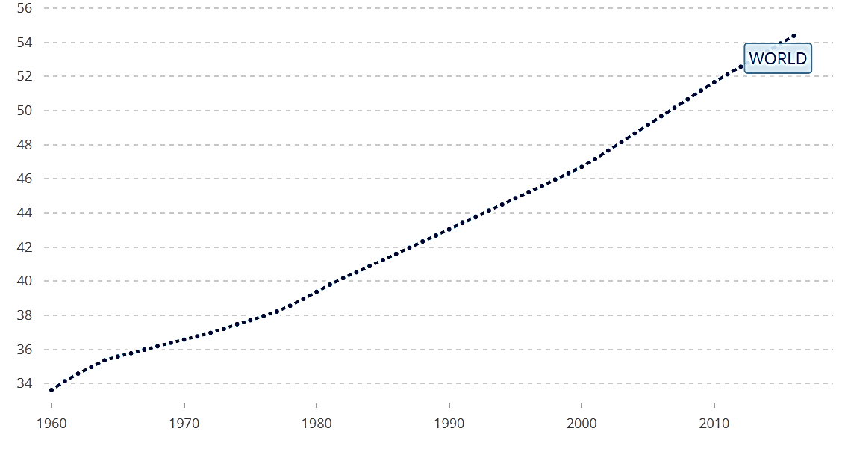
Urban population (% of total)
Source: https://data.worldbank.org/indicator/SP.URB.TOTL.IN.ZS?end=2016&start=1960
According to the UN, serious problems arise in many places with housing, infrastructure, transportation, energy, drinking water, employment, education, and healthcare (World Urbanization Prospects, UN, 2014).
There is a wide variety of urbanization levels achieved by different regions. The most urbanized regions include Northern America (82 per cent living in urban areas in 2014), Latin America and the Caribbean (80 per cent), and Europe (73 per cent). In contrast, Africa and Asia remain mostly rural, with 40 and 48 per cent of their respective populations living in urban areas.
Degree of urbanization (percentage of urban population in total population) by continents in 2017

Source: https://www.statista.com/statistics/270860/urbanization-by-continent/

Several decades ago, most of the largest urban agglomerations in the world were in more developed regions, but today's big cities are concentrated in the global south (e.g., Tokyo, Delhi, Shanghai, Sao Paulo, Mexico City, Mumbai). The fastest growing urban agglomerations are medium-sized towns and cities with less than 1 million inhabitants located in Asia and Africa. As the world continues to urbanize, sustainable development challenges will be increasingly concentrated in cities, particularly in the lower-middle-income countries where the pace of urbanization is fastest. Integrated policies to improve the lives of both urban and rural dwellers are needed.
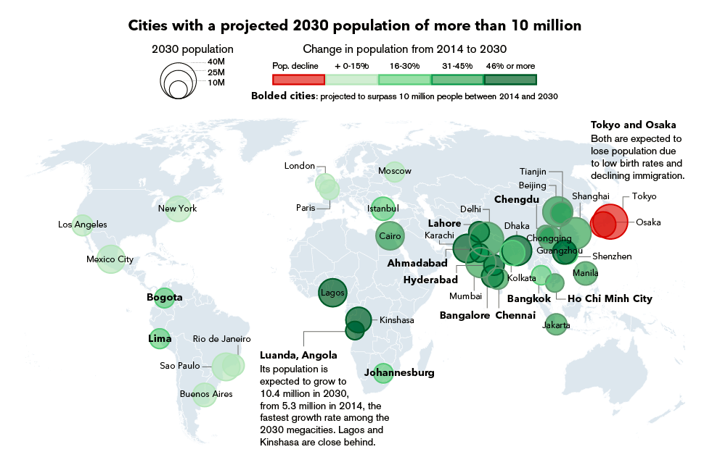
Source: United Nations World Urbanization Prospects
Graphic: Alex Tribou / Bloomberg visual data
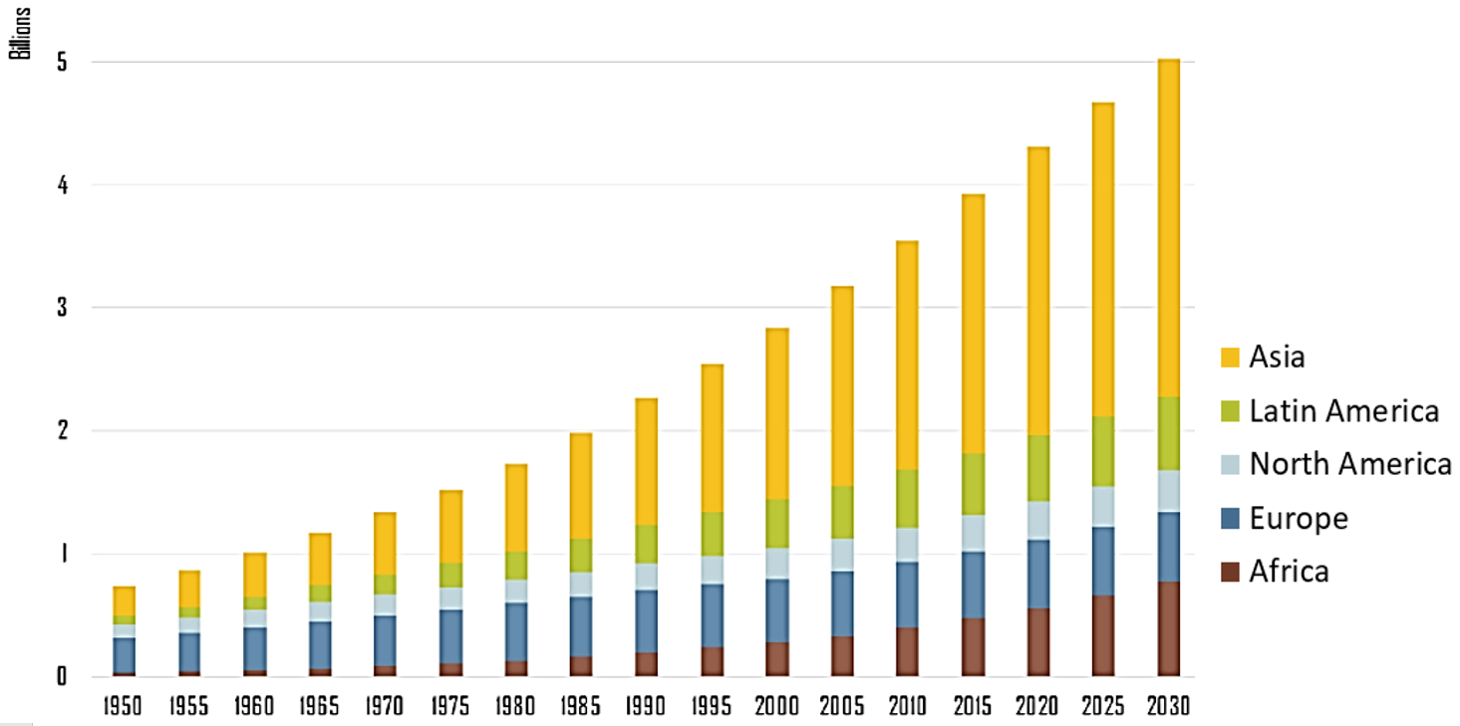
Globally, more people live in urban areas than in rural areas, with more than 50 per cent of the world’s population residing in urban areas. In 1950, 30 per cent of the world’s population was urban, and by 2050, 66 per cent of the world’s population is projected to be urban.

Source: United Nations, Department of Economic and Social Affairs, Population Division.
World Urbanization Prospects.

Definitions of “a city“ and “agglomerations“
There are more ways how to define a city. On the most general level and for the purpose of this study, we defined a city as a geographically defined settlement. Its typical features include high population density, compactness and concentration of built-up areas, typical demographic, social, and occupational structure of residents who usually do not work in agriculture, but instead work in trade, industry, and services. Cities as residential units serve to provide administrative, educational, business, and cultural functions for the wider neighbourhood.
What is...?
A city. There is no universal definition on what is a city. Different countries, municipalities and scientists use different definitions.
A mega city. Definitions on mega cities vary from cities with over 5 million to over 20 million inhabitants. In its State of the World´s Cities 2010/2011 report, UN-HABITAT defines a mega city as a city with 20 million or more inhabitants.
A slum. A slum household is defined as a group of individuals living under the same roof lacking one or more of the following conditions:
Access to improved water; access to improved sanitation facilities; sufficient living area – not more than three people sharing the same room; structural quality and durability of dwellings; and security of tenure.

Sources:
- UN HABITAT website “What is a city?”
- State of the World´s Cities 2010/2011: Cities for All: Bridging the Urban Divide. Press Kit. UN-HABITAT. 2010
State of the World´s Cities 2008/2009: Harmonious Cities. UN-HABITAT. 2008

Source: UNDESA

Example of city´s definition by European Environmental Agency (EEA)
City: The term is used generically to denote any urban form but more often applied to large and densely populated urban settlements (Source: Goodall, B. - Dictionary of Human Geography, Penguin Books, London, 1987). In Europe, there are different accepted approaches to describing the boundaries of a city:
- focused on social or cultural aspects (e.g., based on administrative units, population density),
- focused on biophysical layout (e.g., land cover, contiguity of built-up areas), and
- focused on functional aspects (e.g., labour market and commuting patterns).
In order to capture the whole performance of interconnected urban GI elements, EEA has considered two complementary spatial delineations within a city: inside the city and the urban fringe.
Moving of the population to cities is a modern trend that has been observed over the last few decades and is most often explained by the relocation of rural population for work.

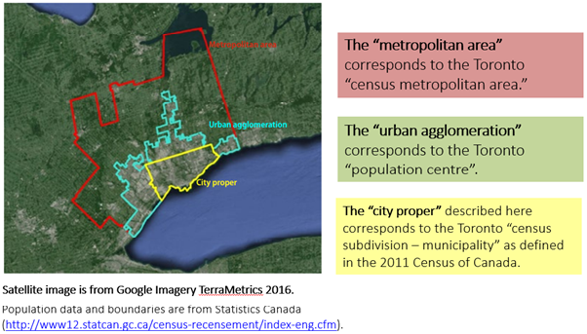
Source: www.un.org
The term “urban agglomeration” refers to the population contained within the contours of a contiguous territory inhabited at urban density levels without regard to administrative boundaries. It usually incorporates the population in a city or town plus that in the suburban areas lying outside of, but being adjacent to, the city boundaries. Whenever possible, data classified according to the concept of urban agglomeration are used. However, some countries do not produce data according to the concept of urban agglomeration but use instead that of metropolitan area or city proper. If possible, such data are adjusted to conform to the concept urban agglomeration. When sufficient information is not available to permit such an adjustment, data based on the concept of city proper or metropolitan area are used.
Source: www.un.org
Estimating the population of urban agglomerations over historical time periods is a major challenge due to the complexity of the urban growth process. Villages can become towns, towns can grow into cities, and cities can be transformed into urban agglomerations in a number of ways: They may increase due to natural population growth - that is as a result of a larger number of births than deaths; they may grow due to rural-urban or urban-urban migration; or they may emerge as a result of administrative changes. These administrative changes can also involve several different processes: They may include the incorporation of sub-urban areas or neighbouring towns into a larger city or the foundation of a completely new city - as was the case with several newly established national capitals. Administrative changes also include the re-naming of urban agglomerations - particularly those that had foreign names been assigned during the colonial period.
This figure tries to highlight some of these processes. The challenge of estimating the population of human settlements arises from the fact that both their name and their physical extend may have changed over past decades - sometimes several times. Different towns (with different names) may have been combined into one urban agglomeration - with the name of one of the original towns or with a completely new name. Population statistics referring to a "city proper" may be discontinued and replaced by data for the much larger area of an "urban agglomeration" with the same name - which may, or may not, include other neighbouring cities.
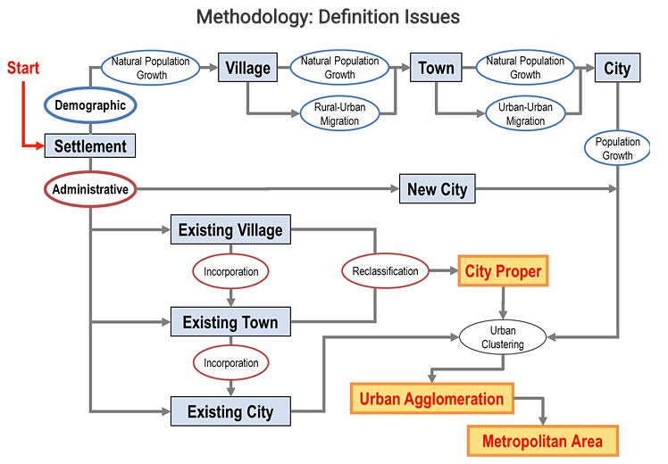
Source: https://esa.un.org/unpd/wup/General/DefinitionIssues.aspx

Importance of sustainability in the cities and urban agglomerations
Taking into consideration the importance of cities and urban agglomerations, and given the projected demographic development over the coming decades, more and more urgent requirements will be made to ensure the sustainability of cities and urban agglomerations. Sustainable city is a term used over the past 30 years and as such, it still has no exact definition. Then, the basic question is what a sustainable city should be like and which conditions the city has to meet in order to be sustainable. In publicly available sources, there are several examples of possible definitions of the term "sustainable city". Sustainable development was defined in the 1987 United Nations World Commission on Environment and Development as “development that meets the needs of the present without compromising the ability of future generations to meet their own needs”.

The term "Sustainable City" is of wider meaning and, in addition to environmental quality requirements, including the resilience to climate change, it also includes other socio-economic aspects. Sustainable development strives to achieve economic development, social development, and environmental protection in a balanced way. Sustainable development has become the main principle of long-term global development, and thus, it also comprises urban development. Essentially, there are several basic characteristics of a sustainable city. These include, for example, energy, food and water self-sufficiency, maintenance of species diversity, low pollution and carbon footprint, and accessible mobility.

Example of definition “Sustainable City“
“Sustainable cities work towards an environmentally, socially, and economically healthy and resilient habitat for existing populations, without compromising the ability of future generations to experience the same.”
Source: http://old.iclei.org/index.php?id=35

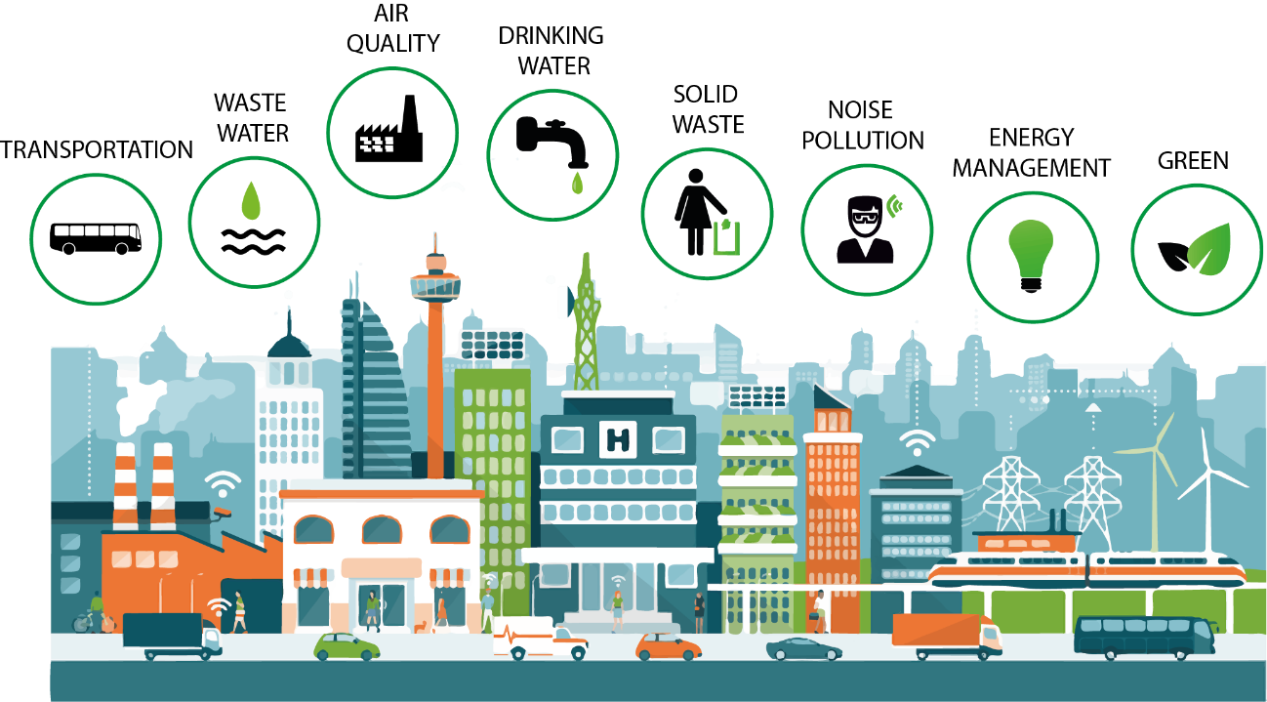

For the purpose of this research project, we understand the term "Greening City", as it was mentioned above, as a city that is capable of providing basic sustainability requirements for present and future generations, especially requirements concerning the environment such as water quality, air quality, waste management. The "Greening Cities" concept is classified in this paper as a long-term global and regional process to contribute to the development of cities and urban agglomerations in the coming decades with respect to the different components of the environment.

CITIES FROM THE VIEWPOINT OF SELECTED ENVIRONMENTAL COMPONENTS
Based on the analysis of the results of a survey sent to the members of the INTOSAI WGEA, we have identified that waste management, air pollution issues, and quality and the supply system of drinking water are the most significant problems and issues of cities and urban agglomerations in the environmental field.

Waste management system
Around the world, waste generation rates are rising. In 2012, the worlds’ cities generated 1.3 billion tonnes of solid waste per year, amounting to a footprint of 1.2 kilograms per person per day. With rapid population growth and urbanization, municipal waste generation is expected to rise to 2.2 billion tonnes by 2025.
Source: http://www.worldbank.org/en/topic/urbandevelopment/brief/solid-waste-management

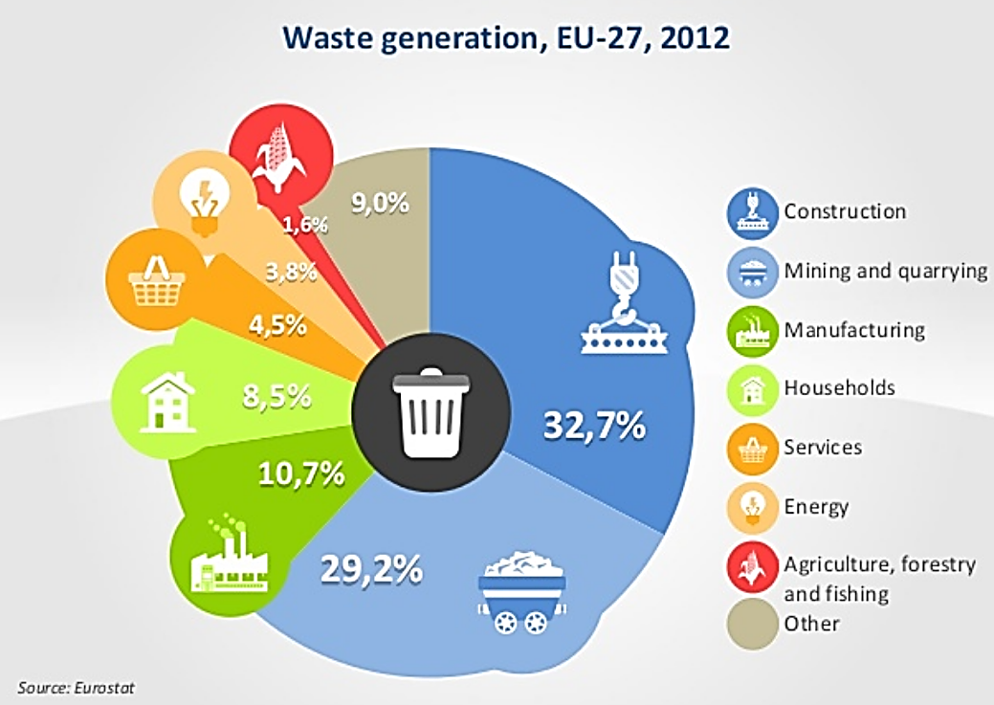
Source: https://www.slideshare.net/infoDiagram/waste-sources-treatment-ecology-presentation-visuals
As early as 2010, UN Habitat published a book entitled “Collection of Municipal Solid Waste in Developing Countries”. This book is written for developing countries. Since it seeks to encourage the designing of waste collection systems based on local information, the approach is valid in any country. The main focus is on municipal solid waste, which is taken to include waste from households, businesses and institutions, construction and demolition waste in small quantities, general solid wastes from hospitals (excluding hazardous wastes), waste from smaller industries that is not classified as hazardous, and wastes from streets, public areas and open drains. It is not concerned with wastes from agriculture, larger industries or the mining industries which normally handle their own wastes.
See also Appendix 1 Case studies – Compliance of municipal waste management system with the intended objectives and regulatory enactments (Latvia, 2015), and Management of municipal solid waste – case study on selected local councils (Sierra Leone, 2014).

Air pollution
According to the United Nations Environment Programme, air pollution is the biggest environmental health risk of our time. Air pollution comes from many sources – from cook stoves and kerosene lamps to coal-fired power plants, vehicle emissions, industrial furnaces, wildfires, and sand and dust storms.
Source: http://web.unep.org/environmentassembly/air

The problem is most acute in urban areas, particularly in Africa and Asia. In low- and middle-income countries, 98 per cent of cities with more than 100,000 inhabitants fail to meet the WHO’s air quality guidelines.
Sources: http://www.who.int/news-room/detail/12-05-2016-air-pollution-levels-rising-in-many-of-the-world-s-poorest-cities http://www.who.int/airpollution/data/cities/en/

The tackling air pollution can bring significant benefits for economies, human health, and the climate. For example, BREATHELIFE is a Climate and Clean Air Coalition initiative led by the WHO and UN Environment. This global campaign aims to mobilize cities and individuals to protect our health and our planet from the effects of air pollution.
Source: http://breathelife2030.org/

Sources of pollution can be divided into:
Natural air pollution
Natural air pollution is caused by forest fires, volcanoes erupting or gases released from the radioactive decay of rocks inside the Earth. Forest fires (which often start naturally) can produce huge swathes of smoke that drift for miles over neighbouring cities, countries, or continents. Giant volcanic eruptions can spew so much dust into the atmosphere that they block out significant amounts of sunlight and cause the entire planet to cool down for a year or more.
Air pollution caused by human activity
Among the human activities that cause air pollution can be included: combustion, the use of chemicals, transport, power plants and factories, etc. Air pollution can harm the health of people and animals, damage crops or stop them growing properly, and make our world unpleasant and unattractive in a variety of other ways.
Source: https://sciencing.com/difference-between-human-natural-air-pollution-23687.html

According to the WHO, air pollution is one of the world's biggest killers: it causes around three million people to die prematurely each year. Many of these deaths happen in developing countries (over half a million in India alone), but wealthier industrial nations suffer too: in the United States, for example, around 41,000 people a year are estimated to die early because of air pollution. Air pollution (along with water pollution) can seriously affect plant growth, cause acid rain, or pollute buildings, etc.
Source: http://www.who.int/phe/publications/air-pollution-global-assessment/en/

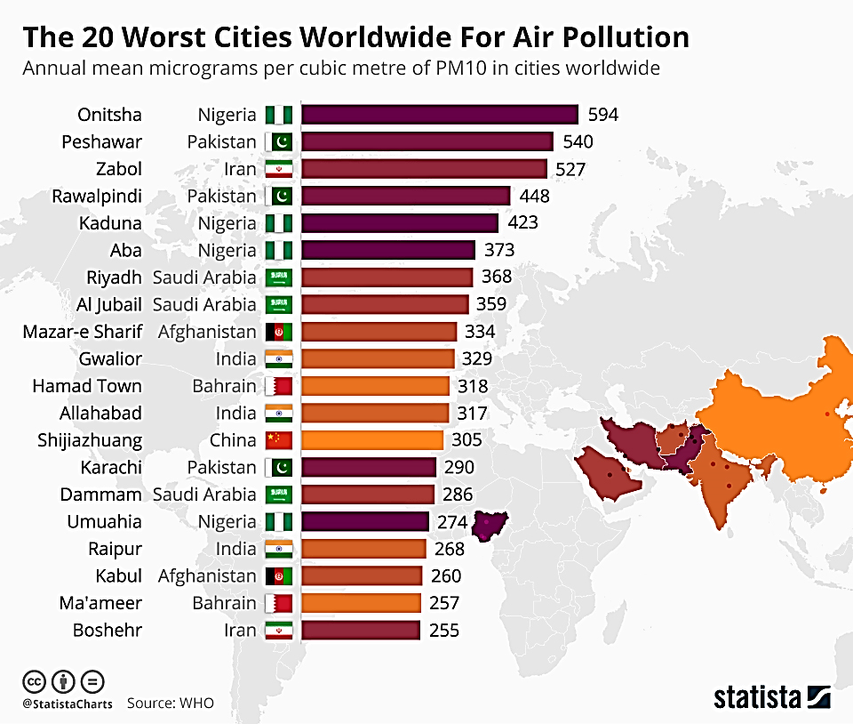

See also Appendix 1 Case studies – Funds earmarked for the support of the air quality improvement (the Czech Republic, 2019), Environmental Pollution (Mexico, 2014), and Special examination to the municipalities of Asunción, Lambaré, Fernando de la Mora, San Lorenzo, Luque (all are local governments), the Secretary of the Environment and the general Directorate of Environmental Health of the Ministry of Public Health and Social Welfare, regarding the Control that those institutions carry out care of air quality (Paraguay, 2014).

Quality and system of drinking water supplies
According to United Nations Department of Economic and Social Affairs (UN DESA), the exploding urban population growth creates unprecedented challenges, among which provision for water and sanitation have been the most pressing and painfully felt when lacking.
WHO and UNICEF announced in 2017 that some 3 in 10 people worldwide, or 2.1 billion, lack access to safe, readily available water at home, and 6 in 10, or 4.5 billion, lack safely managed sanitation. The Joint Monitoring Programme (JMP) report Progress on drinking water, sanitation and hygiene: 2017 update and Sustainable Development Goal baselines (Progress report 2017), presents the first global assessment of “safely managed” drinking water and sanitation services. The overriding conclusion is that too many people still lack access, particularly in rural areas. Progress report 2017 states that:
- Many countries lack data on the quality of water and sanitation services. The report includes estimates for 96 countries on safely managed drinking water and 84 countries on safely managed sanitation.
- In countries experiencing conflict or unrest, children are 4 times less likely to use basic water services, and 2 times less likely to use basic sanitation services than children in other countries.
- There are big gaps in service between urban and rural areas. Two out of three people with safely managed drinking water and three out of five people with safely managed sanitation services live in urban areas. Of the 161 million people using untreated surface water (from lakes, rivers or irrigation channels), 150 million live in rural areas.
Source:
http://www.who.int/en/news-room/detail/12-07-2017-2-1-billion-people-lack-safe-drinking-water-at-home-more-than-twice-as-many-lack-safe-sanitation
Two main challenges related to water are affecting the sustainability of human urban settlements: the lack of access to safe water and sanitation, and increasing water-related disasters such as floods and droughts. These problems have enormous consequences on human health and well-being, safety, the environment, economic growth and development.

Water and urban growth by numbers
- Every second, the urban population grows by 2 people.
- 95 % of the urban expansion in the next decades will take place in the developing world.
- In Africa and Asia, the urban population is expected to double between 2000 and 2030.
- Between 1998 and 2008, 1052 million urban dwellers gained access to improved drinking water and 813 million to improved sanitation. However, the urban population in that period grew by 1089 million people and thus undermined the progress.
- One out of four city residents worldwide, 789 million in total, lives without access to improved sanitation facilities.
- 497 million people in cities rely on shared sanitation. In 1990, this number was 249 million.
- 27 % of the urban dwellers in the developing world do not have access to piped water at home.

Source: http://www.un.org/waterforlifedecade/swm_cities_zaragoza_2010/pdf/facts_and_figures_long_final_eng.pdf

See also Appendix 1 Case studies – Performance Audit of Environmental degradation in the greater Guwahati area with special emphasis on the role of the Pollution Control Board, Assam (India, 2016), and The State´s contaminated areas (Sweden, 2016).

EXAMPLES OF OTHER SIGNIFICANT CHALLENGES THAT INFLUENCE ENVIRONMENT IN THE CITIES
The previous section focused on the areas that the audit institutions consider to be the most significant in terms of selected urban issues. In this sub-chapter, there are mentioned other topics related closely to ecological challenges in the cities.
INFRASTRUCTURE FOR SEWER SYSTEMS
Sewage is wastewater which contains human excreta (faeces and urine), laundry waste, and often kitchen, bathing and other forms of waste water, too. It is highly pathogenic, meaning that it contains many disease causing organisms.
Globally, around two-thirds of the World’s urban dwellers rely on on-site (on-plot) sanitation. At the same time, there is an increasing trend towards replacing on-site sanitation with traditional sewerage systems. Millions of dollars are spent on building sewers and sewage treatment plants while the complementary investments in household sewer connections and toilets are often neglected.
Source: http://blogs.worldbank.org/water/building-urban-sewerage-infrastructure-where-sewage
The conventional wastewater system:
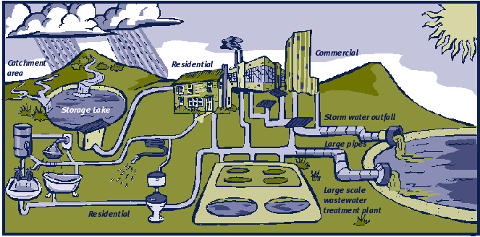
Source: http://www.mfe.govt.nz/publications/waste/sustainable-wastewater-management-handbook-smaller-communities-part-1-1
The collection and treatment of domestic sewage and wastewater is vital to public health and clean water. It is among the most important factors responsible for the general level of good health.
Source: https://www.epa.gov/npdes/municipal-wastewater
The collection and disposal of waste and wastewater is essential in order to control the transmission of waterborne diseases and to prevent degradation of the environment, including groundwater and surface waters.
Source: https://esa.un.org/iys/sewerage.shtml
This indicator presents sewage treatment connection rates, i.e., the percentage of the population connected to a wastewater treatment plant through a public sewage network. It does not take into account independent private facilities, used where public systems are not economic.
Waste water treatment | 2015 | Waste water treatment | 2015
Austria | 94,97¹⁾ | Japan | 77,80
Belgium | 84,19²⁾ | Korea | 92,89
Canada | 84,31³⁾ | Latvia | 77,23
Colombia | 23,10 ⁴⁾ | Lithuania | 76,66
Costa Rica | 6,27 | Luxembourg | 98,50
Czech Republic | 81,00 | Mexico | 55,95
Denmark | 91,01 | Netherlands | 99,40
Estonia | 82,60 | New Zealand | 84,10
Finland | 83,00²⁾ | Norway | 83,80
France | 82,10¹⁾ | Poland | 72,60
Germany | 96,76²⁾ | Portugal | 70,64³⁾
Greece | 92,83 ¹⁾ | Slovak Republic | 64,50
Hungary | 76,55 | Slovenia | 57,59
Chile | 99,85 | South Africa | 57,00⁴⁾
China | 32,55⁵⁾ | Spain | 96,90¹⁾
Iceland | 66,00⁶⁾ | Sweden | 87,00¹⁾
Ireland | 65,74 | Switzerland | 98,00²⁾
Israel | 96,80 | Turkey | 64,02¹⁾
Italy | 60,83⁷⁾ | United States | 75,50⁷⁾
Source: https://data.oecd.org/water/waste-water-treatment.htm

Notes: 1) Data of the year 2014
2) Data of the year 2013
3) Data of the year 2009
4) Data of the year 2011
5) Data of the year 2004
6) Data of the year 2010
7) Data of the year 2012

NOISE POLLUTION
Noise is an unwanted or objectionable sound. It can be a pollutant and environmental stressor, and the meaning of sound is important in determining reaction of different individuals to the same sound. One person’s music is another’s noise.
Source: http://www.who.int/ceh/capacity/noise.pdf
According to the WHO, the environmental noise is responsible for a variety of health effects, including increased risk of ischaemic heart disease, sleep disturbance, cognitive impairment, annoyance, stress-related mental health risks, and tinnitus.
Source: https://www.iaspaper.net/noise-pollution/
The table below shows cities with the highest and with the lowest noise pollution:
Top ten most noise-polluted cities | Top ten least noise-polluted cities
1. Guangzhou, China | 1. Zurich, Switzerland
2. Delhi, India | 2. Vienna, Austria
3. Cairo, Egypt | 3. Oslo, Norway
4. Mumbai, India | 4. Munich, Germany
5. Istanbul, Turkey | 5. Stockholm, Sweden
6. Beijing, China | 6. Dusseldorf, Germany
7. Barcelona, Spain | 7. Hamburg, Germany
8. Mexico City, Mexico | 8. Portland, US
9. Paris, France | 9. Cologne, Germany
10. Buenos Aires, Argentina | 10. Amsterdam, Netherlands
Source: https://knops.co/noise-pollution-50-noisiest-cities/

LIGHT POLLUTION
In addition to noise, light is also ever-present in the urban areas. According to the International Commission on Illumination, light pollution is generic term indicating the sum total of all adverse effects of artificial light.
Light pollution is a by-product of outdoor lighting. Nevertheless, outdoor lighting is not the only cause of light pollution, other causes are car lights, security floodlights, advertising lights, lights from stadiums and other sporting locations, etc. Light pollution includes such effects as sky glow, light trespass, and glare.
Light Pollution Around the World
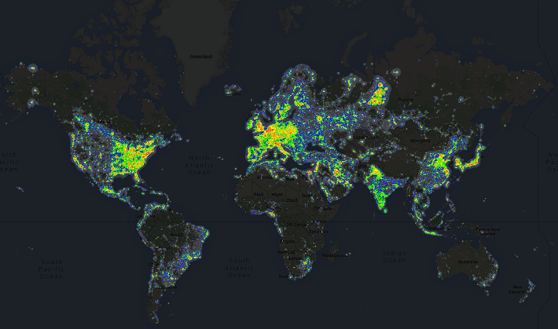
Source: https://brilliantmaps.com/light-pollution/

Consequence of too much light pollution is not only vanishing of starlight in the night sky, but light pollution also disrupts ecosystems, has adverse health effects, wastes energy and interferes with astronomical research. Nowadays, pollution cannot be avoided altogether, but it can be minimized by lighting more efficiently. Light pollution can be reduced by using light when and where it is needed and at the amount that is needed, by using efficient luminaires and lamps, by using energy efficient bulbs with appropriate spectral power distributions, etc.

GREEN INFRASTRUCTURE
As urban areas develop, natural areas are paved over and the ecosystem services such as water infiltration, air quality, temperature mitigation, and flood attenuation are lost. Green infrastructure can continue to provide these services. Green infrastructure refers to both the remaining natural areas within urban development as well as to green areas that are built to mimic the ecosystem services of natural areas in the boundaries of an urban area. Green infrastructure provides numerous ecosystem services such as flood control, air quality, cooling, and recreation.
Urban planners are wary of green infrastructure, although they generally understand its benefits. But green infrastructure delivery can be achieved through existing planning processes.
Green infrastructure relates to standalone and strategically networked environmental features designed for environmental, social, and economic benefits. Examples include permeable surfaces, water surfaces (streams, lakes, etc.), green walls, green roofs, and street trees. Benefits of green infrastructure related thereto include reduced urban heat, lower building energy demand and improved storm water management. There may be challenges in implementing green infrastructure, but these can often be mitigated through good design. Issues include maintenance costs, tree roots, bushfire hazard and power-line interference. Urban planners are increasingly asked to create and deliver urban greening strategies.
Source: https://www.weforum.org/agenda/2016/04/what-is-green-infrastructure-and-how-do-we-include-it-in-urban-planning
According to the Communication from the Commission to the European Parliament, the Council, the European Economic and Social Committee and the Committee of the Regions Green Infrastructure - GI, green infrastructure is based on the principle that ‘protecting and enhancing nature and natural processes […] are consciously integrated into spatial planning and territorial development’. Accordingly, the Green Infrastructure Strategy defines GI as “a strategically planned network of natural and semi-natural areas with other environmental features designed and managed to deliver a wide range of ecosystem services’ in both rural and urban settings.
Source: https://eur-lex.europa.eu/legal-content/EN/TXT/HTML/?uri=CELEX:52013DC0249&from=EN

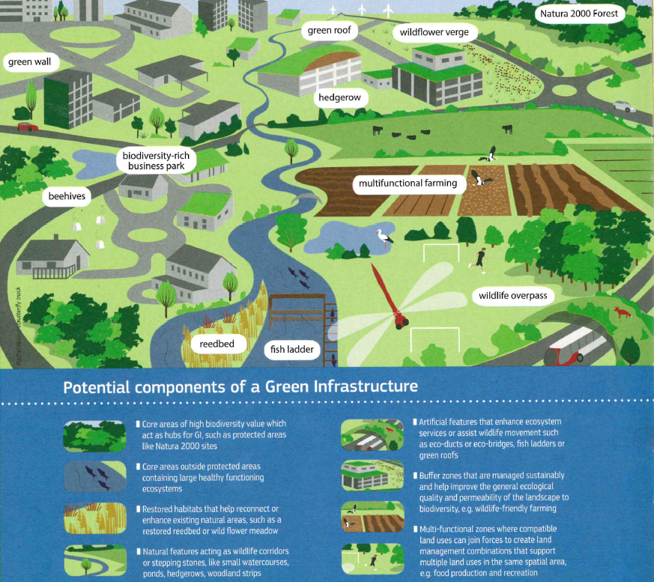 Source: https://www.eea.europa.eu/themes/sustainability-transitions/urban-environment/urban-green-infrastructure/what-is-green-infrastructure#references

See also Appendix 1 Case studies – Federal support for sustainable municipal infrastructure (Canada, 2016), Case on Green City Audit (China, 2017), and Stormwater management – EPA Pilot Project to Increase Use of Green Infrastructure Could Benefit from Documenting Collaborative Agreements (USA, 2017).

SUSTAINABLE URBAN ENERGY
According to UN-HABITAT, regardless of the source, energy is a major factor for development. It is needed for transport, industrial and commercial activities, buildings and infrastructure, water distribution, and food production. Most of these activities take place in or around cities, which are on average responsible for more than 75 per cent of a country’s Gross Domestic Product (GDP) and therefore the main engines of global economic growth. Savings can be made by integrating efficient heating, cooling, insulation, lighting, and water distribution systems in new or rehabilitated buildings that will increase energy retention. Likewise, on site alternative energy sources such as solar panels on a roof can supplement power from the grid. The use of recycled, reused, or low energy building materials will also contribute to a better energy balance.
Source: https://unhabitat.org/urban-themes/energy/
IEA states that cities dominate energy demand, and by extension are responsible for a significant share of carbon emissions. In 2013, the world’s urban areas accounted for about 64% of global primary energy use and produced 70% of the planet’s carbon dioxide emissions. These shares will rise as cities grow and urban economic activity expands. As the world seeks to make more efficient use of its energy resources, increase energy security and meet global climate targets, it is essential that cities take a leading role in the energy transition. Policy at the national level must encourage the deployment of clean energy technologies, and include greenhouse gas emission reduction targets (such as those under the Paris Agreement), carbon pricing mechanisms, and investment in energy research, development and demonstration. According to IEA, key elements of sustainable urban energy systems include rapid transit, district cooling, and high-efficiency buildings.
Source: https://www.iea.org/newsroom/news/2016/september/cities-are-at-the-frontline-of-the-energy-transition.html
Sectors of urban energy systems
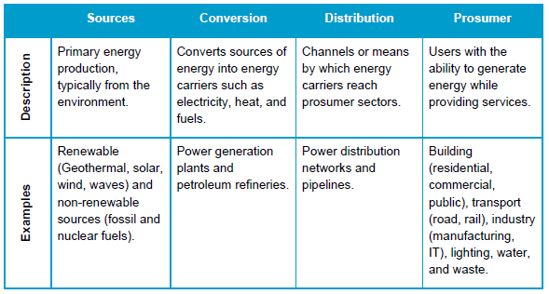
Source: http://www.wrirosscities.org/sites/default/files/Advancing%20Toward%20a%20more%20Sustainable%20Urban%20Energy%20System%20-%20Policy%20and%20Technology%20Considerations%20-%20IEA%20WRI%20Ross%20Center%20for%20Sustainable%20Cities%20-%20May-2015.pdf

URBAN MOBILITY
Mobility is an integral part of urban life. It influences the economic growth as well as the quality of life in urban areas. On the one hand, it enables inhabitants to access their workplace, schools, and other places in the city, on the other hand, it also causes many problems in urban areas including congestion, air pollution, and noise. Moreover, urban road network capacity is often achieved in cities - further expansion of urban road network leads to moderate traffic congestion only in the short term and the only final impact is more cars in cities.
These mounting pressures have driven policymakers to reconsider the advantages of public transport, walking and cycling in urban areas – space-efficiency, social inclusivity and relatively low contributions to noise, air pollution and climate change per passenger – and measures that can be taken to counter the substitution of these options with private car use.
Source: https://www.itf-oecd.org/integrating-urban-public-transport-systems-cycling - PDF document: integrating-urban-public-transport-systems-cycling-roundtable-summary.pdf

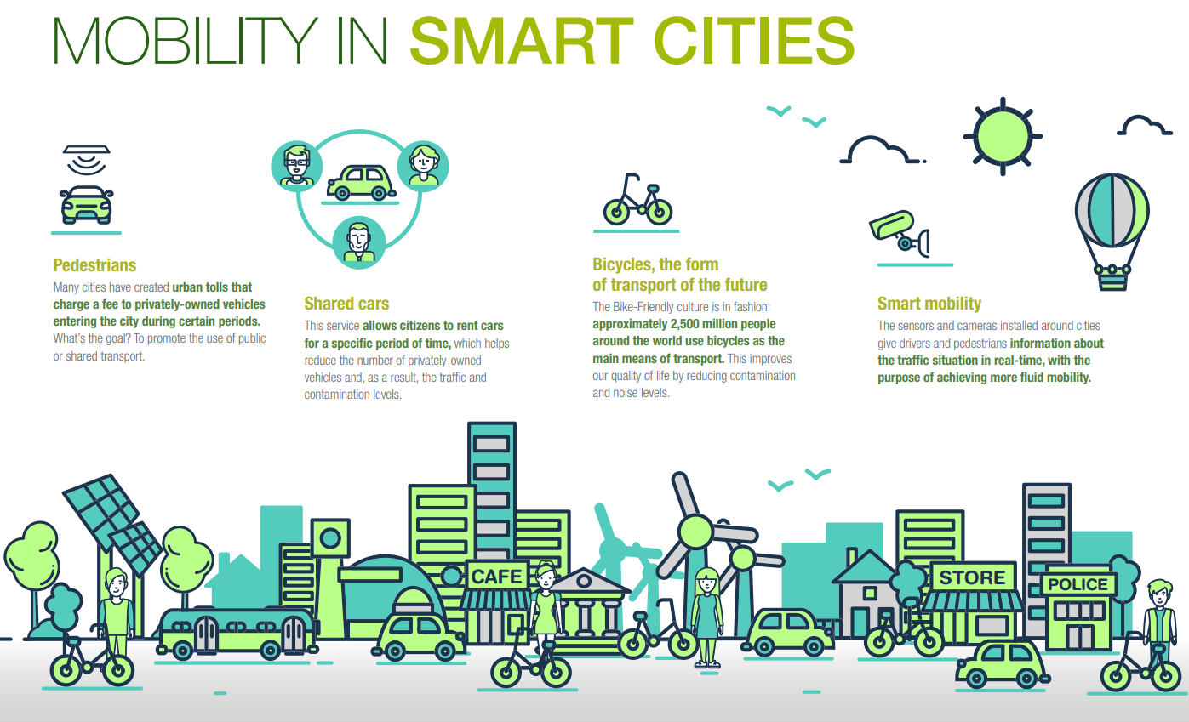
Source: https://www.iberdrola.com/top-stories/technology/smart-mobility

See also Appendix 1 Case studies – Case on Green City Audit (China, 2017), and Effectiveness of EU – supported public urban transport projects (European Court of Auditors, 2014).

TOURISM
Tourism is a vital aspect of an urban economy and urban development. Tourism is continuously growing, accounting for 7% of worldwide exports, one in every eleven jobs and 10% of the world’s GDP. The current challenge for urban tourism is to make sure that this growth is converted into sustainable tourism and that cities are prepared to absorb and welcome a steady flow of tourists.
Source: http://affiliatemembers.unwto.org/event/round-table-sustainable-urban-tourism
On the one hand, tourism increases consumption, creates employment and business opportunities, and improves economic situation in general, but on the other hand, tourism can raise local prices and contributes to environmental problems (increasing pollution by air traffic and urban transportation; increasing amount of waste; insufficient water supply). Also, tourism can cause damages to cultural monuments and local architecture and it may have damaging socio-cultural effects (lack of privacy, destruction of traditions, unification).
According to the United Nations World Tourism Organization (UNWTO), sustainable tourism can be defined as tourism that takes full account of its current and future economic, social and environmental impacts, addressing the needs of visitors, the industry, the environment, and host communities. Sustainable tourism should make optimal use of environmental resources, respect the socio-cultural authenticity of host communities and ensure viable, long-term economic operations. Source: http://sdt.unwto.org/content/about-us-5

The UN General Assembly declared 2017 as the International Year of Sustainable Tourism for Development.
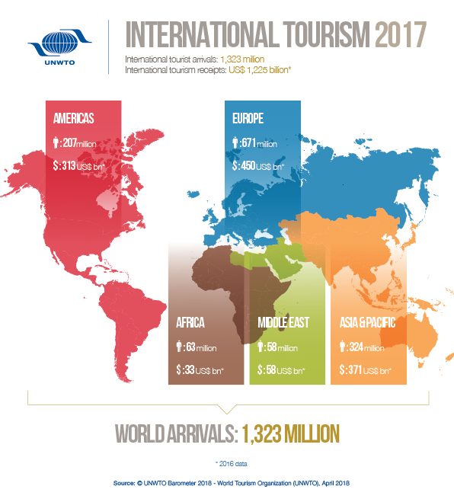
Source: http://media.unwto.org/content/infographics

INITIATIVES AND TRENDS AFFECTING CITIES
There are various initiatives, organizations, and tools all around the world that seek to contribute to improving the urban environment and making city development sustainable. They also take into account some of the issues mentioned above - the problems that the cities are facing in these days. Further details on these initiatives and trends can serve as an additional source of criteria for auditors.

SMART CITIES
Many definitions of a “smart city” exist, and “smart” approaches have been understood differently by different people and sectors. Some definitions note that smart cities are those cities with “smart (intelligent) physical, social, institutional and economic infrastructure while ensuring centrality of citizens in a sustainable environment;” they refer to key characteristics defined by distinct factors (e.g., smart economy, smart mobility, smart people, smart environment, smart living, smart governance) and focus on the strategic use of new technology and innovative approaches to enhance the efficiencies and competitiveness of cities. A definition by the International Telecommunication Union (ITU)’s Focus Group on Smart Sustainable Cities (FG-SSC) reads: “A smart sustainable city is an innovative city that uses ICTs and other means to improve the quality of life, efficiency of urban operation and services, and competitiveness, while ensuring that it meets the needs of present and future generations with respect to economic, social and environmental aspects.”
Source: http://www.sustrancon.org/21-smart-cities.html
Smart City approach requires a combination of smart efforts to improve inhabitants’ quality of life, promote economic growth, and protect the environment from degradation. Key systems of smart and sustainable cities include: smart energy, smart buildings, smart transportation, smart water, smart waste, smart physical safety and security, smart health care, and smart education.
Source: http://habitat3.org/the-new-urban-agenda/documents/issue-papers/ - PDF document – n. 21 Smart Cities – in 6 languages
See also Appendix 1 Case studies – Administration of the Smart grid, Smart city program (Australia, 2014), and Effectiveness of implementation of spatial planning on the Spatial Planning Agency and other relevant institutions in Jakarta (Indonesia, 2016).
RESILIENT CITIES
Resilient Cities is the annual global forum on urban resilience and adaptation convened in Bonn, Germany. The congress series provides an international platform to share the latest knowledge, good practices, challenges, and innovations for creating more resilient cities. It also serves as an annual meeting point to track local progress on the resilience targets of Sustainable Development Goal 11 to make cities inclusive, safe, resilient, and sustainable. The congress outcomes present a snapshot of the state of urban resilience, building on discussions and developments from previous years.
The 8th edition of Resilient Cities focused on implementing integrated, sustainable, and resilient urban development plans. Key discussion points included (1) how to strengthen new and existing partnerships with relevant sectors and actors at multiple scales; (2) how to mobilize resources to accelerate local action; and (3) how to encourage holistic and inclusive approaches.
Source: https://resilientcities2018.iclei.org/

See also Appendix 1 Case studies – Design and Implementation of the Liveable Cities Program (Australia, 2013).

EU GREEN WEEK 2018
Annually, the European Commission organises the EU Green Week focused on a relevant topic for environment protection and the livelihoods of European citizens. In the year 2018, with the theme “Green Cities for a Greener Future”, a series of events and conferences explored ways in which the EU was helping cities to become better places to live and work.
The Conference Green Cities for Greener Future was only a part of the EU Green Week 2018 activities that were held at many places in Europe. There were held more than 280 activities at local and city level from 21 April to 10 June 2018, which included, for example, seminars, guided visits of parks, open days in waste recycling companies and waste water treatment plants, citizens' initiatives including biodiversity, as well as artistic initiatives on green cities and raising public awareness on this issue, clean city days, and other events.
The purpose of the EU Green Week 2018 was to discover ways in which the EU would help cities to become better places to live and work, e.g., the development of policies on air quality, noise, nature and biodiversity, waste management and water resources policies, participatory approaches to urban development, networking and tools for sharing best practices, involving local authorities and citizens, and promoting their sharing of a sustainable future.

THE ITF (INTERNATIONAL TRANSPORT FORUM)
The International Transport Forum at the OECD is an intergovernmental organisation with 59 member countries. It acts as a think tank for transport policy and organises the Annual Summit of transport ministers. ITF is the only global body that covers all transport modes. The ITF is administratively integrated with the OECD, yet politically autonomous.
The ITF works for transport policies that improve peoples’ lives. Its mission is to foster a deeper understanding of the role of transport in economic growth, environmental sustainability and social inclusion and to raise the public profile of transport policy.
Source: https://www.itf-oecd.org/sites/default/files/docs/cop-pdf-03.pdf

Chapter 2 – Legal framework of the “Green Cities – Sustainable Urban Development“
Instruments that influence urban development and sustainability can start at an international level and continue through governments/national levels to the level of self-governments. At each of these levels of governance, it is recommended to implement strategies that would lead to their interconnection in order to achieve the goals of sustainable urban development. The sustainability of cities can be measured by indicators or indices that allow to assess the socio-economic and environmental impacts of urban designs, policies, infrastructures, etc. and can allow cities to monitor the success and impact of sustainability interventions.

THE IMPORTANCE OF INTERNATIONAL AGREEMENTS AND STRATEGIES
Provisions following from international agreements or treaties are an important source of audit criteria. For further connections, we refer to UNEP Auditing the Implementation of Multilateral Environmental Agreements.
The most important international agreement that directly address the issue of Green Cities – Sustainable Urban Development is the document "Transforming our world: the 2030 Agenda for Sustainable Development”. SAIs can also resort to criteria presented in international agreements or treaties that are indirectly concerned with issues that are relevant to the audit.
Important examples of international treaties that at least partially affect urban sustainability include the following examples:
Climate protection | - United Nations Framework Convention on Climate Change,  - Paris Agreement,  - Kyoto Protocol to the United Nations Framework Convention on Climate Change
Nature and landscape protection | - European Landscape Convention,  - Convention on Biological Diversity,  - United Nations Convention to Combat Desertification in those Countries Experiencing Serious Drought and/or Desertification, particularly in Africa
Species diversity | - African-Eurasian Waterbird Agreement,  - Bern Convention,  - CITES - Convention on International Trade in Endangered Species of Wild Fauna and Flora
Air protection | - Convention on Long-range Transboundary Air Pollution
Ozone layer protection | - Vienna Convention for the Protection of the Ozone Layer,  - Montreal Protocol on Substances that Deplete the Ozone Layer
Water protection | - Convention on the Protection and Use of Transboundary Watercourses and International Lakes
Chemicals and environmental risks | - Rotterdam Convention on the Prior Informed Consent Procedure for Certain Hazardous Chemicals and Pesticides in International Trade,  - Stockholm Convention on Persistent Organic Pollutants
Waste management | - Basel Convention on the Control of Transboundary Movements of Hazardous Wastes and their Disposal
Industrial accidents | - Convention on the Transboundary Effects of Industrial Accidents
The international agreements covering so-called horizontal issues – such as public access to information on the environment, the environmental impact assessment, etc. - are also very important (Aarhus Convention on Access to Information, Public Participation in Decision-making and Access to Justice in Environmental Matters, Kyiv Protocol on Pollutant Release and Transfer Registers, Espoo Convention on Environmental Impact Assessment in a Transboundary Context, Protocol on Strategic Environmental Assessment to the Convention on Transboundary Environmental Impact Assessment in a Transboundary Context).
In the area of monitoring the implementation of international treaties, it is advisable to refer to the UNEP handbook prepared by INTOSAI WGEA “Auditing the Implementation of Multilateral Environmental Agreements (MEAs): A Primer for Auditors“.

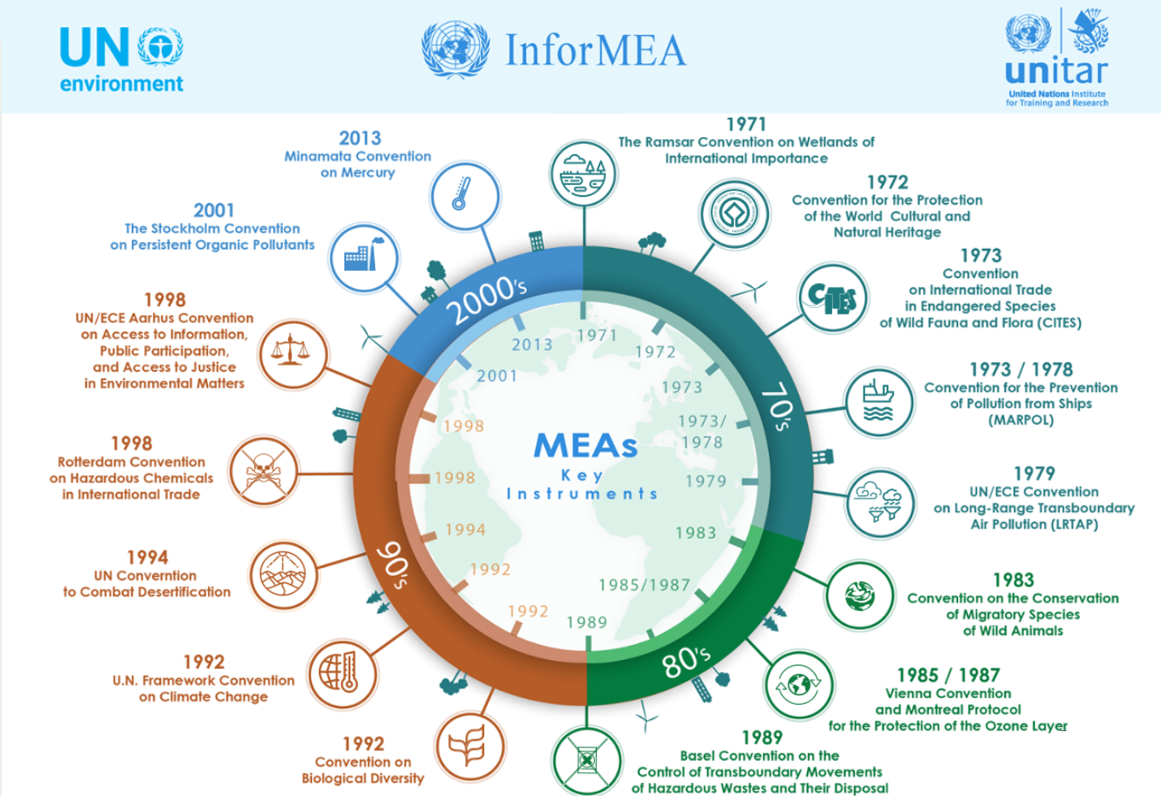
Source: https://www.unitar.org/ksi/international-environmental-and-human-rights-law
Communication between several levels, from supranational through national to regional, is of high importance for the existence of sustainable cities. It is also necessary to communicate with the inhabitants of individual cities and between cities themselves, in order to create an interconnected system that will draw all the benefits of a heavy concentration of people.

UNITED NATIONS (UN)
UN-Habitat is the United Nations programme working towards a better urban future. Its mission is to promote socially and environmentally sustainable human settlements development and the achievement of adequate shelter for all. UN-Habitat was established as a UN agency in 1978 to improve living conditions in cities and towns around the world.
On 21 December 2001, the United Nations General Assembly decided to transform the United Nations Commission on Human Settlements (Habitat) into a fully programme renamed as the United Nations Human Settlements Programme (UN-Habitat) with effect from 1 January 2002. The governing body of the Programme is the UN Habitat Governing Council; the UN-Habitat secretariat is the executive body of the Governing Council and serves as the focal point for human settlements and for the coordination of human settlements activities within the United Nations system.
One of UN-Habitat's key activities is to contribute to the implementation of documents adopted by UN member states, in particular, the Habitat Agenda that was approved by the conference Habitat II. UN-Habitat's activities also contribute to the United Nations global goal of reducing poverty and promoting sustainable development.
The scheme of significant aspects from the perspective of cities according to UN Habitat:
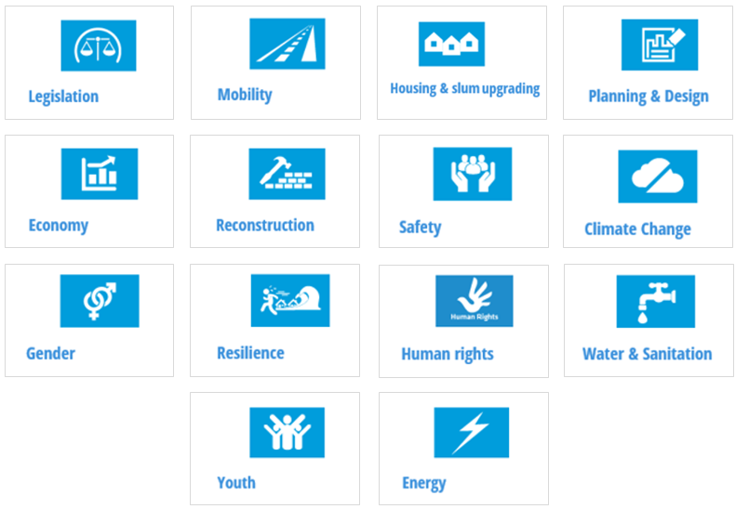
Source: https://unhabitat.org/urban-themes/

ORGANISATION FOR ECONOMIC CO-OPERATION AND DEVELOPMENT (OECD)
Another important organisation which has been dealing with issues of cities and urban agglomerations for a long time, is the OECD.
According to OECD, the urban issues are increasingly prominent on national policy agendas. Cities and metropolitan areas are major contributors to national economies and play a key role as nodes in global markets. Moreover, at a time of deepening globalisation and increasing international competition for investment, metropolitan regions have become the targets of a wide range of public interventions. As a result, throughout the OECD, urban development policies seek to address a range of issues – from managing urban expansion and congestion to fostering competitiveness, innovation, social inclusion and environmental sustainability.
Source: http://www.oecd.org/governance/regional-policy/urbandevelopment.htm
The OECD book, Cities and Climate Change, shows how city and metropolitan regional governments can work in tandem with national governments to respond to climate change. Urban policies can contribute to a global greenhouse gas mitigation agenda and reduce the overall cost of emissions abatement, due to the impact of lifestyles, spatial form and transportation choices on greenhouse gas emissions, and the opportunity to serve as policy laboratories. Local-level financing deserves attention: urban revenue sources can be greened, such as through congestion charges and reforming property taxes that favour sprawl, and new financial instruments are needed, such as simplified, multisectoral urban involvement in the Clean Development Mechanism, Joint Implementation and carbon markets, as well as generally greater access to international and domestic capital markets. National policies and enabling frameworks can leverage existing local policy experiments, accelerate policy responses and learning, mobilise resources, and support harmonised local greenhouse gas inventory methods.
The OECD Green Cities Programme seeks to better understand the concept of green growth in cities; the potential of urban policies for urban and national green growth; and to inform national, sub-national, and municipal governments as they seek to address economic and environmental challenges by pursuing green growth. The programme contributes to the OECD’s horizontal work on green growth, initiated at the request of Ministers of the 34 countries who signed a Green Growth Declaration in 2009, thereby committing to strengthen their efforts to pursue green growth strategies as part of their responses to the crisis.

THE WORLD BANK
Urbanization in developing countries is a defining feature of the 21st century. Between 2000 and 2030, the entire built-up urban area in developing countries is projected to triple. Urbanization has enabled economic growth and innovation across all regions, currently accounting for three-quarters of global economic production. At the same time, urbanization has also contributed to environmental and socioeconomic challenges, including climate change, waste and pollution, congestion, and the rapid growth of slums.

The Sustainable Cities blog is a space for urban development professionals to exchange ideas and engage some of the central questions of sustainable cities:
• What makes a sustainable city?
• How do we measure a city's sustainability?
• What can we do to make cities more inclusive, safe, resilient, and sustainable as they strive to achieve the Sustainable Development Goals?
The blog, including a series titled "Sustainable Communities", is coordinated by the Urban Development Unit within the World Bank's Social, Urban, Rural and Resilience Global Practice. The bloggers are urban development professionals from across the World Bank and around the world.
Source: http://blogs.worldbank.org/sustainablecities/

SUSTAINABLE DEVELOPMENT GOALS
The 17 UN Sustainable Development Goals represent a development programme for the next 15 years (2015-2030) and build upon the successes of the Millennium Development Goals (MDGs) agenda. On 1 January 2016, the 17 SDGs of the 2030 Agenda for Sustainable Development — adopted by world leaders in September 2015 at an historic UN Summit — officially came into force. With these new Goals that universally apply to all, countries will mobilize efforts to end all forms of poverty, fight inequalities, and tackle climate change. The SDGs are the result of a three-year-long negotiation process that began at the 2012 UN Conference on Sustainable Development in Rio de Janeiro. All UN member states, representatives of civil society, the business community, academic communities and citizens from all continents participated in the formulation of the SDGs. The Sustainable Development Agenda was officially endorsed by the United Nations Summit on 25 September 2015 in New York in the document "Transforming our World: The 2030 Agenda for Sustainable Development", which also includes the SDGs The INTOSAI WGEA research study "Delivering the 2030 Agenda (Sustainable Development Goals) focusing on environmental auditing" deals in more detail with the sustainable development goals.

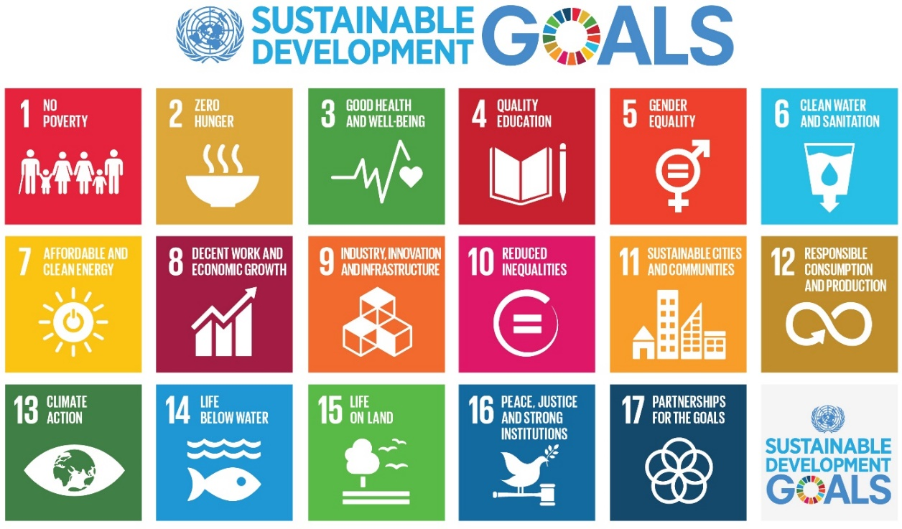
Source: http://www.undp.org/content/undp/en/home/sustainable-development-goals.html

The topic of Greening Cities is related to some of the SDGs that have been defined and approved by the UN summit in September 2015 in the document "Transforming our world: the 2030 Agenda for Sustainable Development”, e.g., Goal 3 “Ensure healthy lives and promote well-being for all at all ages “, Goal 6 “Ensure availability and sustainable management of water and sanitation for all”, Goal 7 “Ensure access to affordable, reliable, sustainable and modern energy for all” or Goal 11 “Make cities and human settlements inclusive, safe, resilient and sustainable”.

GOAL 11 “SUSTAINABLE CITIES AND COMMUNITIES”
In our opinion, the most important goal is no. 11 “Sustainable cities and communities”. According to the UN Economic and Social Council report “Progress towards the Sustainable Development Goals”, in 2015, close to 4 billion people — 54 per cent of the world’s population — lived in cities and that number is projected to increase to about 5 billion people by 2030. Rapid urbanization has brought enormous challenges, including growing numbers of slum dwellers, increased air pollution, inadequate basic services and infrastructure, and unplanned urban sprawl, which also make cities more vulnerable to disasters. Better urban planning and management are needed to make the world’s urban spaces more inclusive, safe, resilient and sustainable. As of May 2017, 149 countries were developing national-level urban policies.
- The proportion of the urban population that lives in developing country slums fell from 39 per cent in 2000 to 30 per cent in 2014. Despite some gains, the absolute number of urban residents who live in slums continued to grow, owing in part to accelerating urbanization, population growth and lack of appropriate land and housing policies. In 2014, an estimated 880 million urban residents lived in slum conditions, compared to 792 million urban residents in 2000.
- As more and more people move to urban areas, cities typically expand their geographic boundaries to accommodate new inhabitants. From 2000 to 2015, in all regions of the world, the expansion of urban land outpaced the growth of urban populations. As a result, cities are becoming less dense as they grow, with unplanned urban sprawl challenging more sustainable patterns of urban development.
- The safe removal and management of solid waste represents one of the most vital urban environmental services. Uncollected solid waste blocks drains, causes flooding and may lead to the spread of water-borne diseases. On the basis of data from cities in 101 countries from 2009 to 2013, 65 per cent of the urban population was served by municipal waste collection.
- Air pollution is a major environmental health risk. In 2014, 9 of 10 people who live in cities were breathing air that did not comply with the safety standard set by WHO.
Source: http://www.un.org/ga/search/view_doc.asp?symbol=E/2017/66&Lang=E

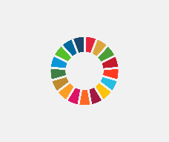
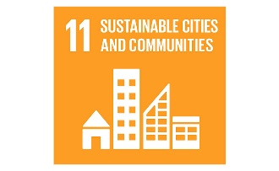
Facts & Figures

- Half of humanity – 3.5 billion people – lives in cities today
- By 2030, almost 60 per cent of the world´s population will live in urban
areas
- 95 per cent of urban expansion in the next decades will take place in
developing world
- 828 million people live in slums today and the number keeps rising
- The world´s cities occupy just 3 per cent of the Earth´s land, but account
for 60-80 per cent of energy consumption and 75 per cent of carbon
emissions
- Rapid urbanization is exerting pressure on fresh water supplies, sewage,
the living environment, and public health
- But the high density of cities can bring efficiency gains and technological
innovation while reducing resource and energy consumption

Source: https://www.slideshare.net/wyakab/the-global-un-sustainable-development-goals

THE IMPORTANCE AND INFLUENCE OF TOOLS DESIGNED FOR SEVERAL AREAS OF THE ENVIRONMENT IN THE CITIES
National policies often define the rules that affect local urban policies in terms of environmental action. National and local cities´ governments should ensure that their policy frameworks are well-aligned and work to support city-level action. As stated in the OECD report “Cities and Climate Change” (2014), local action takes place in the context of broader national frameworks that can either empower or slow down city-level action; therefore, supportive national and regional policies and incentives are required to ensure city-level initiatives have sufficient resources and potential to effect meaningful change.

Governmental/national level
In order to meet the vision of sustainable cities, the cooperation between institutions at the international, national, and local level is crucial. Also, the involvement of cities´ inhabitants and the cooperation of individual cities in creating conditions for sustainability are equally important for urban sustainability. As has been already said, high concentration of people and high-quality infrastructure planning also reduce the individual economic costs associated with the availability of a range of services.

Environmental Policy and Instruments
The principal purpose of the environmental policy is to provide a framework and guidelines for decision-making and activities at the international, national, regional, and local levels aimed at further improvements in the environmental quality as a whole and in the quality of environmental components. The environmental policy focuses on enforcement of sustainable development principles, on continuing integration of the environmental perspective into sectoral policies, and on increasing the economic efficiency and social acceptability of environmental protection programmes, projects, and activities.
Policies/programmes are very important documents which define priorities and objectives of individual environmental components. Auditors can, in the framework of their audit activities, check how reality complies with the provisions stated in these policies/programmes (compliance audit), or the efficiency, economy, and effectiveness of these policies/programmes or their components (performance audit). Taxes, charges, subsidies and other instruments are included in the INTOSAI WGEA publication “Market Based Instruments for Environmental Protection and Management”.

See also Appendix 1 Case studies – Implementation and impact of reforming the tax credit for green investments (the Netherlands, 2014), and Rehabilitation of degraded city and town areas (Poland 2016).

Local/self-governmental level
Local governments, or municipalities as management units in different policy areas and at different levels across countries, are also responsible for implementing specific policies set by national governments. In particular, they are responsible for defining local environmental and development policies and spatial planning, and for developing and managing local infrastructure. The fact is that most world population lives in urban areas, and cities are almost always governed by local governments. Cities are of great importance in the area of ​​ecological footprint, as well as they have a significant potential for using resources and for other environmental challenges. Activities on a local level can deliver direct results that are obvious to urban residents and can be an inspiration for other cities and municipalities to engage in projects aimed at urban sustainability and environmental improvement in cities. They also provide feedback to national governments on the effectiveness and benefits of nationally-based measures and policies. Cities and municipalities directly affect how infrastructure will look, they are responsible for e.g., the specific setting of waste management systems, the wastewater systems, because they finance them from their budgets.
A very interesting source of information is the platform ICLEI - Local Governments for Sustainability. The ICLEI is the leading global network of more than 1,500 cities, towns and regions committed to building a sustainable future. By helping the ICLEI Network to become sustainable, low-carbon, resilient, ecomobile, biodiverse, resource-efficient and productive, healthy and happy, with a green economy and smart infrastructure, we impact over 25% of the global urban population.
According to ICLEI, sustainable cities work towards an environmentally, socially, and economically healthy and resilient habitat for existing populations, without compromising the ability of future generations to experience the same. ICLEI provides a broad range of concrete and globally accessible tools to help cities transition to more sustainable urban management, covering the areas of urban design, eco-budgeting, urbanization, sustainability management and sustainable procurement. ICLEI advocates for cities' greater involvement in international decision making processes by representing their interests at major sustainable conferences and multilateral bodies such as UN Commission on Sustainable Development, Rio+20 and the European Commission, as well as working with our global partners including UNEP, UN-Habitat and Aalborg Commitments Network.
As an example of a municipality as a management unit in different policy areas can serve, for example, the strategic plan of Sydney: Sustainable Sydney 2030 Community Strategic Plan (2013).
Source:
https://www.cityofsydney.nsw.gov.au/__data/assets/pdf_file/0005/99977/6645_Final-version-Community-Strategic-Plan-IPR-Document_FA4-1_low-res.pdf,
Also, the project Greening Australia – Adelaide Green City project – comprises the initiatives including for example Cycling Adelaide, the Building Tune Ups Project measured the energy and water use of office buildings, Affordable Eco Housing Competition, BASEline - Businesses of Adelaide Saving Energy, Business of Sustainability, Green City Festival, Premier's Million Trees Program, Renewable Energy Virtual Display, TravelSmart, Vertical Composting Unit and others.
A lot of examples of cities’ best practice can be found in the publication “Environmental best practice & Benchmarking report” (e.g., local contribution to global climate change, local transport, sustainable land use, air pollution, production and management, consumption and waste water treatment, environmental management of the local authority).
Source:
http://ec.europa.eu/environment/europeangreencapital/wp-content/uploads/2011/06/Environmental-Best-Practice-Benchmarking-Report-Award-Cycle-2012-2013.pdf
See also Appendix 1 Case studies – Efficiency of the public funds spent for communal services (Slovakia, 2016).

ENVIRONMENTAL ASSESSMENT
Environmental assessment has many variations and is applied in diverse ways in different countries for specific projects and policies. EA is a generic term that is often used interchangeably for specific types of impact assessment, such as project-based environmental assessment or strategic-based environmental assessment.
Source: https://www.environmental-auditing.org/publication/
The Strategic Environmental Assessment (SEA) and the Environmental Impact Assessment (EIA) belong to important instruments that influence sustainable cities area. These instruments have their specific status especially in the area of cities and urban agglomerations.
SEA is a procedure to ensure that environmental effects are taken into account in decision making on policies, plans and programmes. It requires environmental impacts to be identified, assessed, mitigated and monitored. Results of SEA are to be communicated at an early stage to decision-makers and to the public, and they should be addressed alongside economic and social considerations. The purpose of SEA is to identify and consider alternative options so that plans approved can be implemented cost-effectively with lowest consequences possible on the environment.
EIA is an assessment of the possible impacts that a proposed project may have on the environment, together with considerations of the natural, social and economic aspects. It may develop further the findings from a SEA.

INDICATORS FOR MEASURING THE SUSTAINABILITY OF CITIES
According to the report “Indicators for Sustainable Cities”, urban sustainability indicators are tools that allow city planners, city managers and policymakers to gauge the socio-economic and environmental impact of, for example, current urban designs, infrastructures, policies, waste disposal systems, pollution and access to services by citizens. They allow for the diagnosis of problems and pressures, and thus the identification of areas that would profit from being addressed through good governance and science-based responses. They also allow cities to monitor the success and impact of sustainability interventions.
According to Food and Agriculture Organization of the United Nations, the important considerations for using indicators are:
- Without good data, based on monitoring, it is not possible to develop indicators.
- Performance measures imply that targets need to be set (i.e. against which performance can be compared).
- Different people living in different places have different values. Indicators must therefore be able to take into account different locations, people, cultures and institutions.
- Sets of indicators evolve over time.
- Sets of indicators are seldom, if ever, complete.
- Measurement of indicators tends to reduce uncertainty, but does not eliminate it.
- Indicators can play an important role in how human activities influence the environment. Changing the indicators will most likely also change the system.
Data availability is another important aspect to consider when selecting an indicator system.

Parameter: a property that is measured or observed.
Variable: an element, feature, or factor that is liable to vary or change
Data set: a collection of parameters that have been measured; usually the source of the specific data used by indicators.
Indicator: a parameter, or a value derived from parameters, which points to, provides information about, and/or describes the state of a phenomenon/environment/area, with a significance extending beyond that directly associated with a parameter value.
Analysis framework: a basic structure underlying a system, concept, or text, used to characterise the major issues to be monitored using indicators. Examples include the Pressure-State-Response (PSR) and the Driving forces, Pressure, State, Impact, Response (DPSIR) frameworks for environmental policies.
Index: a set of aggregated or weighted parameters or indicators.
Indicator set: an agreement that defines the overall objectives and outputs that are measured using a selection of indicators.
Source: Indicators for Sustainable Cities, European Commission, November 2015 (revised March 2018)
Another interesting tool we can mention is the Reference Framework for Sustainable Cities (RFSC), which is an online toolkit (www.rfsc.eu) for local European authorities that are involved in or are willing to start a process of integrated and sustainable urban development. The main objective of the toolkit is to enhance the dialogue within a city and with peer cities tackling the same issues all across Europe. Based on a checklist of 25 questions and a large database of indicators, the toolkit offers practical support to:
- Develop an urban strategy or project which takes into account all fields of sustainable urban development;
- Check the ongoing strategies or projects in a given city and inform about the interactions (positive or negative) of the different policy sectors;
- Monitor the progress of a strategy over a certain period of time.
Source: https://www.smartcitiesdive.com/ex/sustainablecitiescollective/what-are-best-indicators-measuring-sustainability-cities/1047756/
European Commission report also states a number of indicator tools:
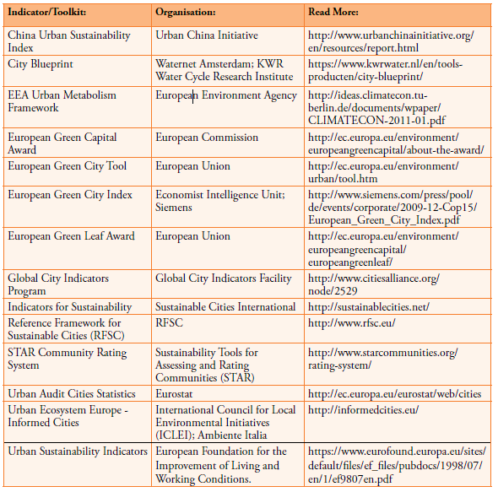
Source: Indicators for Sustainable Cities, European Commission, November 2015 (revised March 2018)
Another interesting tool for comparing the sustainability level of the cities is “The 2016 Arcadis Sustainable Cities Index” which ranks 100 global cities on three dimensions of sustainability: people, planet and profit. These represent social, environmental and economic sustainability and offer an indicative picture of the health and wealth of cities for the present and the future.
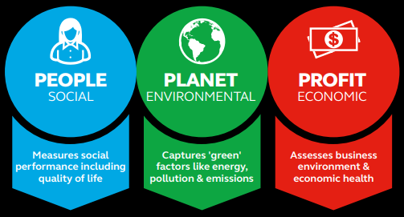
Source: https://www.weforum.org/agenda/2016/09/these-are-the-world-s-most-sustainable-cities/
The People sub-index rates health (life expectancy and obesity), education (literacy and universities), income inequality, work-life balance, the dependency ratio, crime, housing and living costs. These indicators can be broadly thought of as capturing “quality of life”.
The Planet sub-index ranks cities on energy consumption and renewable energy share, green space within cities, recycling and composting rates, greenhouse gas emissions, natural catastrophe risk, drinking water, sanitation and air pollution. These indicators can broadly be thought of as capturing “green factors”.
The Profit sub-index examines performance from a business perspective, combining measures of transport infrastructure, ease of doing business, tourism, GDP per capita, the city’s importance in global economic networks, connectivity in terms of mobile and broadband access and employment rates. These indicators can broadly be thought of as capturing “economic health”.
According to Arcardis, the research shows that cities around the world are not effectively balancing these three pillars of sustainability. Instead, many demonstrate split personalities. While taking the lead in some areas, cities often underperform in one element of sustainability which negatively impacts their overall performance.
Source:https://www.arcadis.com/media/0/6/6/%7B06687980-3179-47AD-89FD-F6AFA76EBB73%7DSustainable%20Cities%20Index%202016%20Global%20Web.pdf

CITY BIODIVERSITY INDEX (OR SINGAPORE INDEX)
Existing environmental indices for cities focus on issues such as clean water, sanitation, energy efficiency, air quality, and waste management. Current biodiversity indicators available are implemented at the national level, and while there are numerous publications and studies done on urban biodiversity, there is no single index that consolidates all these biodiversity-related indicators at the local level. In COP-9 of 2008, Singapore’s then Minister for National Development proposed for the establishment of a city biodiversity index to benchmark biodiversity conservation efforts of cities.
Hence, the National Parks Board of Singapore (NP), together with experts from various countries, assisted the Secretariat of the CBD to develop the Index. The result is the formulation of the ‘Singapore Index on Cities’ Biodiversity or ‘Singapore Index (SI)’, so named in recognition of Singapore’s contribution and leadership. This is a first self-assessment tool to help cities evaluate and benchmark their biodiversity conservation efforts.
The City Biodiversity Index, also referred to as the Singapore Index on Cities’ Biodiversity or the Singapore Index (SI), is a self-assessment tool for cities to evaluate and monitor the progress of their biodiversity conservation efforts against their own individual baselines. It comprises: a) the “Profile of the City”, which provides background information on the city; and b) the 23 indicators that measure native biodiversity, ecosystem services provided by biodiversity, and governance and management of biodiversity based on guidelines and methodology provided in the User’s Manual on the Singapore Index on Cities‘ Biodiversity.
The scoring of the Singapore Index is quantitative in nature. Each indicator is assigned a scoring range between zero and four points, with a total possible maximum score of 92 points. The year in which a city first embarks on this scoring will be taken as the baseline year, and this will be measured against future applications of the Index to chart its progress in conserving biodiversity.
Source: https://www.cbd.int/subnational/resources

Chapter 3 – Examples of good audit practice
This chapter is devoted to the results of a questionnaire survey among members of the INTOSAI WGEA and to examples of selected audits. As regards the environmental aspects of cities and urban agglomerations, the survey is based on the possibilities and types of audits as defined by the Lima Declaration. Audits in the areas of "Greening Cities" thus fulfil their role as described in the Lima Declaration. Having in mind different powers of the audit institutions in accordance with their national mandate, we present here examples of good practice that can serve as a guide and an inspiration for others. In accordance with the Lima Declaration, it is the task of the supreme audit institutions to audit the legality and regularity of financial management and of accounting. In addition to this type of audit, which retains its significance, there is another equally important type of audit - performance audit - which is oriented towards examining the performance, economy, efficiency, and effectiveness of public administration. The SAI's audit objectives - legality, regularity, economy, efficiency and effectiveness of financial management - basically are of equal importance. However, it is for each Supreme Audit Institution to determine its priorities on a case-by-case basis.
We respect that the SAIs have different audit powers at the local level. This is in accordance with the Lima Declaration (Section 18) “The basic audit powers of Supreme Audit Institutions shall be embodied in the Constitution; details may be laid down in legislation.” Based on the analysis of the answers in the questionnaire survey, roughly a quarter of the responding SAIs do not have the mandate to audit local governments.

RESULTS OF THE SURVEY
In cooperation with the INTOSAI WGEA secretariat (SAI Indonesia), a survey on Greening Cities had been sent to all members of the INTOSAI WGEA (78 members). We received 44 completed surveys, which represented 56% of all respondents.
The questionnaire survey asked about:
1a) Are environmental issues related to sustainable cities significant for your SAI from the auditor's point of view? (no; rather no; yes; rather yes; other)
1b) Classify challenges/problems related to the environment and to the topic “Greening cities/sustainable cities” which you consider as the most important in your country.
(air quality; increased noise; waste management; infrastructure for sewage systems; drinking water supplies; transportation; green infrastructure, other)
2) Classify instruments used to influence the topic "Greening Cities/sustainable cities" which you consider as the most important in your country. (international accords, strategies; national legislation; key national policies, programmes or instruments; local governmental programmes and instruments; market based instruments; other)
3) Has your SAI completed (or is it currently working on) any audits in the last five years that addressed some individual environmental components such as air quality, water protection, waste management, ecosystem services & green infrastructure, air quality, increased noise, or infrastructure for sewage systems, etc., and at the same time related to the topic "Greening cities/sustainable cities"?
4) For SAIs that answer yes to question 3: What challenges, if any, has your SAI experienced when auditing issues related to the topic “Greening cities/sustainable cities”? Do you have any obstacles that prevent your SAI from auditing these areas? If yes, please explain.
5) Generally, are you able to audit local authorities, regional governments, districts, provinces etc.? If yes, please give more details.
The following facts can be inferred from the questionnaire survey:
I. Participation in the questionnaire survey from a geographic point of view:
CONTINENT | NUMBER OF SAIs
AFRICA | 6
NORTH AMERICA | 6
SOUTH AMERICA | 3
ASIA | 12
EUROPE | 14
OCEANIA | 3
TOTAL | 44
A total of 44 countries from all continents participated in the survey. The list of these countries is given below:
AFRICA: Cameroon, Lesotho, Morocco, Sierra Leone, Tanzania, Zambia; NORTH AMERICA: Canada, Costa Rica, Ecuador, Guatemala, Mexico, USA; SOUTH AMERICA: Brazil, Paraguay, Peru; ASIA: Afghanistan, Bahrain, China, India, Indonesia, Kazakhstan, Jordan, Kuwait, Pakistan, Philippines, Sri Lanka, Thailand; EUROPE: Albania, Bulgaria, Croatia, Czech Republic, Denmark, Estonia, France, Greece, Latvia, Lithuania, Malta, Portugal, Slovakia, Sweden; OCEANIA: Australia, Fiji, New Zealand.
II. Significance of “Environmental issues related to sustainable cities”
Significance | Index | Rank | No. of submitted questionnaires | No. of involved/relevant questionnaires
No | 0 | 0 | 44 | 43
Rather No | 3 | 3
Rather Yes | 13 | 2
Yes | 26 | 1
* One member used “other”: “The auditor's point of view is not relevant”
Of 43 of relevant answers, 26 countries (60 %) stated that the environment in relation to the sustainability of cities was important to them, and 13 countries (30 %) said that the area was rather significant, which means that 90 % of respondents (audit institutions) consider carrying out environmental audits on urban sustainability as important.
III. The most important challenges/problems related to the environment and to the topic “Greening cities/sustainable cities “.
1. Worldwide results
Challenges/Problems | Index | Rank | No. of submitted questionnaires | No. of involved/relevant questionnaires
Waste Management | 2,16 | 1 | 44 | 43
Air Quality | 2,77 | 2
Drinking Water Supplies | 2,88 | 3
Transportation | 3,12 | 4
Infrastructure of Sewage Systems | 3,12 | 4
Green Infrastructure | 4,21 | 6
Increased Noise | 4,84 | 7
When evaluating all relevant questionnaires regardless of continental representation (economic and social differences between countries and continents), it follows from the questionnaire survey that the most important environmental issues related to urban sustainability are waste management and air quality. Significance is also attributed to the infrastructure of sewage systems, drinking water supplies, and transportation.
IV. Most important instruments used to influence the topic "Greening Cities/sustainable cities"
The questionnaire survey shows that according to 27 audit institutions (i.e., 64 % of the 42 relevant questionnaires), national legislation has the most significant influence on the Greening Cities topic in the countries concerned. Key national policies, programmes and other national instruments together with programmes and instruments of local governments also have a significant impact. On the contrary, according to the surveyed audit institutions, the market based instruments are the least significant (5th place was reported by 19 respondents, i.e., 45 %)

Instruments | Index | Rank | No. of submitted questionnaires | No. of involved/relevant questionnaires
National Legislation | 1,48 | 1 | 44 | 42
Key National Policies, Programmes or Instruments | 2,12 | 2
Local Governmental Programmes and Instruments | 2,62 | 3
International Accords, Strategies | 2,86 | 4
Market Based Instruments | 3,50 | 5

V. Audits, challenges, obstacles and competence to audit Cities
(In the questionnaire survey was required that individual countries inform about their audits that have been carried out over the last five years and where have been addressed some individual environmental components such as air quality, water protection, waste management, ecosystem services & green infrastructure, air quality, increased noise, or infrastructure for sewage systems, etc., and which have been related to the topic “Greening cities/sustainable cities”)
A) Audits
According to the questionnaire survey, most countries (34) have recently carried out or are carrying out now an environmental audit focused on urban sustainability. Only 10 audit institutions said that they had not carried such an audit yet.
B) Challenges & Obstacles
26 audit institutions that are experienced in auditing of this topic have defined the challenges related to audits of sustainability of cities, and at the same time, 16 countries have defined obstacles which, according to their audit experience, may occur. A complete list of the challenges and obstacles is provided in the appendix of the evaluation. Below are the most frequently mentioned challenges and obstacles:

Challenges
- Lack of knowledge and information, e. g.:
- some environmental topics need special expertise to understand & audit;
- lack of information necessary for evaluation and some criteria to be relied upon;
- limited knowledge that auditors possess on the given topic.
- Education (technical terms etc.) and number of employees:
- education needed;
- learning has been provided for auditors;
- lots of reading and understanding of technical terms;
- limited number of personnel to do the audit;
- limited availability of independent experts to support audit findings.
Obstacles
- Lack of knowledge;
- Limited number of personnel to do the audit of employees;
- Limited financial and human resources;
- Insufficient amount of technical staff education needed;
- Some environmental topics need special expertise to understand & audit;
- Data availability, relevant records or data are usually not captured or not readily available;
- Mandate or competence;
- Lack of cooperation of the auditees.
C) Mandate or Competence
The survey results show that approximately one quarter of respondents (10 of 44) does not have competences (mandate) to audit local authorities, regional governments, districts, provinces etc., and 8 of them has a limited mandate to do such an audit (exceptions of circumstances).
For more information, see Appendix 2.

CASE STUDIES
The purpose of this part is to gather qualitative information about best practices and knowledge of the INTOSAI WGEA community in auditing greening cities issues, methodology, challenges related to performing such an audit, and audit findings. The aim of this study is to give examples of best practices and disseminate the audit work of other SAIs in this area.
This appendix includes case studies from environmental and other audits of SAIs from all over the world which covered cities or urban agglomerations. The case studies cover different topics and different attitudes to demonstrate how various area can be audited within the central theme of greening cities.
The appendix presents 17 case studies – each one from the audits related to the topic greening cities – sustainable urban development. These case studies are examples from all over the world (Australia, Canada, China, the Czech Republic, European Court of Auditors, India, Indonesia, Latvia, Mexico, the Netherlands, Paraguay, Poland, Sierra Leone, Slovakia, Sweden and the USA) and contain information on country and year of the publication, type of the audit, audit objective, scope, audit criteria, methods used, findings and recommendations including the source where you can find the whole text or summary from the respective audit. 15 out of 17 audits were performance audits, 1 financial and performance audit and 1 compliance audit.
The case studies include the following topics:
• Smart grid, Smart city program;
• Liveable Cities Program;
• Sustainable municipal infrastructure;
• Energy savings and energy vehicles;
• Support of the air quality improvement;
• Effectiveness of public urban transport projects;
• Environmental degradation;
• Effectiveness of spatial planning;
• Municipal waste management system;
• Environmental pollution;
• Tax credit for green investments;
• Care of air quality;
• Rehabilitation of degraded city and town areas;
• Management of municipal solid waste;
• Communal services;
• The state´s contaminated areas;
• Stormwater management.

Country | Title of the audit
Australia | Administration of the Smart grid, Smart city program
Australia | Design and implementation of the Liveable Cities Program
Canada | Federal support for sustainable municipal infrastructure
China | Case on Green City Audit
Czech Republic | Funds earmarked for the support of the air quality improvement
European Court of Auditors | Effectiveness of EU-supported public urban transport projects
India | Performance Audit of Environmental degradation in the greater Guwahati area with special emphasis on the role of the Pollution Control Board (PCBA), Assam
Indonesia | Effectiveness of implementation of spatial planning on the Spatial Planning Agency and other relevant institutions in Jakarta
Latvia | Compliance of municipal waste management system with the intended objectives and regulatory enactments
Mexico | Environmental Pollution
Netherlands | Implementation and impact of reforming the tax credit for green investments
Paraguay | Special examination to the municipalities of Asunción, Lambaré, Fernando de la Mora, San Lorenzo, Luque (local governments), the Secretary of the Environment and the general Directorate of Environmental Health of the Ministry of Public Health and Social Welfare, regarding the Control that those institutions carry out care of air quality
Poland | Rehabilitation of degraded city and town areas
Sierra Leone | Management of municipal solid waste – case study on selected local councils
Slovakia | Efficiency of the public funds spent for communal services
Sweden | The State´s contaminated areas
USA | Stormwater management  EPA Pilot Project to Increase Use of Green Infrastructure Could Benefit from Documenting Collaborative Agreements

Some countries did not carry out a national audit of this issue, but they gathered existing information and gave an overview of national or public policies and practices, and their assessment.
ESTONIA:
Activities of the state upon protecting groundwater, 2018
http://www.riigikontroll.ee/DesktopModules/DigiDetail/FileDownloader.aspx?FileId=14160&AuditId=2455
Activity of the state and local governments in the collection and recovery of municipal waste, 2016
http://www.riigikontroll.ee/DesktopModules/DigiDetail/FileDownloader.aspx?FileId=13943&AuditId=2417
Sustainability of the state developed drinking water and waste water infrastructure and its impact on achieving environmental goals, 2013
http://www.riigikontroll.eeEST: /DesktopModules/DigiDetail/FileDownloader.aspx?FileId=12976&AuditId=2309
FRANCE:
Public policies for the prevention of air pollution, 2014
https://www.ccomptes.fr/fr/publications/les-politiques-publiques-de-lutte-contre-la-pollution-de-lair
UNITED KINGDOM:
Publication: How European cities achieve renaissance
Research on how seven European cities or regions are tackling regeneration and bringing sustainable growth and renewal to local communities. Creating sustainable communities and neighbourhoods requires integrated action across a range of different sectors – transport, housing, green space, health, leisure, employment and skills.
The purpose of the publication was to illustrate from across a range of different European contexts how successful regeneration has been delivered. There have been drawn out critical factors in each case study that helped to bring about success. The publication was created as a companion piece to report “Thames Gateway: Laying the Foundations”.
https://www.nao.org.uk/wp-content/uploads/2013/02/EU_Cities_Renaissance.pdf

Based on the questionnaire survey and on the basis of the overall assessment of the “Greening Cities” concept considered, SAIs are concerned with environmental audits. Among other things, due to the implementation of SDGs' national targets, the next challenge will be to evaluate and perform audits of selected environmental components in cities and urban agglomerations. The basic role of SAI's activity remains at the national system level, because governments set rules through legislation, strategies, programs, and through specific tools and measures.

APPENDIX 1 – CASE STUDIES

Title | Administration of the Smart grid, Smart city program
Country and year of publication | Australia, 2014
Type of audit | Performance audit
Audit objective | The objective of the audit was to assess the effectiveness of the administration of the Smart Grid, Smart City Program, including the establishment, implementation and ongoing management of the program.
Audit scope | The audit focused on the implementation of the Smart Grid, Smart City Program by the responsible departments (Department of the Environment and the Department of Industry). It did not include a technical assessment of the various projects implemented under the funding agreement. Broader issues associated with smart grids and smart meters, such as potential advantages or disadvantages of time-of-use pricing regimes, or any health and safety concerns that may be associated with smart meters were also not examined.
Audit criteria | The criteria used by the ANAO to address the objective examined the:  - program’s design and establishment, including governance and oversight arrangements;  - grant assessment process to select the provider for the program;  - negotiation and management of the funding agreement; and  - monitoring, reporting and evaluation arrangements put in place to determine the extent to which the program has achieved its objectives.
Methods used | In undertaking the audit, the ANAO:  - reviewed departmental files and program documentation;  - interviewed departmental staff, Ausgrid and other relevant stakeholders, including consumers participating in the Smart Grid, Smart City Program;  - reviewed key program projects, including the retail trial, to determine the extent to which the program objectives had been achieved; and  - conducted site visits to implementation areas for the Smart Grid, Smart City Program in Sydney, Newcastle and the Upper Hunter Valley.
Findings | - Overall, the administering departments established appropriate arrangements to support the implementation of the Smart Grid, Smart City Program. The commissioning and completion of a pre-deployment study, coupled with the engagement of a broad range of stakeholders, informed the design of the program, while oversight arrangements, including an interdepartmental Steering Committee guided the program’s implementation. In addition, the arrangements established to manage the Smart Grid, Smart City funding agreement, including a structured reporting framework to underpin grant payments, enabled the department to monitor whether project milestones were being met and projects were delivered to the required standard.  - There was, however, scope for improvement in several areas of the departments’ administration of the program, including: aspects of the grant assessment and selection process, including probity arrangements; and the measurement and reporting of program performance.  - While the grant assessment and selection process involved three levels of review undertaken by the then Department of the Environment, Water, Heritage and the Arts (DEWHA), an Expert Panel and an Independent Assessment Panel, there was scope for aspects of the process to be strengthened to enhance transparency and accountability. In particular, it was not evident from departmental records that the Independent Assessment Panel had assessed each applicant against the five published merit criteria. The Chair of the Independent Assessment Panel and the Department of the Environment informed the ANAO that each panel member did conduct an assessment of each application against the published merit criteria, with the assessments subsequently used to rank applicants. However, these assessments have not been retained and the assessment report of the panel did not clearly set out this process.  - Probity processes help to ensure that grant assessment and selection processes are transparent and accountable. While DEWHA sought probity advice on aspects of the grant assessment and selection process, overall, the probity arrangements established for the process were not in keeping with those expected for a grant of this scale and complexity. Given the scale of the program and the involvement of independent assessors, there would have been merit in the department: preparing a probity plan; requiring the probity adviser to attend assessment panel meetings; and reviewing the panel’s selection report to confirm that the assessment process undertaken aligned with the published program guidelines and that any identified conflicts of interest had been appropriately managed.  - Over the course of the program’s implementation, the departments have provided information on the progress of various program activities through a range of communication channels, such as stakeholder meetings, program seminars, presentations to conferences and the publication of Ausgrid reports. This information has not, however, specifically addressed the extent to which the program’s objectives are being achieved. Developing and reporting against an appropriate set of outcome-focused key performance indicators would have better: informed the department’s senior managers, Parliament and other stakeholders about the progress being made towards achieving the program’s objectives; and supported the planned program evaluation.
Recommendation | To enhance program performance reporting, both internally and to external stakeholders, the ANAO recommends that the Department of Industry:  - develop relevant, reliable and complete key performance indicators; and  - report against established indicators on the extent to which the program’s objectives and outcomes are being achieved.  - To improve accountability and transparency in grants administration, the ANAO recommends that the Department of the Environment reinforces the importance of:  - implementing probity arrangements that are proportionate to the complexity and risks of grant programs; and  - retaining documentation to appropriately evidence grant assessment and selection processes.
Source URL | https://www.anao.gov.au/work/performance-audit/administration-smart-grid-smart-city-program

Title | Design and implementation of the Liveable Cities Program
Country and year of publication | Australia, 2013
Type of audit | Performance audit
Audit objective | The objective of the audit was to assess the effectiveness of the design and implementation of the Liveable Cities Program (LCP), including the assessment and approval of applications.
Audit scope | The audit covered the key program elements of the LCP, from the planning phase of the program through to the finalisation of agreements with successful applicants. The program was administered by the Department of Infrastructure and Transport.
Audit criteria | The audit examined whether the:  - design, implementation and administration of the program reflected lessons learned from previous audits and the requirements of the Commonwealth’s grants administration framework;  - business practices of the department met policy and legislative requirements, as well as accountability responsibilities;  - assessment of applications and the selection of funding recipients was undertaken in accordance with the published program guidelines and was consistent with the seven key principles for grants administration set out in the Commonwealth Grant Guidelines (CGGs);  - departmental advice to the grant approver was complete and in accordance with the CGGs; and  - funding agreements, project agreements and program monitoring arrangements were appropriate for effective ongoing management.
Methods used | The audit methodology included:  - examining departmental records on the design and implementation of the program, including: the program planning and review documents; applications received, Infrastructure’s assessment of applications and feedback provided to unsuccessful applicants; and advice provided to the Minister and the records of his decisions as funding approver;  - examining the approaches adopted by the department for delivering the program against relevant findings and recommendations from JCPAA reviews and previous ANAO audits; and  - discussions with relevant departmental staff.
Findings | - Infrastructure’s management of the design and implementation of LCP was effective in most respects. Of note was that improvements were evident in the merit‐assessment approach adopted by the department compared with earlier grant programs audited by ANAO. In particular:  - all eligible applications were assessed against published assessment criteria; and  - the scoring approach adopted enabled the comparison of the relative merits of applications against each criterion and in aggregate.  - Infrastructure also adopted an improved approach to briefing the Minister on the outcome of the assessment process. The LCP briefing included a clear funding recommendation to the Minister based on the scores awarded against the assessment criteria and in consideration of the program objectives. In addition, a record was kept of the eight instances where the Minister’s decision diverged from the recommendation of the department—three projects not recommended by Infrastructure were approved by the Minister, and five projects recommended by the department were not approved for funding. This approach provides transparency and accountability for the advice given by Infrastructure, and the funding decisions that were subsequently taken.  - However, there remain opportunities for further improvements to Infrastructure’s grants administration practices. Firstly, there were shortcomings with the assessment of applications in relation to the department’s eligibility checking and aspects of its conduct of the merit‐assessment process. Secondly, it needs to be recognised that applications that are assessed as not satisfactorily meeting the published merit assessment criteria are most unlikely to represent value for money in the context of the program objectives.  - In addition, an evaluation strategy was not developed at the outset of the program and remained outstanding as at May 2013, notwithstanding that most funding agreements had been signed by then and the program was nearly two years into its three-year duration. Such a situation will have an adverse effect on the quality of advice to Ministers on any proposal to provide further funding to the program or to a similar program, as well as in assessing the contribution the program has made to the objectives of the National Urban Policy.  - As indicated, this audit of the LCP has identified improvements in key aspects of Infrastructure’s grants administration practices, which should be embedded in all grant programs within the department.
Recommendation | The ANAO has made three recommendations to address the further opportunities for improvement mentioned above relating to:  - enhancing the assessment of eligible applications, by clearly and consistently establishing benchmarks for scoring against assessment criteria and a minimum score an application is required to satisfy for each criterion in order for an application to be considered for possible recommendation;  - recording the value for money offered by each proposal under consideration, having regard to the published program objectives and assessment criteria; and  - developing an evaluation strategy during the design of a program.
Source URL | https://www.anao.gov.au/work/performance-audit/design-and-implementation-liveable-cities-program

Title | Federal support for sustainable municipal infrastructure
Country and year of publication | Canada, 2016
Type of audit | Performance audit
Audit objective | The overall objective was to determine whether Infrastructure Canada and the Federation of Canadian Municipalities managed two key programs designed to support sustainable communities to achieve their objectives, and whether Infrastructure Canada adequately coordinated the set of programs.
Audit scope | Infrastructure Canada  Federation of Canadian Municipalities  2015-2016  Audit of the federal government´s programmes with an impact on Canadian cities
Audit criteria | - Infrastructure Canada, working with others, is managing the Gas Tax Fund Transfer Payment Program in accordance with key federal policies and relevant agreements.  - Infrastructure Canada can demonstrate that the Gas Tax Fund Transfer Payment Program is meeting the Fund’s objectives.  - The Federation of Canadian Municipalities, with the support of Environment and Climate Change Canada and Natural Resources Canada, can demonstrate that the Green Municipal Fund is meeting the Fund’s objectives.  - Infrastructure Canada has adequate information for decision making on the infrastructure and financing needs of Canadian communities, and the sustainability challenges they face.  - Infrastructure Canada, working in collaboration with others, is ensuring that federal funding is adequately coordinated for municipal infrastructure to improve the environmental performance and the sustainability of Canadian communities.  - Infrastructure Canada, working in collaboration with others, is managing the key federal programs under its responsibility that support municipal infrastructure in a way that mitigates the environmental and financial sustainability risks.
Methods used | - Interviews with officials from audited organizations and with stakeholders.  - Examination of selected project files and databases used for tracking performance information.  - Online survey distributed to all signatories of funding agreements to obtain their views on aspects of the management of the Fund.
Findings | - Infrastructure Canada was not adequately managing the Gas Tax Fund to achieve the Fund’s environmental objectives, and the Department was not adequately coordinating the key federal infrastructure programs under its responsibility that were intended to improve the environmental performance and sustainability of Canadian communities. We also concluded that the Federation of Canadian Municipalities was managing the Green Municipal Fund to achieve part of the Fund’s purpose, but how it was seeking to lever its investments in municipal environmental projects remained to be better defined.  - Overall, we found that although billions of dollars have been allocated to programs with objectives to improve environmental sustainability, Canadians do not have a consolidated national picture of the extent to which these objectives have been achieved. We also found that Infrastructure Canada did not adequately consider environmental risks, such as climate change, in its program and project decisions.  - Without a long-term federal vision that is based on reliable information about the condition of Canada’s infrastructure, and without clear objectives, priorities, and performance measures, Canadians will not know what results to expect from the billions spent on infrastructure through federal programs or how well those programs are working to make communities sustainable for future generations.
Recommendation | - Infrastructure Canada should work with the agreement signatories to develop an effective performance measurement strategy so that it has the information it needs to determine whether the objectives of the Gas Tax Fund have been achieved and to take corrective action when necessary. Infrastructure Canada should use this information to report on Gas Tax Fund outcomes to Parliament and the Canadian public.  - The Federation of Canadian Municipalities, in consultation with the Green Municipal Fund Council (which includes Natural Resources Canada and Environment and Climate Change Canada as members), should develop specific objectives, performance targets, and indicators for levering its investments in municipal environmental projects.  - Natural Resources Canada, Environment and Climate Change Canada, and the Federation of Canadian Municipalities should review the terms and conditions in the funding agreement for the Green Municipal Fund and revise them as needed to address the financial sustainability concerns about the Fund. These parties should consider including a requirement for a regular review of the agreement so that it continues to support Fund objectives.
Source URL | http://www.oag-bvg.gc.ca/internet/English/parl_cesd_201605_01_e_41380.html

Title | Case on Green City Audit
Country and year of publication | China, 2017
Type of audit | Performance audit
Audit objective | From 2016 to 2017, CNAO carried out audits for administration and utilization of key funds earmarked for energy saving and environmental protection across 18 provinces, including subsidies for new energy vehicles, incentive funds for existing energy-saving buildings and incentive funds for comprehensive demonstration of fiscal policies for energy saving and emission reduction.
Audit scope | - Implementation and performance of new energy vehicles promotion.  - Implementation and performance of building energy saving.  - Implementation and performance of comprehensive demonstration for fiscal policy on energy saving and emission reduction.
Audit criteria | - Law  - Regulations
Methods used | - Document review  - Survey  - Spot check
Findings | - The number of promoted new energy vehicles witnessed a steady increase: The audited 18 provinces cumulatively promoted 405,100 new energy vehicles and built 128,000 charging piles, which completed 121.65% and 151.66% of the planned quantities, respectively.  - The excessively-high subsidy criteria were developed for some new energy vehicle models: For the purpose of improving local air quality and accelerating the promotion of new energy vehicles, some regions offered relatively high subsidies to new energy vehicles sold locally.  - A few new energy vehicles are idled after purchase. Due to the lagging infrastructure construction in some cities, the lease and possession quantity of the existing new energy vehicles that exceed the market demand, and the blind purchase of new energy vehicles at low real costs, the new energy vehicles purchased by a few companies are idled.  - Energy-saving reconstruction of some existing building failed to fully bear fruits with satisfying benefits: Due to the imperfect operation mechanism of heating charging and the difficulty in achieving fair charging resulting from different heat consumptions of users at different locations in the same building, heating metering failed to advance at fast pace. Buildings (with total area of over 300 million square meters) failed to launch household-based heating metering, while the heat metering installations were left unused or underutilized.  - Some public building energy consumption monitoring platforms underperformed: The buildings covered by provincial-level public building energy monitoring platforms in three provinces fell short of the required quantity. In-service monitoring platforms monitored 543 public buildings in three provinces, but 246 monitoring points were dwarfed by the missing and inauthentic monitoring data.  - Slow progress were made in some projects: Due to the changes in construction sites, inadequate construction of auxiliary projects and insufficient self-financing funds, by the end of 2016, 17 projects of six demonstration cities participating in comprehensive demonstration for fiscal policies on energy saving and emission reduction didn’t commence on schedule, while 102 projects failed to be completed on schedule.
Recommendation | - The new energy vehicles subsidy criteria should be adjusted in view of actual situations.  - Greater efforts should be made for the construction of auxiliary projects, such as charging facilities.  - It is necessary to strengthen project supervision and intensify monitoring capacity building.
Source URL | Not available

Title | Funds earmarked for the support of the air quality improvement
Country and year of publication | The Czech Republic, 2019
Type of audit | Performance audit
Audit objective | The main objective of the audit was to examine the provision and use of funds spent to support the improvement of air quality and to verify whether these funds contribute to improving air quality in the Czech Republic.
Audit scope | - The Ministry of the Environment of the Czech Republic (hereinafter referred to as “MOE”), the State Environmental Fund of the Czech Republic (hereinafter referred to as “SEF”), the Czech Hydrometeorological Institute (hereinafter referred to as “CHMI”), 4 selected regional governments, 8 selected companies (mainly projects carried out by key air polluters).  - Audit period: 2015 – 2017.  - The audit focused on European and national funding of the air quality improvement in the Czech Republic. The aim of the audit was to verify whether the established measures and funds contribute to improving the air quality in the Czech Republic (if there are effective).
Audit criteria | The selection criteria were: progress of the projects, project costs, project type and planned implementation dates, established indicators.  - The main audit question:  - Are the measures taken to support the improvement of air quality (run by the Ministry of the Environment and financed by European or national funds) effective?  - Subquestions:  - Are the measures to promote the improvement of air quality in the Czech Republic contributing to reducing the level of pollution at least at the level required by the Air Protection Act?  - Do financial funds aimed to raise air quality help eliminate the level of air pollution in the Czech Republic?  - Criteria sources: strategic documents, National Emission Reduction Programme, selected air quality improvement programmes, available statistics including international comparison, e.g. data published by CHMI or by the European Environment Agency, the amount of the support taking into account the period, project topics and the relevant legislation.
Methods used | - Interviews with officials from audited organizations and with stakeholders;  - Examination of selected project files and databases used for tracking performance information;  - Answering of the audit questions;  - Programme documents;  - Audit of the fulfilment of the objectives and purposes of the projects;  - Audit of the project implementation;  - Document analysis, content analysis.
Findings | - Strict absolute emission values for 2020 will be difficult to meet. The Czech Republic has set its own emission reduction targets in the National Emission Reduction Programme of the Czech Republic, the so-called Non-Exceeding national emissions for 2020. In the case of the reduction of fine particle emissions, a reduction of 12% was achieved between 2005 and 2016; to meet the national commitment it would be necessary to reduce the emissions of fine particles by 42% between 2016 and 2020. However, the rate and level of emissions reduction of pollutants into the air in recent years is gradually declining or stagnating.  - The measures taken to improve air quality are not sufficiently and timely fulfilled:  - Total of 7 of the 23 priority measures of the National Emission Reduction Programme was not met within the required deadline or until the end of the audit.  - Another 6 out of 23 priority measures of the National Emission Reduction Programme are implemented on an ongoing basis, but there are significant risks of failure to implement these measures in a timely manner and to the required extent.  - According to the ongoing evaluations of the implementation of the measures of the Air Quality Improvement Programmes, the measures in particular in the transport sector are insufficient. Their implementation has been very limited, especially in the field of transport infrastructure.  - The Ministry of the Environment is not able to perform adequately and conclusively the evaluation of the fulfilment of the measures stipulated in the Air Quality Improvement Programme, as it does not have an effective system set up for the timely collection of data and information.  - There is a risk that the Czech Republic has not met the objective of reducing exposure to fine particles. The text of the EU Directive is not entirely clear as concerns urban background stations and which data should be evaluated. The chosen methodology influences the resulting value of this indicator for the Czech Republic in individual years, including the target year 2015.  - The CHMI does not have the current concept of the State Immission Monitoring Network (hereinafter referred to as "SSIM"). Although SSIM meets the minimum requirements for the number of measuring stations resulting from European and national regulations, the non-conceptual approach to SSIM development entails the risk of failing to reduce the uncertainty of spatial interpretation of air pollution data from 35% in 2011 to 30% in 2023.  - The SEF does not monitor and evaluate the economy, efficiency and effectiveness of funds that are used to support the improvement of air quality from national funds. The SEF did not set quantifiable and measurable targets in the basic documents, which would be a basic prerequisite for the evaluation of implemented projects and the whole programme. The SEF thus does not evaluate the real benefits, impacts and results of individual priority areas or individual announced calls for improvement of air quality in the Czech Republic. In the framework of the audit of the implementation of selected projects, shortcomings related to the award of public contracts were identified.  - No entity from the Czech Republic submitted a project for the LIFE programme support coordinated by the European Commission in the years 2014 to 2016, focusing on air quality and emissions, even if the programme settings enabled it.
Recommendation | Given the significant impact of cross-border transmission on air pollution levels in the Czech Republic and Poland, the Ministry of the Environment should conduct cross-border consultations with Poland in the preparation of the national air pollution control programme.
Source

Title | Effectiveness of EU-supported public urban transport projects
Country and year of publication | European Court of Auditors, 2014
Type of audit | Performance audit
Audit objective | The main objective of this performance audit was to assess the implementation and effectiveness of public urban transport projects co‑financed by EU structural funds.
Audit scope | The audit covered a sample of 26 projects co-financed by the ERDF or the CF during the 2000–06 and 2007–13 programming periods. The selected projects are located in 11 cities in five Member States — Spain, France, Italy, Poland and Portugal. The EU funding allocated to urban transport in these five countries (5,3 billion euro) represents 50 % of the total EU funding (10,7 billion euro). The sample includes projects that consisted of creating, extending or modernising railways (three), metros (eight), light metros (four), trams (six) and one bus project. They range from a single line or a simple section to a whole network. The sample also includes four smaller IT projects relating to operating, information or ticketing systems.
Audit criteria | The selection criteria were: project cost, project type and planned implementation dates.
Methods used | The Court addressed the following questions:  - Were the projects implemented as planned in the grant applications?  - Did the services provided by the projects meet user needs?  - Did the projects achieve their objectives in terms of utilisation?
Findings | - In general, infrastructure and vehicles for most projects were implemented in accordance with  - project specifications. Significant delays affected four urban transport projects and three projects had significant cost overruns.  - Once completed, almost all the projects audited met users’ needs.  - However, a comparison between planned use at specific dates and actual use shows that two thirds of the projects were underutilised.  - This implies underperformance in terms of economic and social benefits (reductions in pollution and congestion etc.) which is generally not followed up by the promoters or the national authorities.  - It may also imply financial imbalances for the public authorities that have to ensure the sustainability of the urban transport concerned.  - The underutilisation of public transport is mainly due to weaknesses in project design and mobility policy. Several could have been addressed at the project planning stage.
Recommendation | The Court recommends that the Commission should:  - for projects subject to its approval, require that management tools will be put in place to monitor the quality of the service and the level of user satisfaction once the project is operational;  - for projects subject to its approval, require that a minimum number of result indicators with related targets are included in the grant agreements and are subsequently measured;  - for projects subject to its approval, require that the estimation of the number of expected users is more rigorously analysed and that the choice of the mode of transport is supported by a quantified comparison of different transport options;  - for projects subject to its approval, require that urban transport projects are included in a sound mobility policy;  - require that the aspects mentioned under points (a) to (d) are also addressed by the Member States’ authorities when managing EU‑funded urban transport projects.
Source URL | https://www.eca.europa.eu/Lists/ECADocuments/SR14_01/QJAB14001ENC.pdf

Title | Performance Audit of Environmental degradation in the greater Guwahati area with special emphasis on the role of the Pollution Control Board (PCBA), Assam
Country and year of publication | India, 2016
Type of audit | Performance audit
Audit objective | To ensure whether:  - PCBA and concerned stakeholders complied with all acts, rules, government policies and instructions for prevention, control and abatement of pollution.  - Effective mechanism was in place in the Government organisations and private entities, involved in prevention, control and abatement of pollution, to ensure that adverse impact of their processes and activities on the environment was minimised.  - There was periodical analysis of the impact of environmental degradation and remedial measures to overcome it were being implemented.
Audit scope | 2010-2015, the Environment and Forest Department, the offices of the Pollution Control Board, Guwahati Municipal Corporation (GHC) and other offices.
Audit criteria | - All related acts, rules like the Water Act, the Air Act, the Environment Act, the Motor Vehicles Act, the Municipal Solid Waste Rules, the Hazardous Waste Rules, the Plastic Waste Rules, the Batteries Rules, the Forest Rules, the e-waste Rules, the Wild Life Protection Act, the National Environment Policy, the Biological Diversity Act, the Wetlands rules, the Guwahati Water Bodies Act, the Ramsar Convention.  - Orders, instructions, guidelines, standards issued by Government, Central Pollution Control Board (CPCB), etc.
Methods used | - Collection of data through document analysis, response to audit queries, questionnaires, joint physical verifications, joint collection of samples and photographical evidence.  - An advertisement was put out in the local newspapers and the website of the office of the Accountant General calling for public comments on the subject.
Findings | - Although that the PCBA was not short of funds, it had not fulfilled its role effectively. Instead of focusing on strengthening its technical manpower for carrying out the essential inspection of industrial establishments and scientific analysis of air and water samples, the PCBA had a disproportionately large nontechnical staff which resulted in huge arrears in mandatory inspections.  - Use-based categorisation of water for identification of various water bodies had not been done leading to risk of using unsuitable water bodies for drinking water.  - The dissolved oxygen, bio-chemical oxygen demand and total coliform levels in the Bharalu river were far beyond the stipulated criteria indicating severe organic pollution and the river had reached a stage where no aquatic organism can survive. Although this river has been categorised among 35 most polluted river stretches in the country, the Pollution Control Board, Assam had failed to prepare a Report and Action Plan as directed by the CPCB.  - There was no sewage treatment plant in the entire state of Assam.  - Pollution Under Control certificates were issued on the verbal request of vehicle owners without physical presence of vehicles.  - Even after 14 years of the enactment of the Municipal Solid Waste Rules stipulating for authorisation by the State Pollution Control Board for creating a landfill, the Guwahati Municipal Corporation had not obtained such approval from the PCBA for the municipal solid waste landfill in Boragaon.  - Out of 243 hazardous waste generating industries, 185 industries (76 %) were functioning without obtaining authorisation from the PCBA.  - There were 15 unregistered plastic manufacturing/recycling units, but the PCBA had not taken any action against them.
Recommendation | Water pollution:  - The PCBA should prepare a time-bound action plan for use-based classification of surface water.  - Monitoring of water on all the parameters identified by the CPCB should be taken up on priority in order to have a proper assessment and reliable  - database of the quality of water.  - Action should be taken timely on defaulters.  Air pollution:  - The PCBA should establish adequate air quality monitoring stations especially in eco-sensitive and commercial areas and monitor all parameters as prescribed.  - Functioning of vehicular pollution emission testing centres should be reviewed and strengthen in co-ordination with the transport Department. The testing centres should be regularly monitored and strict action initiated against agencies issuing inaccurate Pollution Under Control Certificates.  Municipal solid waste (MSW):  - The PCBA should ensure that GMC obtains proper authorisation from them for management of MSW.  - Awareness Campaigns should be initiated by the PCBA in schools and media to ensure that the general public is sensitised regarding scientific disposal of domestic waste.  Bio medical waste:  - The Government must ensure that no Health Care Establishments, Veterinary Institutions and Animal Houses operate without authorisation of the PCBA so that the lives and health of humans and animals are not endangered.  - The PCBA should take penal action against the violators under Environment (Protection) Act.  Other wastes:  - The PCBA should maintain updated information of all hazardous waste generating industries, recyclers, etc. and details of disposal of such waste.  - In order to ensure scientific disposal of hazardous waste, the PCBA should insist on installation of Common Treatment, Storage and Disposal Facility.  - The PCBA should take action against the unregistered plastic manufacturers in the State and ensure that carry bags less than 40 microns are not sold in the market.  - All handlers of batteries may be brought under the PCBA’s registration network and strict monitoring of collection of used batteries ensured.
Source URL | https://www.cag.gov.in/sites/default/files/audit_report_files/Assam_Performance_Audit  _of_Environmental_Degradation_Report_3_2016.pdf

Title | Effectiveness of implementation of spatial planning on the Spatial Planning Agency and  other relevant institutions in Jakarta
Country and year of publication | Indonesia, 2016
Type of audit | Performance audit
Audit objective | The aim of the audit was to assess the effectiveness of the implementation of city spatial planning in creating the sustainable development of DKI Jakarta Province, in the aspect of urban spatial planning policy, institutional, administration and resources, the use and control of urban space and monitoring and evaluation of urban spatial planning.
Audit scope | Performance audit on the implementation of urban spatial planning in DKI Jakarta Province year 2015 and first semester 2016 were limited to the following:  - The audit was not directed to assess the success or failure of the regional government in do the spatial planning of the city. The conclusions shall be focused more on the aspects of governance that should be improved by the regional government in the implementation of urban spatial planning;  - This performance audit was carried out on the spatial planning of DKI Jakarta Province;  - Entities to be audited were focused on Spatial Planning Agency, Development Planning Agency at Sub-National level, Agency of Parks and Funeral Service, Bureau of City Planning and Environment, and Integrated One-Stop Service Agency in Jakarta;  - The audit also focused on the land use permit and building construction permit.
Audit criteria | Audit criteria used to achieve objectives of this audit was developed based on the BPK identification results at the time of understanding the auditee at the preliminary audit. The criteria used criteria of good management practices that had been previously communicated and approved by the auditee. The main criteria of the audit were related to:  - Policy of urban spatial planning;  - Supporting of adequate institutional elements, governance and resources;  - Implementation of the use and control of land use; and  - Monitoring and evaluation of urban spatial planning.
Methods used | The audit was conducted based on the methods that had been set forth in the State Financial  Audit Standards and the Performance Audit Guidelines of BPK which included the following  approaches:  - Audit criteria used good management practices that had been previously communicated and approved by auditee;  - Key areas were determined by considering four aspects, namely management risk, impact, auditability, and significance;  - Audit techniques were developed to obtain and test audit evidence, including review of documents, observation and interview/confirmation in accordance with the objectives and criteria of the audit;  - The method of selecting samples was performed by taking into account costs and effectiveness in certain situations. The approach that was used required professional judgment of the auditor in planning, selection and evaluation of sample results as well as in linking audit evidence generated from the sample with other evidence in making conclusion;  - The conclusion of this performance audit was based on descriptive qualitative approaches with the method of causal reasoning (causality) per main criteria. With causality reasoning, conclusions were formulated based on significant findings which can be either positive achievements or weaknesses.
Findings | Provincial Government of DKI Jakarta had made the following efforts in implementing the spatial planning to create sustainable development:  - Provincial Government of DKI Jakarta already had long term planning as mandated in Law Number 26 Year 2007 on Spatial Planning and Government Regulation Number 15 Year 2010 on the Implementation of Spatial Planning by compiling and establishing spatial planning, detail spatial planning and zoning regulations. Agencies related to spatial planning had also drawn up a medium term strategic plan for 5 years and annual plan;  - Provincial Government of DKI Jakarta had also stipulated the regional regulation on the organization involved in urban spatial planning. In addition, it also established an instrument of land use control in a special regulation. Furthermore, in order to control the land use, one of the devices controlling is through the application of incentive and disincentives mechanisms. Provincial Government of DKI Jakarta had set compensation calculation against exceeding the building floor coefficient. Sanctions for violation of land use had also compiled and stipulated on the Governor Regulation. The government had implemented building control and controlling program through some activities such as patrolling the building, giving warning letters, sealing up to the demolition of buildings that violated the regulations.  Nevertheless, the BPK audit results indicated that the urban spatial planning of Jakarta had not been effective in aspects of: spatial planning policy; institutional, governance and resources; utilization and control of urban spatial planning; and monitoring and evaluation activities on spatial planning at overall city. Provincial Government of DKI Jakarta still needed to make improvements in the spatial planning of the city as there were some weaknesses, as follows:  - In terms of urban spatial planning policy, the main problem was regional spatial plan of DKI Jakarta Province had not been fully in harmony with national policy of the Central Government currently being implemented at some regions of DKI Jakarta. In addition, the detail spatial plan and the zoning regulations of DKI Jakarta had not been determined completely and clearly. Public green open space set in the detail spatial plan and the zoning regulations had not reached 20% and there was a determination of open space zones in densely populated areas;  - In terms of institutional governance and resources, the main problem was the spatial planning of DKI Jakarta had not fully supported with integrated information system and database. Maps had not yet fully met the Geospatial Information Agency standards and they had not been updated on a regular basis periodically. There was no integrated database among agencies involved in urban planning either;  - In terms of utilization and control of urban spatial planning, the main problem was there were some buildings without the building permit standing on the open space. In addition, sanctions of land use violations had not yet implemented properly;  - In terms of monitoring and evaluation of the implementation of spatial planning, the main problem was the government had not yet owned instrument of monitoring and evaluation on the implementation of spatial planning in the form of standard and operational procedures, special units, and reports on city spatial planning. The government had not conducted periodic monitoring and evaluation of achievements organizing the spatial planning of the city.
Recommendation | BPK recommended the Governor of DKI Jakarta Province to do some following things:  - In the case of urban spatial planning policy; the head of spatial planning agency should review and complete the detail city plan in accordance with the applicable regulations.  - In terms of institutions, governance and resources, the governor should:  - Establish policies related to the method of procuring a map that meets Geospatial Information Agency standards in accordance with applicable regulations;  - Establish rules, policies, and standard operating procedures linking licensing process and map updating;  - Provide integrated database among agencies in order to optimize the implementation of urban planning.  - In the case of the utilization and control of urban spatial planning, the governor should:  - Order the Head of Spatial Planning Agency to improve the timeline of transfer mechanism of social facilities and public facilities;  - Order the Head of the Spatial Planning Agency to do buildings control in the open space, prepare the database on the details of the location of building control as material consideration of the proposal to increase the number of control and supervision personnel;  - Order the Head of Spatial Planning Agency to update regulations in the framework of imposing sanctions for land use violations; and  - Order the Head of Spatial Planning Agency to compile the entire related database violation of land use.  - In terms of monitoring and evaluation, the governor should:  - Establish regulations related to the procedures for controlling urban spatial planning including the reporting of the results of monitoring and evaluation;  - Establish a specific unit for monitoring and evaluation the implementation of urban spatial planning; and  - Order the Spatial Planning Agency and other related institutions to compile systems and databases related to the implementation of integrated urban planning.
Source URL | Full report is available upon request: ksbhumas@bpk.go.id

Title | Compliance of municipal waste management system with the intended objectives and regulatory enactments
Country and year of publication | Latvia, 2015
Type of audit | Performance audit
Audit objective | The objective of the audit was to verify whether the organisation of municipal waste management complies with the intended objectives and legal requirements.
Audit scope | The Ministry of Environmental Protection and Regional Development, the State Environmental Service, eight selected local governments, three selected providers of municipal waste disposal service (managing companies of landfill sites).  1.1.2012 - 30.6.2014
Audit criteria | In the payment for waste management waste managers have included only technologically and economically justified expenses necessary for providing effective services.  Waste managers are using proper weight-to-volume recalculation ratios of waste, based on previous experience or other methods (technological process, expert assessment etc.).  Sorting line managers (waste managers or managing companies of landfill sites) are applying natural resource tax for disposal of waste only for waste disposed in the landfill site (not for sorted and recycled waste).
Methods used | The objective of the audit, by carrying out checks in local governments, was to verify whether local governments:  - have ensured that only reasonable expenses are included in the payment for waste management;  - ensure compliance with the environmental protection requirements (incl. separated waste collection).  The objective of the audit, by carrying out checks in the managing companies of landfill sites, was to verify whether the companies:  - have ensured that tariff rate for disposal of waste in landfill sites and natural resources tax for disposal of waste is applied only for the amount of waste disposed in landfill sites;  - which were providing waste management in local governments, have ensured that in the payment for waste management calculated by them, a proper weight-to-volume recalculation ratios are applied.
Findings | - According to the audit findings, during the period 1.1.2012 - 30.6.2014 in 44 local governments a payment for waste management of EUR 3 647 341 EUR was improperly charged from the waste producers, including inhabitants.  - Such overpayment was due to the fact that waste managers had applied an incorrect methodology for calculation of the payment contrary to the actual situation, as well as by improperly charging the natural resources tax for disposal of waste not actually disposed in the landfill site.  - Application of incorrect methodology for weight-to-volume recalculation ratios resulted in overcharge of EUR 2 076 380 from waste producers of 25 municipalities for disposal of actually non-existent waste in the landfill sites.  - The amount of waste disposed in landfill sites was decreased as a result of introduction of waste sorting lines, but the amount of natural resource tax for disposal of waste collected from waste producers, including inhabitants, remained at the previous level, thus waste producers of 44 local governments, including inhabitants, had overpaid the total of EUR 1 570 961 for waste not disposed in the landfill sites.
Recommendation | - For the Ministry of Environmental Protection and Regional Development to improve regulation:  - by requesting that weight-to-volume recalculation ratios for the payment for waste management is set as a result of measurements of waste managers.  - by setting a uniform procedure for charging of natural resources tax only for the part of waste actually disposed at the landfill site.  - For the local governments and waste managers to ensure that weight-to-volume recalculation ratios of waste corresponding to the actual situation are set.  - For the sorting line managers (waste managers or managing companies of landfill sites) to charge natural resources tax only for the part of waste actually disposed in the landfill site.
Source URL | http://www.lrvk.gov.lv/uploads/Majaslapa%20ENG/Audit%20report/2014/2.4.1-14_2014/informativais-zinojums_06-02-final-eng.pdf

Title | Environmental Pollution
Country and year of publication | Mexico, 2014
Type of audit | Performance audit
Audit objective | Audit compliance with the objectives of preventing and controlling environmental pollution and restore the quality of air, soil and water.
Audit scope | The scope of the audit was determined by the thematic content of the review, which analysed the threads of prevention, control, restoration and preservation, as well as the mechanisms of control, evaluation and accountability. In terms of prevention, authorizations for air pollutant emissions, programs to improve air quality, authorizations for the integrated management of hazardous waste and planning instruments for the comprehensive management of Urban Solid Waste were analysed. Regarding control, the air quality monitoring, the mechanisms established between the Secretariat of the Environment and Natural Resources (SEMARNAT) and local governments for the operation of the air quality monitoring system, the capacity for the management and final disposal of urban solid waste, dangerous waste, and special management and the mechanisms established to control soil pollution. Regarding restoration, the actions implemented for the identification and characterization of contaminated sites – in soil and water – and their remediation were examined.  SEMARNAT actions were verified to preserve the air and soil quality. Besides, the costs for the degradation of air, soil and water were estimated, and the resources destined to restore air, water and soil quality were reviewed. Regarding the control, evaluation and accountability mechanisms, the situation of the Ministry’s internal control, the Performance Evaluation System and the information reported by SEMARNAT in the Budget Expenditure of the Federation (PEF) and in the 2014 Public Account were reviewed.
Audit criteria | This audit was selected based on the quantitative and qualitative criteria established in the institutional regulations of the Supreme Audit Institution of Mexico for the integration of the Annual Audits Program to the Federal Public Account 2014, considering the provisions at the SAI of Mexico’s Strategic Plan 2011-2017.
Methods used | The audit was conducted according to regulations applicable to the Supreme Auditing of the Public Account and the methodology established in the Technical Guidelines of the Performance Auditing Unit was used to ensure the achievement of the established objective and scope. These guidelines are supplementary to the institutional regulations and are consistent with INTOSAI’s Fundamental Principles of Performance Auditing. The data provided by the audited entity was, in general, sufficient, of quality, reliable and consistent to apply the established procedures and to support the findings and the opinion of the SAI of Mexico on the fulfilment of the objectives and goals of the pollution prevention and control policy and the restoration of the quality of air, water and soil.
Findings | - In terms of air, up to 2014, while SEMARNAT implemented a strategy for states to have a Management Program to Improve Air Quality – as a management tool to prevent pollution of the air and preserve its quality, it lacked of systems that generate clear, reliable, timely and sufficient information to identify risks and formulate environmental criteria and strategies to prevent atmospheric pollution.  - In terms of soil, from 2007 to 2014, out of the 63 344 companies generating hazardous waste, 98,8 % did not have authorization from SEMARNAT.  - In addition, SEMARNAT did not have the National Program for Waste Prevention and Comprehensive Management and ignored the number of decentralized public organisms responsible for solid waste, which caused that the realized actions were not alienated to the programmed national and institutional goals.  - SEMARNAT presented weaknesses in the promotion and coordination actions to promote c-responsibility with Mexico City, states and municipalities since 15 states lacked of coordination agreements for the development of air quality management programs and the establishment of air quality monitoring systems and management Program to Improve Air Quality. Also, 53,3 % (48) of the 90 cities that fulfil at least one criterion of the national standard, did not have a monitoring network, so the effects on the environment and the people are unknown.  - In terms of soil, SEMARNAT is unaware of the volume of urban solid waste generated, as well as the infrastructure and facilities for their comprehensive management.  - In terms of restoration, SEMARNAT has performed insufficient actions to identify, register and categorize the 1 400 contaminated sites. In 2014, SEMARNAT did not have any criteria, methodology nor a timetable to elaborate and integrate the inventory of contaminated sites.  - In terms of soil, up to 2014, the remediated area represented 0,5 % (1,859,868,7 m²) from the country´s contaminated area. In addition, SEMARNAT´s efforts have not managed to influence the execution of actions to remediate contaminated sites because they have not focused on the attention of those sites with high risk levels for people´s health and the environment.
Recommendation | That SEMARNAT evaluate the pertinence of analysing the reasons for which it did not report – at the 2014 Public Account – the progress of goals or compliance with indicators related to the budget program G026 "Promotion of Air Quality and Vehicle Verification Programs" / “Fomento a Programas de Calidad del Aire y Verificación Vehicular”. In addition, based on the results, that SEMARNAT determine the feasibility of including – in the Public Account – the results of the indicators established in the G026 Results Indicators Matrix in order to have adequate mechanisms for registration and generation of information that allows the adequate rendering of accounts of public management, in accordance with the provisions of articles 54 of the General Law of Government Accounting / Ley General de Contabilidad Gubernamental; 1, second paragraph; 24, section I, and 111, third paragraph, of the Federal Budget and Fiscal Responsibility Law / Ley Federal de Presupuesto y Responsabilidad Hacendaria, and inform the SAI of Mexico the results on the analysis and the undertaken improvement actions.
Source URL | http://www.asf.gob.mx/Trans/Informes/IR2014i/Documentos/Auditorias/2014_0133_a.pdf

Title | Implementation and impact of reforming the tax credit for green investments
Country and year of publication | The Netherlands, 2014
Type of audit | Financial and performance audit
Audit objective | The Court explains the practical impact and social consequences of various government measures taken to improve public finances. This present report considers the savings the government has achieved by reforming the taxation of green investments and compares the actual savings with the government´s estimates. It also considers how much capital private investors have invested in green funds since the government took the measures.
Audit scope | Environment and Natural Resources  Taxation and Duties
Audit criteria
Methods used | Financial analysis
Findings | We noted that the expenses for stimulating green investments were 17 million euros lower in 2011 and 2012 then estimated, at the introduction of the measure.
Recommendation | The Minister of Finance should in his annual report give more insight into the consequences of budget cuts to give parliament a more informed position.
Source URL | https://www.rekenkamer.nl/publicaties/rapporten/2014/09/02/versobering-heffingskorting-groen-beleggen

Title | Special examination to the municipalities of ASUNCIÓN, LAMBARÉ, FERNANDO DE LA MORA, SAN LORENZO, LUQUE (all are local governments), the Secretary of the Environment and the general Directorate of Environmental Health of the Ministry of Public Health and Social Welfare, regarding the Control that those institutions carry out care of air quality
Country and year of publication | Paraguay, 2014
Type of audit | Compliance audit
Audit objective | To Improve Life Quality of the population, through the care of air quality.  Specific goal: to promote the care and protection of the environment, especially the air that is breathed in Greater Asunción (Asunción city and surrounding cities) through the improvement of the management of the municipalities of that cities (local governments), the Secretariat of the Environment and the General Directorate of Environmental Health, a body under the Ministry of Public Health and Social Welfare in the control of the elements that affect air quality.
Audit scope | The work included the review of the management of the audited entities in terms of the responsibilities and functions established in the regulations in force.  Audited period: 2010 - 2013  Between the months of July, August and September, the auditors in the company of the community representatives were presented as links by the municipalities, on-site inspections were carried out of some firms registered in the municipalities, as the companies where the activities affect the quality of the air.
Audit criteria | - National Constitution  - Law Nº 294/93 “Environmental Impact Assessment and its Regulations”  - Law Nº 1561/2000 “What creates the National Environment System, the National Environment Council and the Environment Secretariat”  - Law Nº 836/80 “Sanitary Code”  - Law Nº 716/96 “That sanctions crimes against the Environment”  - Law Nº 1160/97 “Penal Code”  - Law Nº 3966/10 “Functions of the municipality”
Methods used | - Interview  - Questionnaire  - On-site verification  - Request for documents and reports
Findings | The audited municipalities have similar deficiencies:  - They do not have plans and programs of environmental management that take into consideration the care of air quality in their district.  - They do not have management plans and programs regarding the final disposal of decks used in their district.  - The plans and programs of environmental management that take into consideration the care of the air quality in the district of the respective municipalities, are carried out in isolation for each one of them and without the interference of the other municipalities and without practical consequences.  - The works of environmental management that take into consideration the care of air quality in the district of the respective municipalities, are carried out in isolation for each of them, without the interference of other municipalities and without practical consequences.  - Discounting the Municipality of Asunción, the municipalities do not have verification workshops for the control of the state of the vehicles, neither their own nor outsourced, thus not controlling the mechanics of the vehicles for the granting of the ratings to the private owners.  - The municipalities in general do not control the mechanics of the small public transport companies that circulate in their district.  - The departments of Environmental Management and the agencies responsible for air care in the districts of competence of the respective municipalities are incomplete and deficient due to the lack of human and material resources, resources, supplies and budget.
Recommendation | - Comply with the provisions of Law No. 3699/2010 "Organic Municipal"  - Check the status of public transport bus engines.  - Check the status of the motors of the private cars.  - Apply heavy fines to owners of vehicles that pollute the air.  - Comply with the regulations in force and receive the fees for commercial activities and vehicle elements and also for vehicle identification and inspection services.  - Arborize the squares, walks and streets of the municipalities with native species.  - Create awareness in the population about the damage that can be caused to the environment by the improper treatment of emissions that are thrown into the air.  - Improve the control of automotive vehicles registered in municipalities where they do not have vehicle control system.  - Strengthen the environmental control offices of the municipalities (both with human and financial resources and equipment).  - The General Directorate of Environmental Health (DIGESA) must be consistent with the provisions of its charter and implement the necessary mechanisms to integrate air quality control entities.  - The Secretariat of the Environment (SEAM, for its acronym in Spanish) must improve their control systems so that their activities are susceptible to contribute to the change of air quality, verifying the mitigation measures of the fumes and gases produced in the atmosphere jointly with the DIGESA and with the municipalities and the Public Ministry.
Source URL | Not available

Title | Rehabilitation of degraded city and town areas
Country and year of publication | Poland, 2016
Type of audit | Performance audit
Audit objective | To assess the effectiveness of Local Rehabilitation Programmes
Audit scope | Communities and Regions  Environment and Natural Resources  Infrastructure
Audit criteria | Legality, sound management, reliability
Methods used | The audit was conducted at the initiative of the Polish Supreme Audit Office (NIK). It was the first audit concerning this subject matter. The audit encompassed the years 2007-2015 (I half). 17 entities in total were audited: five marshal’s offices, one unit established by a marshal’s office to implement the EU programmes and 11 municipalities. The auditors monitored the works of the Sejm Committees aimed to draft the rehabilitation act, the metropolitan act and the state Municipal Policy. Also articles, press materials and reports concerning the EU financed rehabilitation projects executed in the audited period were used. The methods applied included purposive sampling. The entities to be audited had to comply with the following criteria: Local Rehabilitation Programme in force, application for the EU funding, and a specific number of citizens – both towns with less than 20 thousand citizens, as well as towns with more than 20 thousand inhabitants were selected.
Findings | - In the opinion of the Supreme Audit Office, in the audited municipalities Local Rehabilitation Programmes (LRP) did not contribute towards solving the issue of degraded city and town areas. In the audited period, the municipalities, implementing the tasks planned under the LRPs, did not achieve the results of spatial cohesion of the managed projects, elimination of crisis phenomena nor permanent improvement of the living conditions of the inhabitants of these areas. The investment plans included in the LRPs were implemented only to a small extent and were most frequently limited to single projects which received support in the form of EU funds.  - Furthermore, the conditions for full participation of the local community in the preparation of programmes and rehabilitation projects were not created, which resulted in the lack of joint action of the inhabitants and local authorities. The municipalities did not see LRPs as a tool for integrated management of activities of the entities capable of participating in the rehabilitation process, to achieve the objectives thereof, but merely as a document constituting the basis for applying for financial support from EU resources.  - Moreover, in the event of projects being submitted by entities other than the municipality or a unit thereof, the activities of the municipality were limited to entering the intents into LRPs without verifying their connection and impact on achieving the effects of cohesion of the managed rehabilitation process. The system for implementing the financial resources for the rehabilitation lacked effective mechanisms which could evaluate LRPs in terms of said LRPs ensuring the planned effects of the managed rehabilitation process.  - As a result, the projects in the municipalities were implemented on a “one-off” basis, did not show any interconnections and integrated activities in the social, economic, infrastructural and environmental sphere for the improvement of the living conditions in degraded city and town areas.  - In the five audited provinces, the resources from the European Regional Development Fund in the amount of PLN 1,586,000,000 planned for the rehabilitation of cities and towns were used in 95 %.
Recommendation | - The Minister of Development was recommended to consider the modification of the system used to select the rehabilitation programmes to be financed with the EU funds. It should comprise two stages: first the selection of programmes with the most complementary rehabilitation activities, and then the selection of integrated projects among programmes, which were most highly assessed at the first stage. Such a system may, according to NIK, assure that more EU funding is granted to projects included in programmes that guarantee integrated rehabilitation activities. This will mitigate the risk of ”elected” rehabilitation.  - Managing Institutions of Regional Operational Programmes 2014-2020 were recommended to specify detailed requirements for projects applying for the EU funds. The projects should be directly linked with the contents and the objectives of a programme, they should be possible to implement and should guarantee rehabilitation activities integrated with other projects.  - Commune administrators, mayors and town presidents were recommended to prepare municipal rehabilitation programmes, aimed to manage and integrate activities of various entities, in order to achieve rehabilitation objectives. They were also advised to use the potential and capabilities of local communities in the planning and implementation process of activities conducted in the areas subject to rehabilitation.
Source URL | https://www.nik.gov.pl/kontrole/p/15/037/

Title | Management of municipal solid waste – case study on selected local councils
Country and year of publication | Sierra Leone, 2014
Type of audit | Performance audit
Audit objective | The objective was to assess the implementation of municipal solid waste management activities (waste reduction, separation, collection, treatment and disposal) by local councils under the supervision of the Ministry of Local Government and Rural Development in ensuring environmental sanitation for the general well-being of the people.
Audit scope | Ministry of Local Government and Rural Development which supervises all 19 local councils.  It covered the period 2009 – 2013 and available information for 2014 will be considered. The audit focused on the Management of municipal solid waste by selected local councils i.e. Freetown City Council, Bo City Council, Makeni City Council, Kenema City Council, Western Area Rural District Council, Pujehun District Council, Kenema District Council.
Audit criteria | The assessment criteria were derived mostly from the integrated waste management strategy and policy, local council job description and best practices on waste management.
Methods used | - In order to achieve the objective of the audit, the following audit questions were developed:  - How efficient is the management of solid waste by local councils?  - How capable are local councils to provide efficient implementation of municipal solid waste activities?  - Are there proper monitoring and audits of municipal solid waste management?
Findings | - Local councils had not complied with the requirements of waste separation, hence, waste deposited at transit/skip sites and landfills included medical wastes and recyclable materials like plastics, empty tins/cans, metals, food remains etc.  - Necessary actions were not taken by local councils to identify and address issues relating to inadequate collection and/or access to available disposal services. This was evidenced by overflowed transit/skips as a result of delays in collecting wastes.  - It was noted that illegal disposal of waste in public and prohibited areas was a common practice in all local councils visited.  - Landfills visited were either partially fenced, or not fenced at all. This resulted in the lack of control over the access to the landfills.  - The audit revealed that staff were not assigned to monitor and control the flow of traffic in and out of landfills in local councils visited, except for Freetown City Council.  - On the whole, evidence of monitoring reports on municipal solid wastes was not produced at the request of the auditors.
Recommendation | - The practice of separating and recycling and education of residents about the benefits of waste reduction, separation and recycling should be adopted.  - Adherence to the different waste collection options required by the Integrated National Waste Management Strategy should be implemented by the Environmental Health Division of all local councils. Community participation should be encouraged; through the provision of garbage bins for residents which can be collected at various intervals at an affordable charge.  - Local councils should adopt the use of sanitary landfills which includes the control of leachate, air pollution by waste burning, emission of odour etc. in order to maintain a healthy environment. Landfills should be protected and disinfected periodically as a way of minimising the health risks associated with them.  - Waste management activities undertaken by local councils and other contractors should be regularly monitored and reported on accordingly.  - Ministry of Local Government and Rural Development and Ministry of Health and Sanitation should ensure that local councils prepare annual plans for municipal solid waste management activities and follow-up on the execution of those plans on a periodic basis, through supportive supervision.
Source URL | http://www.auditservice.gov.sl/report/assl-performance-audit-management-of-municipal-solid-waste-2014-09-03.pdf

Title | Efficiency of the public funds spent for communal services
Country and year of publication | Slovakia, 2016
Type of audit | Performance audit
Audit objective | SAO SR monitored what kind of communal services communities provided to their inhabitants, how they implemented the defined goals (programs) and to what extend are the people in the communities satisfied with provided communal services.
Audit scope | 34 municipalities with more than 2,000 inhabitants, of which it was 18 municipalities with a population of 2,000 to 3,000 and 12 municipalities and four cities with more than 3,000 inhabitants.  Audit period was in the years 2012 till 2015.
Audit criteria | - What municipal services did the municipality provide to its inhabitants?  - Has the municipality in the area of communal services adopted strategic planning, programming documents?  - Have the strategic planning, programming documents been drawn up correctly?  - How did the municipality meet the set goals and objectives (programs) in the area of communal services?  - Are the inhabitants of municipalities satisfied with the provided communal services?
Methods used | Audit procedures and techniques emerging from international audit standards ISSAI for performance audit, especially review documents, direct observation, surveys in the form of questionnaires and interviews, analytical methods: program logical model, SWOT analysis, horizontal and comparative analysis.
Findings | - The audit pointed out that the communities missed the specific intentions and goals how to spend the funds efficiently. Even if some communities have the development program approved it has more or less only the formal task.  - The communities do not use their budgets on the system basis according to the program documents but according to the real needs and possibilities. It seems that long-time development is more or less the result of accidental, not targeted, objectively and analytically tenable decision.  - At average, almost one third of communities before elaborating the program documents did not map and analyze the real situation in area of communal services which they intended to change.  - 80% of communities focused their goals and relevant defined measurable indicators only on the output, not on the result, i.e. on the quantity and not on the quality. One of the five key questions could not have been closed during the audit.  - In almost 91 % audited communities the efficiency of funds used for communal services could not have been responsibly evaluated while they had not always defined properly and clearly the measurable indicators, these indicators often existed only formally or the communities did not have them at all.  - At the same time, the auditors found out that some local government units provide only basic, immediate service, others implement also the development projects, mostly with the financial support of EU.  - In 5 communities the auditors have been detecting systematically actively the satisfaction with services. The requested persons expressed their satisfaction mostly with the communal and small building waste disposal, with the public lighting, cemetery maintenance.  - On the other hand, they perceived dissatisfaction with the administration and maintenance of local roads and public green.  - Hence, SAO SR informed competent ministries on the results of audits and in order to improve the situation it suggested the concrete recommendations.  - The most essential is that the State must define methodology, procedural progress for preparation, realisation and evaluation of strategy documents on how should communities proceed in planning goals and designing sustainable projects.
Recommendation | The auditors recommend to communities to pay close attention to elaboration and continuous updating of the Economic and Social Development Programme and subsequently develop the program budget on the basis of intentions and goals of Economic and Social Development programme.  The auditors also formulated a series of recommendations to the state authorities, including the recommendation to the ministry of finance to develop the state methodology for the program budget and its interconnection to goals of Economic and Social Development programme.
Source URL | Download report

Title | The State´s contaminated areas
Country and year of publication | Sweden, 2016
Type of audit | Performance audit
Audit objective | The purpose of the audit is to investigate whether conditions exist for effective prioritisation of remediation in areas that are owned or have been contaminated by the State. The purpose is further to investigate the risks of considerable expenditure for remediation of such areas and whether accounting for and reporting of the risks is transparent.
Audit scope | The audit covers both contaminated areas that refer to existing and discontinued central government agencies or organisations, and contaminated areas that have been transferred to state-owned or private companies when certain central government activities have been corporatized.  The Swedish Fortifications Agency, the Swedish Armed Forces, the Swedish Environmental Protection Agency, the Geological Survey of Sweden (SGU) and the Swedish Transport Administration are those primarily affected.
Audit criteria | - What knowledge and overview of the State's contaminated and hazardous areas and the need for remediation do the authorities and the government have?  - Is responsibility for remediation clear and to what extent is responsibility for remediation taken?  - What estimates of costs for the remediation of contaminated and hazardous areas exist?  - Are the costs of remediation reported and is the reporting transparent?  - Is the decision basis for which areas to be remediated well-grounded so that priorities can be set based on what is economically efficient?  - Which priorities form the basis of government’s and state-owned companies’ remediation efforts?  - Are the priorities affected by the division of responsibilities between government agencies?
Methods used | - Interviews have been conducted with, or written responses have been obtained from, representatives of the Ministry of Finance, the Ministry of Defence, the Ministry of Environment and Energy as well as the Ministry of Industry. Interviews have also been conducted with Swedish Fortifications Agency, the Swedish Armed Forces, the Surgeon General, the Swedish Environmental Protection Agency, the Geological Survey of Sweden, the Swedish Geotechnical Institute and the Swedish Transport Administration.  - We have also studied relevant legislation, reports and other documents and asked supplementary questions.  - The Swedish NAO has also collected existing data on government costs for the remediation of contaminated areas. The Office of the Auditor General has also collected existing data on government costs for the remediation of contaminated areas.
Findings | - The Swedish NAO’s overall conclusion is that there are considerable deficiencies in surveys of contaminated areas owned by the State or contaminated by central government activities.  - Consequently, it is also true that few cost estimates for remediation have been carried out. This makes it more difficult to assess the order and pace at which remediation or clearance of contaminated or high-risk areas should take place in order to be effective. Assessments of risks to human health and the environment are also more difficult, as well as reporting of previous and expected expenditure for remediation and clearance. Some of the findings of the audit are listed below:  - There are general deficiencies in the overall surveys of contaminated areas in Sweden by the County Administrative Boards; for example, there are areas contaminated by substances whose hazards have only been noticed in recent years and which have not been included. Many contaminated areas owned by the State or contaminated by central government activities are not included in the County Administrative Boards’ surveys. There are several reasons for this, such as the fact that areas at the disposal of the Swedish Armed Forces may be subject to secrecy provisions.  - After 2007 no estimates have been made of the costs of remediation of the most contaminated areas in Sweden. Earlier estimates show, however, that it may be a matter of billions of SEK. For example, the Swedish Armed Forces’ future expenditure for remediation of areas contaminated by highly fluorinated substances (PFAS) is not currently known, but is expected to involve very large amounts.  - The audit shows that the State takes varying responsibility for older contamination. On the one hand the agencies, like other operators, are entitled to restrict their responsibility for older contamination, on the other hand this means that many areas contaminated by central government activities are not decontaminated. In addition, limited responsibility for older contamination may lead to increased pressure on the appropriation for grants for decontamination. The number of old contamination sites that the State does not take responsibility for decontaminating is probably considerable.  - The work of decontamination is governed for some agencies to a great extent by the local and regional environmental supervision agencies’ priorities and level of activity and not by their own systematic actions. Thus there is a risk that available resources for decontamination are not used effectively.  - Decontamination covered by the environmental guarantee is in practice given priority before decontamination of areas managed by the Swedish Transport Administration and certain other investments. This follows from the contractual regulation of the environmental guarantee and the Swedish Transport Administration’s interpretation of it. This means that intended remediation by a company, for example before a sale, may be given priority over the Swedish Transport Administration’s remediation of areas it manages or over the implementation of various traffic safety measures.
Recommendation | Recommendations to the Government:  - Facilitate effective economic planning and assignment of priorities on the basis of overall public benefit between different remediation needs as regards the State’s contaminated or potentially hazardous areas, by developing overall guidance with principles for assigning priorities. The principles should take into account risk to human health and the environment as well as the number of people who risk exposure and other public interests, such as pressure for development. Such guidance would also facilitate cost assessments, reporting and overview.  - Clarify the regulation of the Swedish Armed Forces’ responsibility for remediation of contamination.  - Clarify the regulation of responsibility between the Swedish Armed Forces and the Swedish Fortifications Agency for remediation of decontamination and clearance of unexploded ordnance (UXO). In addition, the Government should clarify what the Swedish Fortifications Agency's surplus from sales of training areas and artillery ranges may be used for.  - Consider setting up reporting requirements for agencies’ work with contaminated areas and instructing the agencies concerned to cooperate on management of contaminated areas.  - Develop reporting to the Riksdag in the Central Government Annual Report with regard to the State’s contaminated or potentially hazardous areas. This is in light of the risk of major expenditure both for individual agencies and for the State as a whole and to give a fair presentation of the central government commitment to decontamination and clearance.  Recommendations to the agencies:  - Develop surveys of contaminated areas, to gain a better basis for risk assessment and cost estimates and thus be able to order priorities effectively.  - Improve follow-up and estimate overall costs for remediation.  - Develop and enhance cooperation on management of contaminated areas.  - In addition, the Swedish NAO addresses a separate recommendation to the Swedish Transport Administration:  - Make a survey of the scope at an overall level of the central government commitment under the environmental guarantee and extend the dialogue with the companies concerned concerning handling of the guarantee.
Source URL | https://www.riksrevisionen.se/en/audit-reports/audit-reports/2016/the-states-contaminated-areas.html

Title | Stormwater management  EPA Pilot Project to Increase Use of Green Infrastructure Could Benefit from Documenting Collaborative Agreements
Country and year of publication | USA, 2017
Type of audit | Performance audit
Audit objective | How Green Infrastructure Allows Stormwater to Replenish Groundwater  - To what extent selected municipalities are incorporating green infrastructure into their efforts to comply with national Pollutant Discharge Elimination System permits and consent decrees that address combined sewer overflows, and what is known about funding for such efforts.  - To describe what challenges, if any, these municipalities reported facing to incorporate green infrastructure into their efforts to comply with those permits and consent decrees; and  - To examine efforts the Environmental Protection Agency (EPA) is taking to help municipalities use green infrastructure.
Audit scope | The Environmental Protection Agency  31 municipalities  February 2016 – September 2017
Audit criteria | Clean Water Act, Stormwater management, and other documents
Methods used | Survey of representatives of 31 municipalities, review EPA regulations, guidance, reports, information and tools on EPA´s green infrastructure website. Interviews with officials from EPA´s Office.
Findings | - Almost all 31 municipalities GAO surveyed reported using green infrastructure to comply with their Clean Water Act permits or combined sewer overflow (CSO) consent decrees. The Environmental Protection Agency (EPA) regulates stormwater pollution under the Clean Water Act, which requires municipalities to obtain permits to discharge stormwater into waterbodies. EPA has also entered into consent decrees with municipalities that have CSOs—events where raw sewage is discharged into waterbodies. Green infrastructure uses natural processes to manage stormwater, such as capturing stormwater so it can seep into soil. However, of 27 municipalities responding, 15 reported that less than 5 percent of the area subject to their permit or consent decree drained into green infrastructure, with the remaining area draining into grey infrastructure, such as concrete sewers, or directly to waterbodies. Most of the municipalities reported funding green infrastructure with fees and general revenues. Of the 31 municipalities GAO surveyed, 26 reported that green infrastructure was more challenging than grey infrastructure in aspects of infrastructure development, such as developing project operation and maintenance cost estimates. Nevertheless, 25 of these municipalities reported instances where they used green infrastructure even though it was more challenging. Some municipalities reported that they were less familiar with green infrastructure but used it anyway because it performed better or it provided additional benefits, the community wanted to use it, and the municipality saw an opportunity to learn about green infrastructure.  - EPA provides multiple resources to educate and assist municipalities on the use of green infrastructure. In 2016, the agency launched a pilot project with five municipalities to encourage states, communities, and municipalities to develop long-term stormwater plans to increase their use of green infrastructure. Key to the success of the pilot project is collaboration among many stakeholders from across each community, such as members of the local utility, transportation, and recreation departments, as well as local organizations. GAO has previously identified key considerations, such as documenting agreements on how to collaborate that can benefit collaborative efforts. However, EPA has not yet documented collaborative agreements with pilot stakeholders. EPA could better assure that the stakeholders will successfully develop long-term stormwater plans if it documents how the stakeholders will collaborate.
Recommendations | - GAO recommends that EPA document agreements, when working with municipalities and other stakeholders, on how they will collaborate when developing long-term stormwater plans.  - EPA generally agreed with GAO’s recommendation and plans to implement it over the next 12 to 18 months.
Source | https://www.gao.gov/products/GAO-17-750

APPENDIX 2 - SUMMARY OF MAIN CHALLENGES FROM THE SAIs´ POINT OF VIEW AS REGARDS THE GREENING CITIES ISSUE
Challenges
- lack of knowledge and information, e. g.: > the most frequented answers
- some environmental topics need special expertise to understand & audit
- lack of information necessary for evaluation and some criteria to be relied upon
- limited knowledge that auditors possess on the given topic
  - lack of knowledge of environmental regulations by the officials of the Decentralized Autonomous Governments (local government)
- poor information
- lack of technical information so expert criteria are required
- lack of automated information and records on the location of the alignments granted
- lack of information records and systems that allow the assessment of results from air, water and soil resources pollution prevention and control
- limited knowledge of newly assigned auditors which tend to study first the operation and process of an agency before they can conduct a thorough audit
- mismatch information provided by municipalities and other institutions
- data availability, relevant records or data are usually not captured or not readily available
- uncooperative management – difficulty in obtaining data/information for the audit
- data is fragmented between entities and rendered its analysis problematic
- internal expertise on these topics is lacking
- availability of data/information relative the subject of the audit
- sometimes the auditors have to merely accept the data given to them by the auditee as they lacked the expertise to validate the same
- most of the time the unavailability of data/information relative the subject of the audit is preventing the auditors in pursuing the audit
- education (technical terms etc.) and number of employees > the most frequented answers
- education needed
- learning has been provided for auditors
- lots of reading and understanding of technical terms
- limited number of personnel to do the audit
- limited availability of independent experts to support audit findings
- many new policies are being put forward, which request that the auditors track the latest requirements of national policies quickly and high requirement for their capability to analyse the policies
- the intervention of several stakeholders
- the difficulty of measuring results and impact
- weakness of the reporting on the issues
- long term projects lasting more than 5 years
- lack of cooperation from the auditees
- benchmarking EPAs performance to similar institution in the sub region
- the size of the cities and magnitude of problems like unauthorised/unregulated settlements and slums and governance issues associated with the same
- limited performance audits
- the presence of environmental obstacles next to the land allocated for housing
- very complexed regulations regarding waste management
- need to increase number of environment performance audits
- a large subject
- specific methodologies to develop
- poor development of the subject in the country
- the gases emission control
- to define criteria on effectiveness and efficiency related to air quality monitoring (density of monitoring stations)
- to define criteria on effectiveness and efficiency related to environmental inspections and sanctions system in the field of air quality
- absence of data in digital format to measure indicators
- complexity of the technical themes covered
- institutional databases incomplete, which limited access to much of the information related to wastewater discharges
- incompatibility of digital cartographic information with the geographic information system used for the analysis
- limited by a federal mandate to audit the Government
- auditees do not have budgets specifically for issues related to air quality, water protection, waste management, etc.
- improvement in the registration of institutional information and databases
- local governments did not have at all or had a poor register of waste holders
- the environmental impact of the undertaken measures is not calculated > there are no performance indicators for these measures
- new policy planning documents are restricting to make assessment of the effectiveness of the system
- a risk in coming up with recommendations which are not feasible or not cost-effective

Obstacles
- no obstacles --> it is not a priority area at the meantime > frequent answer
- lack of knowledge > frequent answer
- employees
- limited number of personnel to do the audit > frequent answer
- limited financial and human resources > frequent answer
- insufficient amount of technical staff > a cooperation agreement with specialized laboratories is necessary (water and air quality, for example) > frequent answer
- human resource capacity has affected the scope of the audit which could have tackle more issues in the case involving more auditors possessing experience and knowledge required > frequent answer
- some environmental topics need special expertise to understand & audit > frequent answer
- data availability, relevant records or data are usually not captured or not readily available > frequent answer
- however, it has not yet performed a specific audit on these individual components, related at the same time to the topic “Greening cities / sustainable cities” > > frequent answer
- mandate > frequent answer
- do not audit the efforts of provinces and cities themselves as it is not within our mandate
- limitations of the ANAO audit mandate
- NAO Estonia has no right to conduct performance audit in local authorities (only compliance)
- the National Assembly of Ecuador, with the amendments made in 2015, eliminated the competence of the Supreme Audit Institutions to audit the management of public entities > they are currently performing compliance audits
- the unavailability of data/information relative the subject of the audit is preventing the auditors in pursuing the audit > frequent answer
- the lack of cooperation from the auditees > frequent answer
- difficulty measuring the impact of rehabilitating the wild environment
- inadequate or lack of trainings on the subject matter
- since time limitation prevents the auditors to perform their work on green city thoroughly, they choose to go on with the most urgent parts first
- different understandings of the definition “Greening/sustainable cities”
- US GAO does not make recommendations directly to state or local level > therefore, we need a federal nexus to make recommendations to the federal agency managing programs or funds that provide grants for green infrastructure or utility infrastructure generally

Glossary
A City is a large human settlement. City is a place, “(...) where large numbers of people live and work; they are hubs of government, commerce and transportation, but (...) no standardized international criteria exist for determining the boundaries of a city and often multiple different boundary definitions are available for any given city.” [United Nations 2016]
Source: https://1url.cz/VMi5k

The Urban Agglomeration is “a type of urban settlement defined by the de facto population contained within the contours of a contiguous territory inhabited at urban density levels without regard to administrative boundaries. It usually incorporates the population in a city or town plus that in the suburban areas lying outside of but being adjacent to the city boundaries.” [United Nations; 2018]

The City Proper is “a type of urban settlement defined according to legal/political boundaries and an administratively recognized urban status that is usually characterized by some form of local government”. [United Nations; 2018]

The Metropolitan Area is “a type of urban settlement defined by both the contiguous territory inhabited at urban levels of residential density and additional surrounding areas of lower settlement density that are also under the direct influence of the city (e.g., through frequent transport, road linkages, commuting facilities etc.).” [United Nations; 2018]
Source: https://population.un.org/wup/General/GlossaryDemographicTerms.aspx

Urbanization is “an increasing percentage of a country's population comes to live in towns and cities. It may involve both rural-urban migration and natural increase.” [Urban Environment Glossary]

A Sustainable (urban) management is “an approach to urban management that seeks to maintain and improve the quality of life for current and future urban dwellers. Aspects of management may be social (housing quality, crime), economic (jobs, income) or environmental (air, water, land, resources).” [Urban Environment Glossary]
Source: https://1url.cz/uMi5I

A Resilient City “is one that has developed capacities to help absorb future shocks and stresses to its social, economic, and technical systems and infrastructures so as to still be able to maintain essentially the same functions, structures, systems, and identity.” [ResilientCity.org]
Source: https://www.resilientcity.org/index.cfm?id=11449

Bibliography
European Commission. 2015. Indicators for Sustainable Cities, European Commission: In-Depth Report (revised March 2018).
Goodall, B. 1987. Dictionary of Human Geography. London: Penguin. Penguin reference. ISBN 01-405-1095-8.
United Nations. 2015. World Urbanization Prospects 2014 Revision. UN, New York.

Other Internet Sources
ARCADIS. 2016. Putting people at the heart of city sustainability in Sustainable Cities Index (online). Available from: https://www.arcadis.com/media/0/6/6/%7B06687980-3179-47AD-89FD-F6AFA76EBB73%7DSustainable%20Cities%20Index%202016%20Global%20Web.pdf [Cit. 20-11-2018]
Blackett, I. (2015). Building urban sewerage infrastructure – but where is the sewage? The Water Blog (online). Available from: http://blogs.worldbank.org/water/building-urban-sewerage-infrastructure-where-sewage [Cit. 14-11-2018]
Breathelife: A global campaign for clean air (online). Available from: http://breathelife2030.org [Cit. 14-11-2018]
Brilliant Maps. 2015. Light Pollution Around The World (online). Available from: https://brilliantmaps.com/light-pollution [Cit. 20-11-2018]
City of Sydney. 2013. Sustainable Sydney 2030 in Community Strategic Plan (online). Available from: https://www.cityofsydney.nsw.gov.au/__data/assets/pdf_file/0005/99977/6645_Final-version-Community-Strategic-Plan-IPR-Document_FA4-1_low-res.pdf [Cit. 20-11-2018]
Convention on Biological Diversity. Cities and Subnational Governments (online). Available from: https://www.cbd.int/subnational/resources [Cit. 20-11-2018]
Energy for One World. 2016. The Global UN Sustainable Development Goals (online). Available from: https://www.slideshare.net/wyakab/the-global-un-sustainable-development-goals [Cit. 20-11-2018]
Environmental best practice & benchmarking Report. European Green Capital (online). Available from: http://ec.europa.eu/environment/europeangreencapital/wp-content/uploads/2011/06/Environmental-Best-Practice-Benchmarking-Report-Award-Cycle-2012-2013.pdf [Cit. 14-11-2018]
EPA. National Pollutant Discharge Elimination System (NPDES) (online). Available from: https://www.epa.gov/npdes/municipal-wastewater [Cit. 20-11-2018]
European Environment Agency (EEA). 2017. What is green infrastructure? (online). Available from: https://www.eea.europa.eu/themes/sustainability-transitions/urban-environment/urban-green-infrastructure/what-is-green-infrastructure#references [Cit. 20-11-2018]
GI. Enhancing Europe’s Natural Capital (online). Available from: https://eur-lex.europa.eu/legal-content/EN/TXT/HTML/?uri=CELEX:52013DC0249&from=EN [Cit. 20-11-2018]
Green, J. 2018. What Is the Difference Between Human & Natural Air Pollution? in Sciencing (online). Available from: https://sciencing.com/difference-between-human-natural-air-pollution-23687.html [Cit. 20-11-2018]
IBERDROLA. Are we ready for the latest advances in urban mobility? in Smart Urban Mobility (online). Available from: https://www.iberdrola.com/top-stories/technology/smart-mobility [Cit. 20-11-2018]
Ijjasz-Vasquez, E. Ogude, H. 2008. Debunking myths about migrants, refugees, and jobs in South Africa. Sustainable Cities (online). Available from: http://blogs.worldbank.org/sustainablecities/ [Cit. 14-11-2018]
International Energy Agency. 2016. Cities are at the frontline of the energy transition (online). Available from: https://www.iea.org/newsroom/news/2016/september/cities-are-at-the-frontline-of-the-energy-transition.html [Cit. 20-11-2018]
ITF OECD. 2018. PDF document in Integrating Urban Public Transport Systems and Cycling (online). Available from: https://www.itf-oecd.org/integrating-urban-public-transport-systems-cycling [Cit. 20-11-2018]
KNOPS. 2017. The 50 noisiest cities (online). Available from: https://knops.co/noise-pollution-50-noisiest-cities/ [Cit. 20-11-2018]
Ministry for the Environment, New Zealand. 2018. Part 1: Understanding wastewater within natural and human systems: 3. Wastewater management systems (online). Available from: http://www.mfe.govt.nz/publications/waste/sustainable-wastewater-management-handbook-smaller-communities-part-1-1 [Cit. 14-11-2018]
OECD. 2016. Waste water treatment (online). Available from: https://data.oecd.org/water/waste-water-treatment.htm [Cit. 20-11-2018]
OECD. A New Paradigm for Urban Mobility (online). Available from: https://www.itf-oecd.org/sites/default/files/docs/cop-pdf-03.pdf [Cit. 20-11-2018]
OECD. Urban Development: Urban Policies For An Increasingly Urban World in UN 2014 (online). Available from: http://www.oecd.org/governance/regional-policy/urbandevelopment.htm [Cit. 14-11-2018]
Resilient Cities 2018. 2018. The 9th Global Forum on Urban Resilience and Adaptation (online). Available from: https://resilientcities2018.iclei.org/ [Cit. 20-11-2018]
Ritchie, H. Roser, M. 2018. Urbanization in OurWorldInData (online). Available from: https://ourworldindata.org/urbanization [Cit. 20-11-2018]
Sandeep. 2017. Noise pollution: Effects, Causes and Solutions of Noise pollution in IASpaper. (online). Available from: https://www.iaspaper.net/noise-pollution/ [Cit. 20-11-2018]
Statista. 2018. Degree of urbanization (percentage of urban population in total population) by continent in 2018 (online). Available from: https://www.statista.com/statistics/270860/urbanization-by-continent/ [Cit. 20-11-2018]
Statistics Canada. 2016. Census Program (online). Available from: https://www12.statcan.gc.ca/census-recensement/index-eng.cfm [Cit. 21-11-2018]
Sustainable City (online). Available from: http://old.iclei.org/index.php?id=35 [Cit. 14-11-2018]
The World Bank. 2018. Solid Waste Management (online). Available from: http://www.worldbank.org/en/topic/urbandevelopment/brief/solid-waste-management [Cit. 20-11-2018]
The World Bank. 2018. Urban population (online). Available from: https://data.worldbank.org/indicator/SP.URB.TOTL.IN.ZS?end=2016&start=1960 [Cit. 20-11-2018]
Thomson Reuters (online). Available from: http://reports.thomsonreuters.com/9billionbowls/ [Cit. 14-11-2018]
Thorpe, D. What are the Best Indicators for Measuring the Sustainability of Cities? in Smart Cities Dive (online). Available from: https://www.smartcitiesdive.com/ex/sustainablecitiescollective/what-are-best-indicators-measuring-sustainability-cities/1047756/ [Cit. 20-11-2018]
UN HABITAT (online). Available from: https://unhabitat.org/urban-themes/ [Cit. 20-11-2018]
UN Habitat. 2015. Habitat III Issue Papers. Smart Cities, n. 21 (online). Available from: http://habitat3.org/the-new-urban-agenda/documents/issue-papers/ [Cit. 14-11-2018]
UN Habitat. 2015. Sus Tran Con. Habitat III Issue Papers (online). Available from: http://www.sustrancon.org/21-smart-cities.html [Cit. 14-11-2018]
UN HABITAT. Energy (online). Available from: https://unhabitat.org/urban-themes/energy [Cit. 20-11-2018]
United Nations Development Programme. Sustainable Development Goals (online). Available from: http://www.undp.org/content/undp/en/home/sustainable-development-goals.html [Cit. 14-11-2018]
United Nations. 2008. Sewerage Systems in ESA (online). Available from: https://esa.un.org/iys/sewerage.shtml [Cit. 20-11-2018]
United Nations. 2010. Water and Cities Facts and Figures (online). Available from: http://www.un.org/waterforlifedecade/swm_cities_zaragoza_2010/pdf/facts_and_figures_long_final_eng.pdf [Cit. 14-11-2018]
United Nations. 2014. World Urbanization Prospects in ESA(online). Available from: https://esa.un.org/unpd/wup/publications/files/wup2014-highlights.pdf [Cit. 20-11-2018]
United Nations. 2016. The World’s Cities in 2016: Data Booklet (online). Available from:
http://www.un.org/en/development/desa/population/publications/pdf/urbanization/the_worlds_cities_in_2016_data_booklet.pdf [Cit. 21-11-2018]
United Nations. 2017. Report of the Secretary-General. Economic and Social Council (online). Available from: http://www.un.org/ga/search/view_doc.asp?symbol=E/2017/66&Lang=E [Cit. 14-11-2018]
United Nations. 2018. Methodology: Definition Issues in World Urbanization Prospects 2018 (online). Available from: https://esa.un.org/unpd/wup/General/DefinitionIssues.aspx [Cit. 20-11-2018]
United Nations. 2018. World Urbanization Prospects: The 2018 Revision (online). Available from: https://population.un.org/wup/Publications/Files/WUP2018-KeyFacts.pdf [Cit. 20-11-2018]
United Nations. 2018. Glossary of Demographic Terms in World Urbanization Prospects 2018 (online). Available from: https://population.un.org/wup/General/GlossaryDemographicTerms.aspx [Cit. 21-11-2018]
United Nations. Dimensions of Pollution: Air (online). Available from: http://web.unep.org/environmentassembly/air [Cit. 14-11-2018]
United Nations. International, Environmental and Human Rights Law in UNITAR (online). Available from: https://www.unitar.org/ksi/international-environmental-and-human-rights-law [Cit. 20-11-2018]
UNWTO. 2017. Infographics (online). Available from: http://media.unwto.org/content/infographics [Cit. 14-11-2018]
UNWTO. 2017. Round Table on Sustainable Urban (online). Available from: Tourismhttp://affiliatemembers.unwto.org/event/round-table-sustainable-urban-tourism [Cit. 14-11-2018]
UNWTO. Definition in Making Tourism More Sustainable - A Guide for Policy Makers, UNEP and UNWTO, 2005, p.11-12 (online). Available from: http://sdt.unwto.org/content/about-us-5 [Cit. 14-11-2018]
Urban Environment Glossary in Quizlet (online). https://1url.cz/uMi5I [Cit. 21-11-2018]
Walker, R. Poponi, D. Lefevre, B. Advancing Toward a more Sustainable Urban Energy System (online). Available from: http://www.wrirosscities.org/sites/default/files/Advancing%20Toward%20a%20more%20Sustainable%20Urban%20Energy%20System%20-%20Policy%20and%20Technology%20Considerations%20-%20IEA%20WRI%20Ross%20Center%20for%20Sustainable%20Cities%20-%20May-2015.pdf [Cit. 20-11-2018]
WGEA. 2016. Working Group on Environmental Auditing (online). Available from: https://www.environmental-auditing.org/publication/ [Cit. 20-11-2018]
WHO. 2009. Children's Health and the Environment. WHO Training Package for the Health Sector (online). Available from: http://www.who.int/ceh/capacity/noise.pdf [Cit. 14-11-2018]
WHO. 2016. Air pollution levels rising in many of the world’s poorest cities in News Release (online). Available from: http://www.who.int/news-room/detail/12-05-2016-air-pollution-levels-rising-in-many-of-the-world-s-poorest-cities [Cit. 20-11-2018]
WHO. 2016. Ambient air pollution: A global assessment of exposure and burden of disease (online). ISBN: 9789241511353. Available from: http://www.who.int/phe/publications/air-pollution-global-assessment/en/ [Cit. 20-11-2018]
WHO. 2017. 2.1 billion people lack safe drinking water at home, more than twice as many lack safe sanitation in News Release (online). Available from: http://www.who.int/en/news-room/detail/12-07-2017-2-1-billion-people-lack-safe-drinking-water-at-home-more-than-twice-as-many-lack-safe-sanitation [Cit. 20-11-2018]
WHO. 2018. Global Ambient Air Quality Database (online). Available from: http://www.who.int/airpollution/data/cities/en/ [Cit. 14-11-2018]
World Economic Forum. 2016. These are the world’s most sustainable cities (online). Available from: https://www.weforum.org/agenda/2016/09/these-are-the-world-s-most-sustainable-cities/ [Cit. 20-11-2018]
World Economic Forum. What is green infrastructure, and how do we include it in urban planning? (online). Available from: https://www.weforum.org/agenda/2016/04/what-is-green-infrastructure-and-how-do-we-include-it-in-urban-planning [Cit. 20-11-2018]
Zvirinsky, P. 2015. Waste Sources Treatment Ecology (online). Available from: https://www.slideshare.net/infoDiagram/waste-sources-treatment-ecology-presentation-visuals [Cit. 20-11-2018]

Sources for Case studies
Algemene Rekenkamer. 2014. Versobering heffingskorting groen beleggen (online). Available from: https://www.rekenkamer.nl/publicaties/rapporten/2014/09/02/versobering-heffingskorting-groen-beleggen [Cit. 20-11-2018]
ANAO. 2013. Design and Implementation of the Liveable Cities Program (online). Available from: https://www.anao.gov.au/work/performance-audit/design-and-implementation-liveable-cities-program [Cit. 20-11-2018]
ANAO. 2014. Administration of the Smart Grid, Smart City Program (online). Available from: https://www.anao.gov.au/work/performance-audit/administration-smart-grid-smart-city-program [Cit. 20-11-2018]
ASF. 2014. Secretaría de Medio Ambiente y Recursos Naturales: Contaminación Ambiental (online). Available from: http://www.asf.gob.mx/Trans/Informes/IR2014i/Documentos/Auditorias/2014_0133_a.pdf [Cit. 20-11-2018]
Audit Service. 2014. Audit Report on the Management of Municipal Solid Waste - Case Study on Selected Local Councils (online). Available from: http://www.auditservice.gov.sl/report/assl-performance-audit-management-of-municipal-solid-waste-2014-09-03.pdf [Cit. 20-11-2018]
European Court of Audition. 2014. Effectiveness of EU-supported public urban transport projects (online). Available from: https://www.eca.europa.eu/Lists/ECADocuments/SR14_01/QJAB14001ENC.pdf [Cit. 20-11-2018]
Government of Assam. 2016. Performance Audit of Environmental degradation in the greater Guwahati area with special emphasis on the role of the Pollution Control Board, Assam (PCBA) (online). Available from: https://www.cag.gov.in/sites/default/files/audit_report_files/Assam_Performance_Audit_of_Environmental_Degradation_Report_3_2016.pdf [Cit. 20-11-2018]
NIK: Najwyższa Izba Kontroli (online). Available from: https://www.nik.gov.pl/kontrole/p/15/037/ [Cit. 20-11-2018]
OAG. 2016. Federal Support for Sustainable Municipal Infrastructure (Office of the Auditor General of Canada) in Report 1 (online). Available from: http://www.oag-bvg.gc.ca/internet/English/parl_cesd_201605_01_e_41380.html [Cit. 20-11-2018]
Swedish NAO. 2016. The State’s contaminated areas (online). Available from: https://www.riksrevisionen.se/en/audit-reports/audit-reports/2016/the-states-contaminated-areas.html [Cit. 20-11-2018]
The State Audit Office. 2014. Compliance of municipal waste management system with the intended objectives and regulatory enactments in Informative Report (online). Available from: http://www.lrvk.gov.lv/uploads/Majaslapa%20ENG/Audit%20report/2014/2.4.1-14_2014/informativais-zinojums_06-02-final-eng.pdf [Cit. 20-11-2018]
US GAO. 2017. Stormwater Management in EPA Pilot Project (online). Available from: https://www.gao.gov/products/GAO-17-750 [Cit. 20-11-2018]

Communication from the Commission to the European Parliament, the Council, the European Economic and Social Committee and the Committee of the Regions Green Infrastructure (GI) - Enhancing Europe’s Natural Capital /* COM/2013/0249 final */
CBD = Convention on Biological Diversity
The General Law for the Prevention and Integral Management of Waste / Ley General para la Prevención y Gestión Integral de los Residuos defines remediation as the set of measures to which contaminated sites are subjected to eliminate or reduce contaminants to a safe level for health and the environment or prevent their dispersion in the environment without modifying them, while the General Law of Ecological Equilibrium and Environmental Protection / Ley General del Equilibrio Ecológico y la Protección al Ambiente defines restoration as the set of activities aimed at recovering and restoring the conditions that favour the evolution and continuity of natural processes; therefore, the remediation is aimed at recovering and restoring the quality of the soil.
Goodall, B. (1987) The Penguin Dictionary of Human Geography. London: Penguin.

